**Date:** October 2016

Semantic Modeling for Information Federation (*SMIF*)

*Version 0.8 10/12/2016*

*__________________________________________________*

OMG Document Numbers

Manifest  ad/2016

Submission document ad/2016 (this document)

SMIF Conceptual model XMI ad/2016

SMIF MOF Meta model XMI ad/2016

SMIF Profile XMI ad/2016

SMIF Profile mapping XMI ad/2016

SMIF OWL Mapping XMI ad/2016

Non-normative artifacts (ZIP) ad/2016

__________________________________________________

Copyright © 2016, Object Management Group, Inc.

Copyright © 2016, Data Access Technologies, Inc. (Model Driven Solutions Division)

Copyright © 2016, PNA-Group, Ltd.

Copyright © 2016, No Magic Inc.

Copyright © 2016, 88 Solutions, Inc.

Copyright © 2016, Thematix Partners LLC

USE OF SPECIFICATION - TERMS, CONDITIONS & NOTICES

The material in this document details an Object Management Group specification in accordance with the terms, conditions and notices set forth below. This document does not represent a commitment to implement any portion of this specification in any company's products. The information contained in this document is subject to change without notice.

LICENSES

The companies listed above have granted to the Object Management Group, Inc. (OMG) a nonexclusive, royalty-free, paid up, worldwide license to copy and distribute this document and to modify this document and distribute copies of the modified version. Each of the copyright holders listed above has agreed that no person shall be deemed to have infringed the copyright in the included material of any such copyright holder by reason of having used the specification set forth herein or having conformed any computer software to the specification.

Subject to all of the terms and conditions below, the owners of the copyright in this specification hereby grant you a fully-paid up, non-exclusive, nontransferable, perpetual, worldwide license (without the right to sublicense), to use this specification to create and distribute software and special purpose specifications that are based upon this specification, and to use, copy, and distribute this specification as provided under the Copyright Act; provided that: (1) both the copyright notice identified above and this permission notice appear on any copies of this specification; (2) the use of the specifications is for informational purposes and will not be copied or posted on any network computer or broadcast in any media and will not be otherwise resold or transferred for commercial purposes; and (3) no modifications are made to this specification. This limited permission automatically terminates without notice if you breach any of these terms or conditions. Upon termination, you will destroy immediately any copies of the specifications in your possession or control.

PATENTS

The attention of adopters is directed to the possibility that compliance with or adoption of OMG specifications may require use of an invention covered by patent rights. OMG shall not be responsible for identifying patents for which a license may be required by any OMG specification, or for conducting legal inquiries into the legal validity or scope of those patents that are brought to its attention. OMG specifications are prospective and advisory only. Prospective users are responsible for protecting themselves against liability for infringement of patents.

The IPR mode for this submission is **Non-Assert**.

GENERAL USE RESTRICTIONS

Any unauthorized use of this specification may violate copyright laws, trademark laws, and communications regulations and statutes. This document contains information which is protected by copyright. All Rights Reserved. No part of this work covered by copyright herein may be reproduced or used in any form or by any means--graphic, electronic, or mechanical, including photocopying, recording, taping, or information storage and retrieval systems--without permission of the copyright owner.

DISCLAIMER OF WARRANTY

WHILE THIS ATION IS BELIEVED TO BE ACCURATE, IT IS PROVIDED "AS IS" AND MAY CONTAIN ERRORS OR MISPRINTS. THE OBJECT MANAGEMENT GROUP AND THE COMPANIES LISTED ABOVE MAKE NO WARRANTY OF ANY KIND, EXPRESS OR IMPLIED, WITH REGARD TO THIS ATION, INCLUDING BUT NOT LIMITED TO ANY WARRANTY OF TITLE OR OWNERSHIP, IMPLIED WARRANTY OF MERCHANTABILITY OR WARRANTY OF FITNESS FOR A PARTICULAR PURPOSE OR USE. IN NO EVENT SHALL THE OBJECT MANAGEMENT GROUP OR ANY OF THE COMPANIES LISTED ABOVE BE LIABLE FOR ERRORS CONTAINED HEREIN OR FOR DIRECT, INDIRECT, INCIDENTAL, SPECIAL, CONSEQUENTIAL, RELIANCE OR COVER DAMAGES, INCLUDING LOSS OF PROFITS, REVENUE, DATA OR USE, INCURRED BY ANY USER OR ANY THIRD PARTY IN CONNECTION WITH THE FURNISHING, PERFORMANCE, OR USE OF THIS MATERIAL, EVEN IF ADVISED OF THE POSSIBILITY OF SUCH DAMAGES.

The entire risk as to the quality and performance of software developed using this specification is borne by you. This disclaimer of warranty constitutes an essential part of the license granted to you to use this specification.

RESTRICTED RIGHTS LEGEND

Use, duplication or disclosure by the U.S. Government is subject to the restrictions set forth in subparagraph (c) (1) (ii) of The Rights in Technical Data and Computer Software Clause at DFARS 252.227-7013 or in subparagraph (c)(1) and (2) of the Commercial Computer Software - Restricted Rights clauses at 48 C.F.R. 52.227-19 or as specified in 48 C.F.R. 227-7202-2 of the DoD F.A.R. Supplement and its successors, or as specified in 48 C.F.R. 12.212 of the Federal Acquisition Regulations and its successors, as applicable. The specification copyright owners are as indicated above and may be contacted through the Object Management Group, 140 Kendrick Street, Needham, MA 02494, U.S.A.

TRADEMARKS

MDA®, Model Driven Architecture®, UML®, UML Cube logo®, OMG Logo®, CORBA® and XMI® are registered trademarks of the Object Management Group, Inc., and Object Management Group™, OMG™ , Unified Modeling Language™, Model Driven Architecture Logo™, Model Driven Architecture Diagram™, CORBA logos™, XMI Logo™, CWM™, CWM Logo™, IIOP™ , IMM™ , MOF™ , OMG Interface Definition Language (IDL)™ , and OMG SysML™ are trademarks of the Object Management Group. All other products or company names mentioned are used for identification purposes only, and may be trademarks of their respective owners.

COMPLIANCE

The copyright holders listed above acknowledge that the Object Management Group (acting itself or through its designees) is and shall at all times be the sole entity that may authorize developers, suppliers and sellers of computer software to use certification marks, trademarks or other special designations to indicate compliance with these materials.

Software developed under the terms of this license may claim compliance or conformance with this specification if and only if the software compliance is of a nature fully matching the applicable compliance points as stated in the specification. Software developed only partially matching the applicable compliance points may claim only that the software was based on this specification, but may not claim compliance or conformance with this specification. In the event that testing suites are implemented or approved by Object Management Group, Inc., software developed using this specification may claim compliance or conformance with the specification only if the software satisfactorily completes the testing suites.

**OMG’s Issue Reporting Procedure**

All OMG specifications are subject to continuous review and improvement. As part of this process we encourage readers to report any ambiguities, inconsistencies, or inaccuracies they may find by completing the Issue Reporting Form listed on the main web page http://www.omg.org, under Documents, Report a Bug/Issue (http://www.omg.org/technology/agreement.)

Table of Contents

0 Submission-related material 15

0.1 Submission Introduction 15

0.2 Submission Team 15

0.2.1 Submitters 15

0.2.2 Contributors & Supporters 15

0.3 Proof of concept 15

0.4 Resolution of Requirements 15

0.4.1 Mandatory requirements 15

0.4.2 Non-mandatory features 19

0.5 Resolution of Discussion Issues 20

1 Scope 20

1.1 Business Need 20

1.2 Approach 23

1.3 Unified Meta Model & Notation 24

2 Conformance 24

3 Normative References 25

4 Terms and Definitions 26

5 Introduction to SMIF Concepts 26

*5.1**SMIF Concept of concept (Non normative)* 26

*5.2* *Pragmatic world view* 27

*5.3* *Models* 28

*5.4* *Concepts* 29

5.4.1 Dictionary Concepts 31

*5.5* *Facts* 31

*5.6* *Context* 31

*5.7* *Entities* 32

*5.8* *Values and Anything* 33

*5.9* *Situations* 33

5.10 Relationships 33

*5.11* *Types* 34

5.11.1 Types and Instances 34

5.11.2 Multiple inheritance and multiple classification 34

5.11.3 Situation Types & Properties 34

5.11.4 Facets 35

5.11.5 Roles 35

5.11.6 Phases 35

5.12 Rules 35

5.12.1 Constraints 36

5.12.2 Mapping rules 36

5.13 Expressions 36

5.14 Characteristics, Quantity Kinds & Unit Types 36

5.15 Terms and Naming 37

5.16 SMIF Lexical Scope & Physical Representations 37

5.17 Patterns 37

5.18 Situation and pattern instances 37

5.19 Record Structures and Structured Types 38

5.20 Views and Viewpoints 38

6 SMIF Conceptual Model & Abstract Syntax [Normative] 39

6.2 SMIF Conceptual Model 40

6.2.1 Diagram: SMIF Packages 40

6.3 SMIF Conceptual Model::Expressions 42

6.3.1 Diagram: Expressions 42

6.3.2 Class Constant Reference 42

6.3.3 Association Constant Value 42

6.3.4 Class Equality 43

6.3.5 Association Equality Constraint 43

6.3.6 Class Evaluation 43

6.3.7 Association Expression Context 43

6.3.8 Class Expression Context 43

6.3.9 Association Expression Evaluation 44

6.3.10 Class Expression Node 44

6.3.11 Class Function Call 44

6.3.12 Association Function Called 44

6.3.13 Association Function Implementation 45

6.3.14 Class Function Type 45

6.3.15 Class Object Operation Type 45

6.3.16 Association OO Target 45

6.3.17 Association Result type 45

6.3.18 Class Traversal 46

6.3.19 Association Traverse Through 46

6.4 SMIF Conceptual Model::Identifiers 47

6.4.1 Diagram: Identifiers 47

6.4.2 Association Identification 47

6.4.3 Class Identifier 48

6.4.4 Association Identifier in Namespace 48

6.4.5 Association Identifier Preference 48

6.4.6 Class IRI Identifier 48

6.4.7 Class Name 48

6.4.8 Class Namespace 49

6.4.9 Association Naming Relationship 49

6.4.10 Class Technical Identifier 49

6.4.11 Class Term 49

6.4.12 Class Text Identifier 49

6.4.13 Class Unique Identifier 50

6.4.14 Class Unique Text Identifier 50

6.5 SMIF Conceptual Model::Kernel 51

6.5.1 Diagram: SMIF Kernel Base 51

6.5.2 Diagram: SMIF Kernel Rules 52

6.5.3 Diagram: SMIF Kernel Values 53

6.6 SMIF Conceptual Model::Lexical Scope 54

6.6.1 Diagram: Lexical Scope 54

6.6.2 Class Conceptual Package 54

6.6.3 Association Definition 54

6.6.4 Class Include 55

6.6.5 Class Lexical Reference 55

6.6.6 Class Lexical Scope 55

6.6.7 Class Logical Package 55

6.6.8 Class Mapping Package 55

6.6.9 Class Model 55

6.6.10 Class Package 56

6.6.11 Class Physical Package 56

6.6.12 Association Prefix 56

6.6.13 Class Prefix 56

6.6.14 Association Scope 56

6.6.15 Association Scope Reference 57

6.6.16 Association Statement 57

6.7 SMIF Conceptual Model::Mapping 58

6.7.1 Diagram: Facades 58

6.7.2 Diagram: Mapping Rules 58

6.7.3 Class Computed Facade 59

6.7.4 Association Concrete Map End 59

6.7.5 Association Concrete Pattern Relation 59

6.7.6 Class Facade 59

6.7.7 Association Map Rule Type Assertion 59

6.7.8 Association Mapped Property 60

6.7.9 Association Mapped Relationship 60

6.7.10 Class Mapping 60

6.7.11 Class Mapping Pattern 60

6.7.12 Class Match Rule 61

6.7.13 Class Match Rule End 61

6.7.14 Class Property End 61

6.7.15 Association Reference Map End 62

6.7.16 Association Reference Pattern Relation 62

6.7.17 Class Relationship End 62

6.7.18 Association Representation 62

6.7.19 Class Representation Rule 62

6.7.20 Association Represented Concept 63

6.8 SMIF Conceptual Model::Metadata 64

6.8.1 Diagram: Metadata 64

6.8.2 Association Assertion Statement 64

6.8.3 Class Definition 65

6.8.4 Association Definition Relationship 65

6.8.5 Class Information Source 65

6.8.6 Class Metadata 65

6.8.7 Association Metadata relationship 66

6.8.8 Association Record of a thing 66

6.8.9 Association Source of Information 66

6.8.10 Class Statement 66

6.9 SMIF Conceptual Model::Patterns 68

6.9.1 Diagram: Patterns 68

6.9.2 Association Defining Relative Property 68

6.9.3 Class Focus Property 69

6.9.4 Association Match Rules 69

6.9.5 Class Part Property 69

6.9.6 Class Pattern 69

6.9.7 Class Pattern of Type 70

6.9.8 Association Pattern Properties 70

6.9.9 Class Pattern Property 70

6.9.10 Class Pattern Property Subset 71

6.9.11 Class Pattern Relationship 71

6.9.12 Association Pattern Relationship 71

6.9.13 Class Quantified Property 71

6.9.14 Class Relative Property 72

6.9.15 Association Subject of Pattern Relationship 72

6.9.16 Class Type Pattern Property 72

6.10 SMIF Conceptual Model::Properties 74

6.10.1 Diagram: Properties 74

6.10.2 Class Annotation Property 74

6.10.3 Association Bound Individual 75

6.10.4 Association Bound Property 75

6.10.5 Association Bound Subject 75

6.10.6 Class Characteristic Binding 75

6.10.7 Class Characteristic Type 75

6.10.8 Association Properties Relationship 76

6.10.9 Class Property Binding 76

6.10.10 Class Property Type 76

6.11 SMIF Conceptual Model::Relationships 78

6.11.1 Diagram: Relationships 78

6.11.2 Class Relationship 78

6.11.3 Class Relationship Type 79

6.12 SMIF Conceptual Model::Rules 80

6.12.1 Diagram: General Rules 80

6.12.2 Diagram: Property Constraints 81

6.12.3 Diagram: Rules in Context 82

6.12.4 Diagram: Rules Summary 83

6.12.5 Diagram: Type Constraints 84

6.12.6 Class Conditional Rule 84

6.12.7 Class Covering Constraint 85

6.12.8 Association Covering Constraint 85

6.12.9 Class Disjoint 85

6.12.10 Class Enumerated 85

6.12.11 Class Equivalent 85

6.12.12 Class Facet Classification Constraint 85

6.12.13 Association Generalization 86

6.12.14 Class Multiplicity Constraint 86

6.12.15 Association Multiplicity Reference 86

6.12.16 Association Multiplicity Target 87

6.12.17 Class Property Constraint 87

6.12.18 Class Property Transitivity Constraint 87

6.12.19 Association Property Type 87

6.12.20 Class Property Type Constraint 88

6.12.21 Class Rule 88

6.12.22 Association Rule Constrains 88

6.12.23 Association Rule Subsumption 88

6.12.24 Association Specialization 89

6.12.25 Class Type Constraint 89

6.12.26 Class Type Generalization Constraint 89

6.12.27 Association Unique Set 90

6.12.28 Class Uniqueness Constraint 90

6.13 SMIF Conceptual Model::Situations 91

6.13.1 Diagram: Situations 91

6.13.2 Class Actual Situation 91

6.13.3 Class Situation 91

6.13.4 Class Situation Type 92

6.14 SMIF Conceptual Model::Structures 93

6.14.1 Diagram: Records 93

6.14.2 Diagram: Structures 94

6.14.3 Class Record 94

6.14.4 Class Record Type 94

6.14.5 Association Record types for a type 95

6.14.6 Class Structure 95

6.14.7 Class Structure Property Binding 95

6.14.8 Class Structure Type 95

6.14.9 Class Structured Property Type 95

6.15 SMIF Conceptual Model::Top level 96

6.15.1 Diagram: Top Level 96

6.15.2 Class Actual Entity 96

6.15.3 Association Assertion 97

6.15.4 Class Context 97

6.15.5 Association Extent of Context 97

6.15.6 Class Identifiable Entity 98

6.15.7 Class Proposition 98

6.15.8 Class Temportal Entity 98

6.15.9 Class Thing 98

6.16 SMIF Conceptual Model::Types 100

6.16.1 Diagram: Type-instance 100

6.16.2 Diagram: Types 101

6.16.3 Class Entity Type 101

6.16.4 Association Extent of Type 101

6.16.5 Class Facet 102

6.16.6 Class Intersection Type 102

6.16.7 Class Phase 102

6.16.8 Class Role 102

6.16.9 Class Type 103

6.16.10 Class Union Type 103

6.17 SMIF Conceptual Model::Values 104

6.17.1 Diagram: Values 105

6.17.2 Class Base Unit Type 105

6.17.3 Class Quantity kind 106

6.17.4 Class Quantity Value 106

6.17.5 Association Referenced System of Units 106

6.17.6 Class Structured Value 107

6.17.7 Class Structured Value Type 107

6.17.8 Class System of Units 107

6.17.9 Class Unit Type 107

6.17.10 Class Value 108

6.17.11 Class Value Type 108

7 Foundational Assumptions (Normative) 109

7.1 Multiple representations of overlapping concepts 109

7.2 Models may include “ground facts” 109

7.3 Conceptual Models 109

7.4 Identity and identifiers 109

7.5 Facts & propositions 109

7.6 Representations of a concept 110

7.6.1 Represents Relation 110

7.7 Representation identifiers 110

7.7.1 Example physical identifiers 110

7.8 Sources 110

7.9 Ownership 111

7.10 Lifetime and context of facts 111

8 Mapping to OWL 2 (normative) 112

8.1 Class 112

8.2 Class Generalization 112

8.3 Class with Datatype Property 112

8.4 Class with Self-Referential Object Property 113

8.5 Class with Object Property 114

8.6 <<Anything>> with Datatype Property 114

8.7 <<Anything>>with Self-Referential Object Property 115

8.8 <<Anything>> with Object Property 115

8.9 Class with Object Property without Range 115

8.10 Class with Subproperty 116

8.11 Class with Universal Quantification Constraint on Property I 117

8.12 Class with Universal Quantification Constraint on Property II 117

8.13 Class with Existential Quantification Constraint on Property 118

8.14 <<Anything>> with Self-Referential Subproperty 119

8.15 <<Anything>> Holder with Subproperty 119

8.16 Class with Subproperty without a Range 120

8.17 Class with Necessary and Sufficient Property 121

8.18 Class With Property Having Unspecified Multiplicity 122

9 Annex A: UML Conceptual Modeling Profile Semantics (normative) 123

9.1 Introduction 123

9.1.1 Classes 124

9.1.2 Instances 124

9.1.3 Class Generalization 125

9.1.4 Properties 130

9.1.5 Associations 131

9.1.6 Property and association end hierarchies 132

9.1.7 Association Classes 132

9.1.8 Annotation 133

9.1.9 Specific kinds of classes 134

9.1.10 Assertions about concepts 137

9.1.11 Constraining properties and associations 137

9.1.12 Tightening a property’s type 138

9.1.13 Inferring a type from its properties 140

9.1.14 Property Chain 141

9.1.15 Equivalent Property 142

9.1.16 Equivalent Class 143

9.2 SMIF Profile::SMIF Concept Modeling Profile Reference 144

9.2.1 Diagram SMIF Conceptual Modeling Profile 144

9.2.2 Stereotype Annotation 144

9.2.3 Stereotype Annotation Property 145

9.2.4 Stereotype Anything 145

9.2.5 Stereotype Base Unit Type 145

9.2.6 Stereotype Classifies 145

9.2.7 Stereotype Concept Model 146

9.2.8 Stereotype Disjoint With 146

9.2.9 Stereotype Enumerates 146

9.2.10 Stereotype Equivalent Class 146

9.2.11 Stereotype Equivalent Property 146

9.2.12 Stereotype Equivalent To 147

9.2.13 Stereotype External Reference 147

9.2.14 Stereotype Has Value 147

9.2.15 Stereotype Information Model 148

9.2.16 Stereotype Intersection 148

9.2.17 Stereotype Is In Context 148

9.2.18 Stereotype Model 148

9.2.19 Stereotype Phase 149

9.2.20 Stereotype Quantity Kind 149

9.2.21 Stereotype Resource 149

9.2.22 Stereotype Role 149

9.2.23 Stereotype Sufficient 150

9.2.24 Stereotype Synonym 150

9.2.25 Stereotype Union 150

9.2.26 Stereotype Unit Type 150

9.2.27 Stereotype Value Type 151

9.3 UML Profile – SMIF Rules & Model Mapping Semantics 152

9.3.1 Structure of Rule Specifications 152

9.3.2 Rule Model 152

9.3.3 Representations 153

9.3.4 Mapping Rules 153

9.3.5 <<Match>> Elements 155

9.3.6 Pattern element traversals and patterns 156

9.3.7 Multiplicity constraints in patterns 157

9.3.8 Subsets of Pattern Elements 158

9.3.9 <<Pattern Element>> computations and constraints 160

9.3.10 <<Pattern Element>> strength 161

9.3.11 <<Pattern Element>> strength=Assert 161

9.3.12 <<Pattern Element>> strength=Exists 161

9.3.13 <<Pattern Element>> strength=Default 162

9.3.14 <<Pattern Element>> quantifier 163

9.3.15 <<Pattern Element>> explicit 164

9.3.16 Property Chains 165

9.3.17 Pattern Precedence 166

9.3.18 Generic Rules 167

9.3.19 Facades and Representation Computations 167

9.4 SMIF Profile::SMIF Rules Profile Reference 170

9.4.1 Diagram SMIF Rules Profile 170

9.4.2 Stereotype Facade 170

9.4.3 Stereotype Map 171

9.4.4 Stereotype Mapping Rule 171

9.4.5 Stereotype Match 172

9.4.6 Stereotype Pattern Element 172

9.4.7 Enumeration Pattern Element Strength 173

9.4.8 Enumeration Quantifier 174

9.4.9 Stereotype Represents 174

9.4.10 Stereotype Rule 175

9.4.11 Stereotype Rule Model 175

9.4.12 Stereotype Subset of 175

9.4.13 Stereotype Subsumes 176

9.5 SMIF Profile::SMIF Computation Rules 176

9.5.1 Diagram SMIF Computation Rules 176

9.5.2 Class ExistsRule 176

9.5.3 Class List First 177

9.5.4 Class MapID 177

9.5.5 Class Rule Computation 177

9.5.6 Class Summarize 177

10 Profile mapping to SMIF Model (Normative) 179

10.1 SMIFProfileToModelMapping::High level representation 179

10.1.1 Diagram: Anything 179

10.1.2 Diagram: Classes 179

10.1.3 Diagram: Lexical Structure 180

10.1.4 Diagram: Patterns 181

10.1.5 Diagram: Relationships 182

10.1.6 Diagram: Rules 183

10.1.7 Diagram: Types 184

10.1.8 Diagram: Values 185

10.2 SMIFProfileToModelMapping::Mapping rules 186

10.3 Class Annotation value mapping 186

10.4 Class Association mapping 187

10.5 Class Class mapping 187

10.6 Class Class property mapping 188

10.7 Class Containment mapping 189

10.8 Class Enumeration mapping 189

10.9 Class Equivalent property chain mapping 190

10.10 Class Equivalent property mapping 190

10.11 Class Equivalent with mapping 191

10.12 Class Generalization mapping 191

10.13 Class Generalization set covering mapping 193

10.14 Class Generalization set disjoint mapping 194

10.15 Class Is in context mapping 195

10.16 Class Mapping rule mapping 195

10.17 Class Named element Mapping 196

10.18 Class Pattern property mapping 197

10.19 Class Property hierarchy mapping 198

10.20 Class Synonym mapping 199

11 Concept Index 200

Preface

**OMG**

Founded in 1989, the Object Management Group, Inc. (OMG) is an open membership, not-for-profit computer industry standards consortium that produces and maintains computer industry specifications for interoperable, portable, and reusable enterprise applications in distributed, heterogeneous environments. Membership includes Information Technology vendors, end users, government agencies, and academia.

OMG member companies write, adopt, and maintain its specifications following a mature, open process. OMG’s specifications implement the Model Driven Architecture® (MDA®), maximizing ROI through a full-lifecycle approach to enterprise integration that covers multiple operating systems, programming languages, middleware and networking infrastructures, and software development environments. OMG’s specifications include: UML® (Unified Modeling Language™); CORBA® (Common Object Request Broker Architecture); CWM™ (Common Warehouse Metamodel); and industry-specific standards for dozens of vertical markets.

More information on the OMG is available at http://www.omg.org/.

**OMG Specifications**

As noted, OMG specifications address middleware, modeling and vertical domain frameworks. All OMG Specifications are available from the OMG website at:

*http://www.omg.org/spec*

Specifications are organized by the following categories:

Business Modeling Specifications

Middleware Specifications

1. CORBA/IIOP
2. Data Distribution Services
3. Specialized CORBA

IDL/Language Mapping Specifications

Modeling and Metadata Specifications

1. UML, MOF, CWM, XMI
2. UML Profile

Modernization Specifications

Platform Independent Model (PIM), Platform Specific Model (PSM), Interface Specifications

1. CORBAServices
2. CORBAFacilities

OMG Domain Specifications

CORBA Embedded Intelligence Specifications

CORBA Security Specifications

All of OMG’s formal specifications may be downloaded without charge from our website. (Products implementing OMG specifications are available from individual suppliers.) Copies of specifications, available in PostScript and PDF format, may be obtained from the Specifications Catalog cited above or by contacting the Object Management Group, Inc. at:

OMG Headquarters

109 Highland Ave,

Needham, MA 02494 USA

Tel: +1-781-444-0404

Fax: +1-781-444-0320

Email: *pubs@omg.org*

Certain OMG specifications are also available as ISO standards. Please consult http://www.iso.org

**Typographical Conventions**

The type styles shown below are used in this document to distinguish programming statements from ordinary English. However, these conventions are not used in tables or section headings where no distinction is necessary.

Times/Times New Roman - 10 pt.: Standard body text

**Helvetica/Arial - 10 pt. Bold:** OMG Interface Definition Language (OMG IDL) and syntax elements.

**Courier - 10 pt. Bold:** Programming language elements.

Helvetica/Arial - 10 pt: Exceptions

NOTE: Terms that appear in italics are defined in the glossary. Italic text also represents the name of a document, specification, or other publication.

**Issues**

The reader is encouraged to report any technical or editing issues/problems with this specification to <http://www.omg.org/report_issue.htm>.

# Submission-related material

## Submission Introduction

The SMIF submission team is pleased to present a revised submission to the “Semantic Modeling for Information Federation” Request for Proposal ad/2011-12-10

The IPR mode for this submission is **Non-Assert**.

Clause 0 of this document contains information specific to the OMG submission process and is not part of the proposed specification. The proposed specification starts with Clause 1. All clauses are normative unless otherwise specified.

## Submission Team

### Submitters

The following companies submitted this specification:

1. Data Access Technologies, Inc. (Model Driven Solutions Division)
2. Cory Casanave
3. No Magic, Inc.
4. Jim Logan
5. PNA-Group, Ltd.
6. Sjir Nijssen
7. 88 Solutions
8. Manfred Koethe
9. Thematix Partners LLC
10. Elisa Kendall

### Contributors & Supporters

Contributors

* Tibco Software Inc.
  + Paul Brown

## Proof of concept

No Magic has a released product implementing most of the SMIF profile and OWL mapping. Prototype efforts for mapping are expected but have not yet fully validated the model and mappings.

## Resolution of Requirements

### Mandatory requirements

|  |  |
| --- | --- |
| 6.5.1.1 Proposals shall define the SMIF Conceptual Model as a model of the concepts required to model information and achieve federation using SMIF. This model shall be a conceptual domain model of SMIF itself, expressed in the SMIF Notation (see requirement 6.5.2.2). | The conceptual models are specified in clause 8 using UML/SMIF notation expressed using the SMIF conceptual modeling profile. |
| 6.5.1.2 The SMIF Conceptual Model shall define the concepts necessary for creating conceptual domain models (CDMs), sufficiently general to express the semantics being represented by the information modeling constructs in the languages identified in requirement 6.5.3.1, including the following capabilities: | Due to the similarity of needs, the SMIF model is one language that may be used for different levels of abstraction. The level of abstraction and purpose of a specific model is specified. |
| 1. General capabilities for modeling all relevant aspects (i.e., all rules, laws, etc.) of concepts, including (but not necessarily limited to) the definition of: individual things, relationships, classification of individual things (including multiple classification), sub-classification and inheritance (including multiple inheritance), roles (that describe how individual things are involved in various processes, compositions and relationships), composition and constraints. | Capabilities relevant to information federation are included. Modeling of “all rules and laws” is considered out of our information federation scope, but follow-on efforts could address additional concerns. Concepts applicable to rules and laws may be modeled like any other concept.  All the following are included:   * Individuals * Relationships * Classification (of anything) * Multiple classification * Sub-classification (Generalization), including multiple inheritance. * Roles * Constraints   Specific models of compositions as patterns are intended to be included in SMIF models. |
| 1. Definition of one or more names by which users refer to a concept, as well as one or more *separate* reference identifiers that would normally be hidden from users. (This is required to maintain the stability of concept references across multiple languages, communities and viewpoints.) | Concepts may have any number of names and identifiers. Names and identifiers may be scoped by a context. |
| 1. Definition of the *context* of concepts, allowing for the grouping of concepts such that no single dominant decomposition is required (that is, in addition to just a hierarchical grouping, allow for a multi-dimensional separation of concerns [Ossher1999] delineated by multiple contexts). | Context is a first-class SMIF concept that relates a set of things to applicable assertions that hold for them. Something may be in any number of context across multiple contextual dimensions. |
| 1. Definition of *patterns* of reusable, parameterized conceptual structures and the use of such patterns within a context. | Patterns are a first-class concept. |
| 1. Definition of *units* that describe what can be measured about various conceptual *quantities* and asserting that some conceptual quantity is measured in specific units. | Units are represented using unit types bound to quantity kinds. |
| 1. Ability for *federated definition* of concepts; that is, allowance for the definition of a concept in a CDM such that it can be modified and/or extended across multiple contexts and models. | SMIF uses an open world assumption that may be closed in a specific context. As such definitions may be federated and extended. |
| 6.5.1.3 The SMIF Conceptual Model shall define the concepts necessary for creating logical information models (LIMs), capable of representing information context, information structures, integrity rules, derivation rules, views and viewpoints as may be found in the languages referenced in requirement 6.5.3.1, but not be bound to any particular data representation or schema language, including the following capabilities: | Due to the similarity of needs, the SMIF model is one language that may be used for different levels of abstraction. The level of abstraction and purpose of a specific model is specified. |
| 1. Usage of one or more terms and/or concepts defined in a CDM, as identified by MBRs between a LIM and the CDM, to define the semantics of information elements in one or more LIMs. | A CDM concept may be represented by any number of LIM concepts. |
| 1. Identification of concepts from a CDM (“what can be known about a subject domain”) as being required or optional in a LIM (“what may or must be included in a particular information structure”), with appropriate cardinalities. | A CDM specifies the semantics of the domain, not the data. Data cardinalities may be different from real-world cardinalities. What we can know, must know and do know may be independent. This is accomplished by using the “represents” relation and mappings. |
| 1. Ability for different LIMs related to the same CDM to represent different (and possibly incompatible) subsets of information about conceptually the same things (as semantic precision does not imply universal agreement). | See response to (b). |
| 1. Ability for a LIM to *close* the definition of a concept that has a federated definition in the related CDM, fixing it relative to a specific context in the CDM relevant to the LIM. (Once a definition is closed, it can then be assumed that no further statements will be made about that concept within the context relevant to a particular LIM thus allowing for the application of defaults and constraints impacting that concept.) | SMIF rules operate on a closed set of models based on their context whereas the models may be extended or refined in other contexts. Context is the foundation for closing the world. |
| 1. Ability to define *viewpoints* that specify *views* on a CDM or LIM that act as effective contexts for a particular purpose relevant to one or more other LIMs, including formation of views from composite concepts. | Each LIM is effectively a viewpoint that is mapped to the underlying CDM using MBRs. See 5.20. |
| 6.5.1.4 The SMIF Conceptual Model shall define the concepts necessary for creating model bridging relations (MBRs), sufficient to enable independently conceived models at all levels (CDM, LIM, PDS) to be federated, such that the similarities and differences between elements defined in each can be expressed, including the following capabilities: | Due to the similarity of needs, the SMIF model is one language that may be used for different levels of abstraction. The level of abstraction and purpose of a specific model is specified. |
| 1. Ability to relate identical and similar information concepts that have been independently conceived and represented in information models using the same or different information modeling languages or physical schema. | Identical and similar concepts are mapped using representation and mapping rules. The mapped models may or may not be independently conceived. |
| 1. Ability to handle differences in name, structure, representation, property sets and underlying semantic theories. | Mapping rules provide for differences in naming and structure. Mapping rules may be defined between compatible semantic theories. SMIF |
| 1. Ability to relate the same information across views that share the same underlying concepts and to specify one view of a model from another (*projection*). | See the response (b). |
| 1. Ability to state the *purpose* for an information structure in one model relative to the related structure in another model. (Examples of purposes include creating, reading, updating and deleting recorded information and providing a snapshot in time, measurement, expected value or required value of a property of or association between information records.) | The purpose of a mapping may be specified in the textual documentation of a mapping; no other support is deemed necessary. |
| 6.5.1.5 Proposals shall define a Kernel as a subset of the SMIF Conceptual Model with the minimum set of foundational concepts necessary in order to precisely define all other concepts within the SMIF Conceptual Model. Proposals shall provide a formal logic interpretation of the semantics of the SMIF Kernel, expressed in a formal logic such as Common Logic as defined in ISO standard 24707. | The kernel is defined as a subset of the SMIF model expressed in the diagrams under the package “Kernel”.  The kernel is defined as a mapping to the fUML subset of UML, which provides a formal logical interpretation of the semantics in Common Logic. As the kernel is also specified in UML, no specific mapping is required.  Like MOF, fUML does not comprehend SMIF subsets and redefines restrictions, as such these restrictions are not enforced by the fUML kernel. |
| 6.5.2.1 Proposals shall define a SMIF Metamodel as a MOF or SMOF model of the abstract syntax of a modeling notation sufficient for completely defining any conceptual data model (CDM), logical information models (LIM) or model bridging relation (MBR). | A MOF meta model of SMIF is included. It is directly derived from the SMIF conceptual model by removing SMIF extensions not valid in MOF. MOF does not comprehend SMIF subsets and redefines restrictions. As such, these restrictions are removed in the MOF model and must be enforced by other means. They remain restrictions on the model structure. |
| 6.5.2.2 Proposals shall define at least one graphical concrete and at least one textual concrete syntax for the SMIF Metamodel. The graphical notations shall be specified using the OMG diagram definition standard based on the abstract syntax. | The SMIF graphical notation included leverages UML and the SMIF profile for UML.  While various “fact modeling” textual notations have been evaluated in creating SMIF, no text notation is included at this time.  It is anticipated that other notations will be defined for the SMIF model in later efforts. |
| 6.5.2.3 To the greatest extent practical, the SMIF Metamodel and notations shall be based on reuse or adaptation of existing modeling and logic languages. Proposals shall provide justification when this is not considered to be the best solution. | The SMIF graphical notation utilizes UML and is grounded in fUML semantics, which is transitively grounded in Common Logic. In keeping with the philosophy of SMIF, the relationship to other models is expressed as mappings. |
| 6.5.2.4 The content of models expressed using the SMIF Metamodel shall be Web addressable resources, each having a unique Web identity in support of Linked Open Data. | As a MOF meta model SMIF models are web addressable. The OWL/RDF mapping of SMIF also produces web addressable model content. |
| 6.5.2.5 Proposals shall provide an MBR model bridging from the SMIF Conceptual Model to the SMIF Metamodel, specifying how CDMs, LIMs and MBRs based on concepts defined in the SMIF Conceptual Model may be represented using the SMIF Metamodel and so expressed in SMIF notations. Conversely, all statements made as part of any model represented using the SMIF Metamodel shall have a precise and well-defined semantic mapping to the SMIF Conceptual Model. | The SMIF meta model is a minor transformation from the SMIF conceptual model using the same semantics, terms, constructs and model identity. For this reason, no mapping was deemed necessary. |
| Proposals shall define normative MBR models, in the SMIF Language, that bridge the SMIF Conceptual Model to metamodels for the following existing languages, in order support the federation of information defined in these languages.   1. Entity-relationship (ER) modeling, with a metamodel such as that proposed for IMM 2. SQL Data Definition Language (DDL), with a metamodel such as that proposed for IMM 3. XML schema definitions (XSDs), with a metamodel such as that proposed for IMM 4. Unified Modeling Language (UML) 5. Semantics of Business Vocabularies and Rules (SBVR) 6. OWL web ontology language, with the metamodel as given in ODM 7. RDF Schema (RDF/S), with the metamodel as given in ODM | Mappings are specified for UML and OWL. Additional mappings may be included as user demand indicates. Experience indicates that mappings should be independent of the foundation specification such that they can be developed and maintained independently. This helps to avoid monolithic specifications. |
| 6.5.3.2 Proposals shall provide a minimum of four non-normative examples drawn from different domains, demonstrating the overall applicability of the proposed SMIF Language to the definition, extension, validation, federation and integration of information models and their physical schema representations. | Extensive examples are provided in OMG submissions based on SMIF. These include “threat/risk” (OMG document SYSA/2016-0-02 ) and draft versions of FIBO. Other multiple other small examples are included in this document.  Numerous examples are provided in this specification. |

### Non-mandatory features

|  |  |
| --- | --- |
| 6.6.1 Proposals may provide a direct mapping from the SMIF Metamodel to RDF, RDF/S and/or OWL, as an exchange format beyond that provided by XMI based on the SMIF Metamodel abstract syntax. | A mapping to OWL-2 is included. |
| 6.6.2 UML Profile for SMIF  6.6.2.1 Proposals may define a profile of UML that represents all or part of SMIF using UML stereotypes, tagged values and OCL constraints.  6.6.2.2 If a UML Profile is included, an MBR shall be defined between the profile and the SMIF Metamodel.  6.6.2.3 If a UML Profile is included, proposals shall describe the fidelity of the profile and any information loss between the profile and corresponding models expressed in SMIF notation. | A UML profile for SMIF (at all levels) is included and defines the graphical syntax for SMIF. Other notations may be added in the future. |

## Resolution of Discussion Issues

|  |  |
| --- | --- |
| References to and naming of individuals. | All SMIF entities may have multiple names and identifiers. This includes individuals as well as types and metadata. Each term is a first-class entity that may be defined in a context independent of the original definition. Context may also be used to cope human languages. |

# SMIFScope

## Business Need

Our ability to share, manage, analyze, communicate and act upon information is at the foundation of the modern enterprise and open, collaborative government. Information sharing is essential for an integrated approach to enterprise supply chains, fighting terrorism, business and government intelligence, inter-organizational collaboration and integrating enterprise applications. Yet, this essential capability has remained difficult and expensive to achieve in information systems which are frequently isolated, stove piped, and difficult to integrate. The inability of our systems to share information hampers the ability of our organizations to collaborate and for our processes, services, and information resources to work together. Much of our information technology budgets are consumed by attempts to overcome this “semantic friction” in our systems and organizations are currently spending more on application integration than on building new applications [Gartner2011]. The overall human and financial cost to society from our failure to share and reuse information is many times the cost of the systems’ operation and maintenance.

In general, information sharing can be understood at a number of different levels.

* *Infrastructure* is the technology used to maintain data and move it from one place to another.
* *Format* is the way data are structured, its syntax.
* *Semantics* deals with how data is interpreted as meaningful information. For an information system, this interpretation is reflected in how the data is processed in order to carry out the business purpose of the system.

We are effective at dealing with data infrastructures today, and we are somewhat effective at handling multiple data formats, albeit via manual and point-to-point integrations. However, we are not very good at understanding how the semantics of data in independent data sources are related. Too often, how each system interprets shared data is implicit in the specific design and operation of the systems. Differences in structure, terminology, viewpoint, and notations make system-specific data structures hard to integrate, negatively impacting the capability to federate these systems or the information they contain.

Full semantic integration requires information systems to all properly and consistently interpret the data exchanged among the systems. This, in turn, requires that there be an explicit understanding of what the desired semantic interpretation *is* at a business level. A semantic *model* can be used to express this understanding in a way that can be validated by the business stakeholders of the systems being integrated. And, given a computational underpinning for such a model, it can then also be used for supporting analyses and deductions necessary to carry out the necessary integration.

Unfortunately, for most existing information systems, the desired semantics have not been effectively modeled. The following are some scenarios in which semantic integration is, nevertheless, critical. Diverse and disparate efforts are currently being made to address these scenarios, examples of which are included with the scenario descriptions below. But, as of today, there is no consistent way to address modeling for semantic integration in general across all these areas.

* *Data integration between business systems.* Many large businesses have a critical need to better integrate systems in support of complex products. Not only may their business area have suffered financial distress, but there may be a need for new government reporting or new analytics and integration due to acquisitions. Such organizations typically have multiple layers of existing data bases, middleware specifications and XML schemas for use in web services, event brokers, etc. Most, if not all, of the existing systems and technologies still need to be supported. There may be dozens or even hundreds of enterprise systems involved and hundreds or thousands of small applications and spreadsheets.

*Example.* A common approach chosen for integrating major business systems is to create a “canonical model” of the data within a domain and then map data into and out of that model using data mapping tools. Unfortunately, while there are various proprietary tools to support such an effort, there is no widely available standard-based tooling for the job. For instance, while UML can be and is used for the modeling part of the job, a general modeling notation such as UML is not for the conceptual level of modeling required, and there is currently no standard profile to adapt it to the task nor for mapping data into and out of a canonical model in general. (The Model Driven Message Interoperability specification provides some support for the latter, but only limited to message format transformation for the financial services domain.)

* *Data federation across multi-disciplinary teams.* Developing complex systems often involves many parties who are widely distributed in location and time. Such development therefore requires efficient and effective information exchange during the complete development and operations lifecycle of the system. This can only be achieved by realizing semantic integration between all involved parties.

*Example.* The European Cooperation for Space Standardization (ECSS)[1] addresses this issue by introducing the concept of *a global conceptual model.* This model is used in the implementation of “space system data repositories” as federations of physical databases. These databases are geographically dispersed and change over time but are logically integrated in an interoperable architecture, so that data can be exchanged effectively and reliably. Such data repositories need to be stable over a long period of time, so modeling must be at the semantic level *independent* of technology and tools. This modeling allows for upgrading the implementation technology without changing the model and data itself. The primary aim of this is to substantially reduce the system development and operation costs while achieving greater precision and federation.

* *Information federation across an industry.* Major industries, such as finance and telecommunications, need to deal with the representation of information relative to multiple contexts, taking into account different business processes, specific modeling goals and needs, visualization and implementation requirements or the existence of overlapping modeling domains. These differing contexts and conditions may require emphasizing different aspects and characteristics of essentially the same information. The representation of a concept in one view may be different from the representation of the same concept in another view as the context-specific details that are relevant differ from view to view. Information can be described using different yet compatible paradigms (e.g., domain-specific languages vs. UML and profiles) yet the meaning and semantics of the information should stay the same regardless of the format and viewpoint. This, again, highlights the need to focus on a common core model of shared semantic concepts.

*Examples.* Some examples of efforts to deal with industry-level information federation are the Shared Information and Data (SID) Model, developed by the TM Forum [TMForum], the Common Information Model (CIM) developed by the Distributed Management Task Force [DMTF] and the Reference Information Model (RIM)developed by Health Level Seven [HL7].

* *Information sharing and federation of threat and risk information,* Threats and risks are increasingly multi-dimensional in nature – spanning physical space and cyber space. Threat actors understand and exploit our stove piped approach to sharing and analyzing information which leads to ineffective collaboration and mediation. Only by federating information across multiple domains such as cyber, physical, critical infrastructure, criminal, intelligence and defense, irrespective of technical and political boundaries, can we effectively counter multi-dimensional intentional threats, natural events and system failures.

*Examples.* Attacks on our critical infrastructure have and will combine cyber attacks with physical attacks. This has been seen in exploits of our electric power grid where physical weaknesses are combined with Cyber to harm our physical infrastructure. By combining Cyber, criminal and terrorist information we will be better able to deal with these critical threats.

* *Data federation across government organizations.* Information sharing has been recognized by governments as a key enabler for purposes as diverse as fighting terrorism to financial transactions. There has been some progress in standardizing exchange schemas, which is a big step ahead of no standards at all, but the need exists to ensure that there is no ambiguity in the semantics of the exchanged data in order to safely enable the reuse of that data. In addition, any such standard must accept that there are and will be other such standards and that these also need to be federated.

*Example.* The U.S. Information Sharing Environment (ISE) “provides analysts, operators, and investigators with integrated and synthesized terrorism, weapons of mass destruction, and homeland security information needed to enhance national security and help keep our people safe” [ISE]. ISE depends on fixed schemas for information sharing, i.e., the National Information Exchange Model (NIEM) and the Universal Core (UCORE). These schemas provide XML Schema definitions that are claimed to be sufficiently common and universally understood by relevant stakeholders regardless of the IT systems being used within their intended domains. Even within NIEM, though, hundreds of overlapping schemas have been defined.

* *Model federation across different modeling metamodels.* The OMG itself has multiple standards related to modeling. These standards were originally created independently, resulting in difficulties when users try to use them together to share information embodied in models using the different standards. A conceptual domain model, distilled from the existing OMG modeling standards, would facilitate their comparison, acknowledging the commonality (or lack thereof) between the different concepts and definitions and bridging those concepts.

*Example.* OMG specifications related to just process modeling include BPMN, UML Activities, BPDM, and SPEM. A case in point in the difficulty this has caused relates to the *UML Profile for DODAF and MoDAF* (UPDM), a wide ranging profile supporting US Department of Defense (DOD) and UK Ministry of Defence (MOD) architecture frameworks. The UPDM community wishes, for example, to be able to use BPMN process models in the context of their UML Profile. A stopgap tactic has been to define an additional *UML Profile for BPMN*, which allows BPMN-looking diagrams to be drawn in UML, but it is clear this is not a strategic approach. A better approach would be to create a “process modeling” conceptual domain model that would then permit model bridging relations between BPMN, UML, BPDM and SPEM models, allowing sharing across users’ process models

* *Schema Evolution*. As information systems evolve to support changing enterprise needs, the datasets they use need to evolve as well. While some changes are additive and readily accommodated, others involve factoring and evolving concepts. At their core, such changes require the evolution of the dataset schema underlying the system and the migration of the data from the old to new schemas. Such changes also impact the logic that interacts with the dataset and every external interface and related data structure. While there is some tooling available for schema migration, there is little available to aid in the evolution of the logic and external interfaces. The absence of semantic understanding of the relationship between the schema and external interface data structures makes tooling to aid in the evolution problematic.

*Example.* It is common for an enterprise to represent the concept of *customer* as a composite of information about the person and the role that person plays with respect to the enterprise. Evolving needs, including regulatory requirements, require many enterprises to now factor this concept so that they can represent that the same person may play other roles as well, such as employee. Such semantic understanding is required to enforce constraints such as a prohibition against the same individual playing both the customer and employee role in a transaction. The absence of semantics-based tooling makes such changes labor intensive and error prone.

Current standards for information and data modeling may be effective at defining a particular data model for a particular application using a particular technology to solve a particular problem. But, as highlighted by the above examples, the methodology for using these standards at a higher level of abstraction – namely for cross-domain and cross-organizational semantic modeling – is not as well or as widely understood. As a consequence, the models available within a given organizational context are often not well suited to use across multiple dimensions or technologies, and so poorly support the needs for sharing and federation.

## Approach

As described in Section 6.2.1, the scope of SMIF encompasses conceptual domain modeling, logical information modeling and the modeling of bridging relations between models at all levels. Figure 1 summarizes the general organization of models into conceptual, logical and physical layers and indicates the scope of SMIF within it. The following more precisely defines the terminology used to describe this scope.

* *Conceptual Domain Model (CDM).* A CDM is not a traditional data model, as such, but, rather, a model of the terms and concepts of an area of concern or *domain[2],* which may be a broad industry area such as telecommunications, finance or even metamodeling or may be more focused on a specific organization or application area. From a formal point of view, a CDM is a model of a real or possible world. It primarily addresses the semantics, concepts and terminology of a domain, capturing the meaning that usually is not available or not specific in a data model, while making data representation, viewpoint and application specific considerations separate concerns. The objective of a CDM is to capture the semantics of one or more domains as a well-defined set of (potentially federated) concepts, predicates (to express properties about the concepts and to relate them) and integrity rules (constraining instances). For a given domain, many CDMs may co-exist, e.g. CDMs that have been developed by different entities and express differing conceptual frameworks.

For the purpose of this RFP, conceptual domain modeling is limited to modeling terms and concepts of a domain or set of domain as a conceptual domain model. Modeling processes and services is considered out of scope. However, this does not imply that all modeling of the dynamics of concepts is necessarily out of scope. (Future RFPs may address further process-oriented conceptual modeling requirements.)

* *Logical Information Model (LIM).* A LIM acts as an intermediary between CDMs and physical data schema (see below). The objective of a LIM is to provide a purpose-specific but implementation technology-independent view of information in terms of logical data structures. There can be multiple different ways to represent the same information from different viewpoints and for specific purposes. Each viewpoint may have its own structure, local vocabulary and subset of all possible information in a domain. These purpose-specific commitments are made in the LIM. Elements of a LIM are related to the CDM concepts, predicates and integrity rules they represent (using Model Bridging Relations, see below) and may extend or embed other logical elements. A LIM model addresses a specific viewpoint and purpose and, as such, selects those types, properties and relations of interest and structures them for that purpose. A LIM may impose more structure than a CDM. For a particular purpose, users want to look at information in a particular way – with specific organization and hierarchies. Many “enterprise canonical data models” fall into the LIM category.
* *Physical Data Schema (PDS).* A PDS describes how to implement a LIM in a database or exchange format of choice. That is, it defines the application- and technology-specific representations of data. There can be many PDS representations of the same LIM. PDSs grounded in LIMs (using Model Bridging Relations, see below) provide the basis for federation of data defined in those schemas. Such fixed schemas become a particular *projection* of information for a particular purpose, but not the only way to access the same information. Most PDS models are imported from existing schema for mapping or generated from a LIM based on production rules using MDA.
* *Model Bridging Relation (MBR).* An MBR defines a connection between different sets of elements in the same or different models. This connection may be between models of the conceptual, logical and physical modeling layers, or within models of a given layer. MBR connections allow for different representations and organizations of the same things in different ways. MBRs may bridge different models created as part of a single, wider effort, or they may address connections between independently conceived models. Linking the semantics of information in its different conceptual, logical and physical representations, MBRs are the foundation that enables federation.

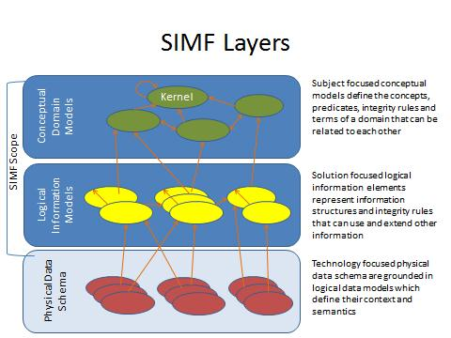

Figure Information Modeling Layers and SMIF Modeling Scope

As indicated in Figure 1, the scope of SMIF includes CDMs, LIMs and MBRs (where the lines in the diagram represent MBRs). While PDSs are out of scope for SMIF, model bridging relations to PDSs are part of SMIF.

## Unified Meta Model & Notation

While SMIF supports modeling at multiple levels, there is a single meta model for SMIF. A model defines the layer it is intended to model. Likewise, the same syntax is used at all levels. While there is a unified meta model, some model elements are more appropriate for one layer or another – which is defined in section 2.

# Conformance

The Conformance clause identifies which clauses of the specification are mandatory (or conditionally mandatory) and which are optional in order for an implementation to claim conformance to the specification.

Note: For conditionally mandatory clauses, the conditions must, of course, be specified.

There are five distinct types of conformance. These are listed below. Unless otherwise stated these types of conformance are independent.

1. *Abstract syntax conformance.* A tool demonstrating abstract syntax conformance provides a user interface and/or API that enables instances of concrete SMIF metaclasses to be created, read, updated, and deleted. The tool must also provide a way to validate the well-formedness of models that corresponds to the constraints defined in the SMIF metamodel. Abstract syntax may be further refined as either:
   1. Conceptual model conformance – corresponding to all elements not included in the packages “Rules” & “Mapping rules”.
   2. Rule abstract syntax conformance – corresponding all conceptual model packages.
2. *UML Profile conformance.* A tool demonstrating UML Profile conformance provides a user interface and/or API that enables instances of SMIF UML notation to be created, read, updated, and deleted. Note that a conforming tool may provide the ability to create, read, update and delete additional diagrams and notational elements that are not defined in SMIF. UML Profile conformance may be further refined as either:
   1. Conceptual Modeling Profile Conformance – All elements defined for the conceptual modeling profile, clause 10.2
   2. SMIF Rules profile conformance - All elements defined for the SMIF Rules profile, clause 10.4.
3. *Model interchange conformance.* A tool demonstrating model interchange conformance can import and export conformant XMI for all valid SMIF models, including models with profiles defined and/or applied. Model interchange conformance implies abstract syntax conformance. A conforming SMIF tool shall be able to load and save XMI as a SMIF MOF meta model.
4. *Semantic conformance.* A tool demonstrating semantic conformance provides a demonstrable way to interpret SMIF semantics, e.g., data transformers, code generation, model execution, or semantic model analysis.

Where the SMIF specification provides options for a conforming tool, these are explicitly stated in the specification. In a number of other cases, certain aspects of the semantics are listed as "undefined" or “intentionally not specified” or “not specified”, allowing for domain- or application-specific customizations. Only customizations that do not contradict the provisions of this specification will be deemed to conform to it. However, models whose meaning is based on such customizations can only be interchanged without loss with tools that support the same or compatible customizations.

This specification comprises this document together with XMI serialization contained in machine-consumable files as listed on the cover page. If there are any conflicts between this document and the machine-consumable files, the machine-consumable files take precedence.

# Normative References

The following normative documents contain provisions which, through reference in this text, constitute provisions of this specification. For dated references, subsequent amendments to, or revisions of, any of these do not apply.

List of normative references. (specific reference to be included)

|  |  |
| --- | --- |
| [UML] | OMG Unified Modeling Language (UML) Superstructure v2.5  <http://www.omg.org/spec/UML/2.5/> |
| [MOF] | OMG Specification ptc/2013-08-20, Meta Object Facility (MOF) Core, v2.5 |
| [ODM] | ODM Ontology Denition Metamodel, 2 September 2014. <http://www.omg.org/spec/ODM/1.1/> |
| [OWL-2] | W3C/TR REC-owl2-syntax:2009 OWL 2 Web Ontology Language: Structural Specication and Functional-Style Syntax. W3C Recommendation, 27 October 2009. http://www.w3.org/TR/2009/REC-owl2-syntax-20091027/ |
| [NIEM] | <http://reference.niem.gov/> |
| [WGS-84] | <http://earth-info.nga.mil/GandG/wgs84/> |
| [JCGM 200:2008] | <http://www.iso.org/sites/JCGM/VIM/JCGM_200e_FILES/MAIN_JCGM_200e/01_e.html> |
| [NIST-SI] | <http://physics.nist.gov/cuu/pdf/sp811.pdf> |
| [NIST-800] | <http://csrc.nist.gov/publications/PubsSPs.html> |
| [BFO] | <http://ifomis.uni-saarland.de/bfo/> |
| [MathWorld] | From *MathWorld*--A Wolfram Web Resource. <http://mathworld.wolfram.com> |

To provide for informal definitions of common concepts various non-normative sources have been used. This included Wikipedia.com accessed under their creative commons license.

# Terms and Definitions

For the purposes of this specification, the following terms and definitions apply.

Terms defined in other sections

* See section 1.2 for definitions of:
  + *Conceptual Domain Model (CDM).*
  + *Logical Information Model (LIM).*
  + *Physical Data Schema (PDS).*
  + *Model Bridging Relation (MBR).*
* All terms defined in the model, clause 6, are defined in SMIF.

Other Terms

* **Instance**: An “instance” designates something categorized by a type (including meta types). For example; “Fido is an instance of Dog” means that Fido <has type> Dog and that Dog <categorizes> Fido. Note: Instance does not imply (or prevent) any implementation or other restrictions such as “Factories” or “Single Classification” as do some programming languages.
* **Fac**t: Facts are something that someone or something asserts to be true. The class of things that can be asserted are called “propositions” as they can be true or false. Once asserted to be true, these propositions are facts. Of course the relevance, trust or belief in facts is open to interpretation.
* **Concept**: Everything we describe in a SMIF model is considered a *concept*. A concept is anything conceived. For something to be in a model there must be a conception of it. Concepts are inclusive of types, categories, values and individuals.
* **Identity**: That which makes something differentiated from something else. Identity is an abstraction that should not be confused with identifiers, which are symbols, adopted by convention, used to identify a particular thing having identity.

# Introduction to SMIF Concepts

The following is a high-level, non-normative, description of some of the fundamental SMIF concepts.

The fundamental concepts will be described in a way that most practitioners can relate it to their familiar experiences. In this chapter we will gradually build a semantic-conceptual architecture (an architecture that is completely independent of any particular technology and in which there is a clear distinction between the world of the things and the world of the representations of those things).

The prime aim of this chapter is to demonstrate the value that a SMIF semantic-conceptual model and transformations can offer to the ever-increasing need of federation of (information) systems in business and government practice.

## *SMIF Concept of concept (Non normative)*

The SMIF meta model can be used to model and integrate information from multiple sources at different levels of abstraction. A key element of SMIF is conceptual models, as described above that model a real or possible world. To provide for mapping, models of data must also be expressed.

A conceptual model (CDM) includes these real world concepts. Data models include concepts of data about these things. Thus the term “concept” in this document can refer to anything that can be referenced in a SMIF model, which is anything. Note that in the SMIF model the “top level”, the class that all others inherit from is called “anything”. There is no class “Concept” in SMIF. The term concept simply means “something we conceive of and model”. To model something, we must have a conception of it, so to be more precise – we express our conception (concept) of something in a model.

There are other times when the topic is the model its self or the components of the model. In this respect a SMIF model is just data. When referencing the SMIF representation of a concept the term “SMIF Element” will be used. A SMIF element is the data representation of a concept in a model repository.

## *Pragmatic world view*

Any conceptual system has strengths and weaknesses and is colored by the influences, people and domains which influenced the conceptualizations. From a pragmatic point of view there is a good understanding of what a “Tree” is (the word sense of tree that refers to a plant most babies could identify). However, when you look very close and at the “edges” such categorizations can be fuzzy. On a similar note when you get to the edges of quantum mechanics and near-light speed travel, our common views of the world can break down, or become unknown or controversial. Those who study language carefully may say that every meaning of every word is contextual and that dictionary and thesaurus don’t completely work.

While all of the above may be true, taken to the extreme it would make communication impossible and synthesizing or transforming information impractical. On the other hand, if you take a pragmatic world view there is a lot that can be done to communicate, even across those with different backgrounds, and most of us just don’t deal with quantum mechanics and “warp speed”. SMIF and the conceptual models built on it use a pragmatic world view and are designed to deal with structured (or at least semi-structured) data. However, such pragmatics are modularized into component models such that those who need to deal with extreme detail in some area may do so without breaking the entire system.

If the “precision dial” were turned all the way up to account for all these edge cases the model would get complex and unusable. Most people understand things based on what the “mostly are”, not the edge cases.

The other extreme is to make definitions and their representation very narrow and specific, perhaps to a system or particular discipline. This other extreme may also have such “fuzzy” definitions that they are no more than hints. This extreme also has its problems and would make wide-scale communications and synthesis impossible. In fact, such overly specific data representations and fuzzy schema are essentially what we are federating with SMIF – the design of specific systems.

So between overly complex and overly specific or fuzzy is the useful middle ground we seek. That middle ground is to be precise and true within this pragmatic world view.

SMIF does not restrict a model to being very loose or very precise, but in general we expect:

* Terms mean what they do in a dictionary definition, refined to a word sense
* Where a concept is more specific it will be scoped by appropriate context (e.g. an expert’s quantification [Keslick, John A. (2004). ["Tree Biology Dictionary"](http://www.treedictionary.com/). Retrieved 2012-07-30.] of what defines a tree may be more specific than common concepts)
* Concepts will have the most general definition and relationships reasonable within the context in which they are defined (note that this sometimes introduces general abstract concepts). Note also that this is different from common practices in defining schema where the same essential meaning is repeated everywhere it is used.
* We are treating the world in terms of Newtonian mechanics (e.g. space/time is not relative). Where applicable, we are concerned with the surface of the earth and the near vicinity (e.g. in understanding location and gravity). However, such assumptions should reference an earth context and off-earth models are possible.
* Generic concepts are better under-defined (having fewer axioms than may be possible) than over-specified. This allows more specific concepts or “theories of the world” to specialize and reuse the generic ones.
* The concepts defined and mapped are being used in some structured way, not unstructured natural language (this does not preclude the structuring of natural language by automated or “human in the loop” means, but this is out of our scope). We do expect that natural language processes may interpret text to define SMIF axioms.

SMIF does provide semantics to support the evaluation of context, scope and trust so domains “on the edges” may still use SMIF, but should be careful about what SMIF features or SMIF models may say about common concepts.

In terms of the spectrum of formal logics and formal languages, SMIF is in the middle. It is specifically designed and intended for the role of semantic mediation or real (and probably messy) data. This is different from most of the “ontology languages” that are designed for general inference and “decidability” of 100% valid and consistent formal models. The priority for SMIF conceptual models is that they capture the real domain semantics, even if those semantics may be inconvenient for some inference algorithms. As such, the SMIF logic does not fit into some of the common categories; it is not a “description logic”, nor is it necessarily a “frame logic” or “first order”. In particular, SMIF relationships are “first class”, that is statements can say things about other statements like “Jim doesn’t believe joe likes sue”. Each of these relationships is its own thing, not part of any “frame” or “object”. SMIF includes a specific concept of context to scope statements. Also, you can also create new kinds of kinds – “metatypes” in modeling land. For these reasons a SMIF conceptual model will probably not be “first order”, but will use higher order logic.

Those wishing to use specific inferencing capabilities, such as those provided by OWL-DL, may use techniques to simulate higher order logic of first-order logics or ignore higher order statements. The SMIF mapping rules are intended to be able to operate against SMIF models without the use of higher order logic inferencing.

These capabilities are not arbitrary – they represent real concepts people need to express about the real world and map real data. By expressing those concepts directly we have a valid “pivot point” for federating data. It should be noted that the kernel of the SMIF language is formalized -described in formal logic, but SMIF does not require such formality in conceptual or information models.

## *Models*

SMIF models describe some subject area or domain for the purpose of defining and sharing *information* within and about that domain and with other related domains. SMIF defines a modeling language for this purpose; users of SMIF use that modeling language to describe applicable concepts; in some cases, a model captures generic, cross domain concepts while in the remaining cases a model may be more specific, that is specific to a discipline, domain, organization or system (we will consider all of these a “domain”). Ultimately a model focused on a domain, any domain, shares many concepts with other domains – the sharing of such concepts is the basis for communications among people, organizations and systems with different backgrounds and purposes. For this reason, domain specific models typically use or specialize more generic cross-domain concepts. To support this requirement SMIF also provides for models that describe general concepts and then provides capabilities to map those general concepts to more specific domain concepts.

**Information**

Models are themselves *information* **about something**. A concept defined in a model is not “the thing”, but a **description of that thing from some perspective**. For this reason, the subject of the model and the perspective are important for understanding the content of the model and how it may relate to other models. A model is fundamentally *information*, that information may be represented in different ways: textually, as tables, graphically, etc. SMIF defines some ways to represent information but other representations may be used as is appropriate for a purpose. The same information is typically rendered in multiple different formats for different purposes and stakeholders.

**Bridging technologies**

A model needs some way to store information. SMIF defines an abstract syntax (nevertheless illustrated with sufficient concrete examples) for storing SMIF information and multiple physical representations, in keeping with the SMIF philosophy of *bridging* technologies. Regardless of the technology, a SMIF model can be thought of as a repository of information. \

**Model representation and exchange using MOF**

Since SMIF is, its self, information about information it is also called a “meta model”. As a foundation for expressing and sharing concrete SMIF models, SMIF uses [MOF], an OMG technology for model management. MOF includes the specification of XML, the format that is used for all MOF models and therefor SMIF.

## *Concepts*

Everything we describe in a SMIF model is considered a *concept*. The SMIF meta model can be used to model and integrate information from multiple source at different levels of abstraction. A key element of SMIF is conceptual models as described above – models a real or possible world. To provide for mapping models of data must also be expressed.

A conceptual model (CDM) includes these real world concepts. Data models include concepts of data about these things. Thus the term “concept” in this document can refer to anything that can be referenced in a SMIF model, which is anything. Note that in the SMIF model the “top level”, the class that all others inherit from is called “anything”. There is no class “Concept” in SMIF. The term concept simply means “something we conceive of and model”. To model something, we must have a conception of it, so to be more precise – we express our conception (concept) of something in a model using the SMIF syntax and vocabulary.

The conceptual domain model (CDM) is a model where we express our conception of a real or possible world

There are other times when we must consider is the model “data” its self or the components of the model data. In this respect a SMIF model is just data. When referencing the SMIF representation of a concept the term “SMIF Element” will be used. A SMIF element is the data representation of a concept in a model repository.

The term concept is used because a model describes how we conceive or understand something from a perspective. For example, we may all understand there is something we call the “Eiffel tower”. In the figure below this information is represented in a very familiar format, an extended Venn diagram. We see a clear distinction as said above between the world of the things and the world of names and information about the things, an essential distinction in SMIF.

A person preferring a textual representation could use the following formal representation:

(1a) “There is something in the world that we are thinking of when the term “Eiffel tower” is used”.

Or in short but sufficient format:

(1b) There is something in the world that is referred to as Eiffel tower.

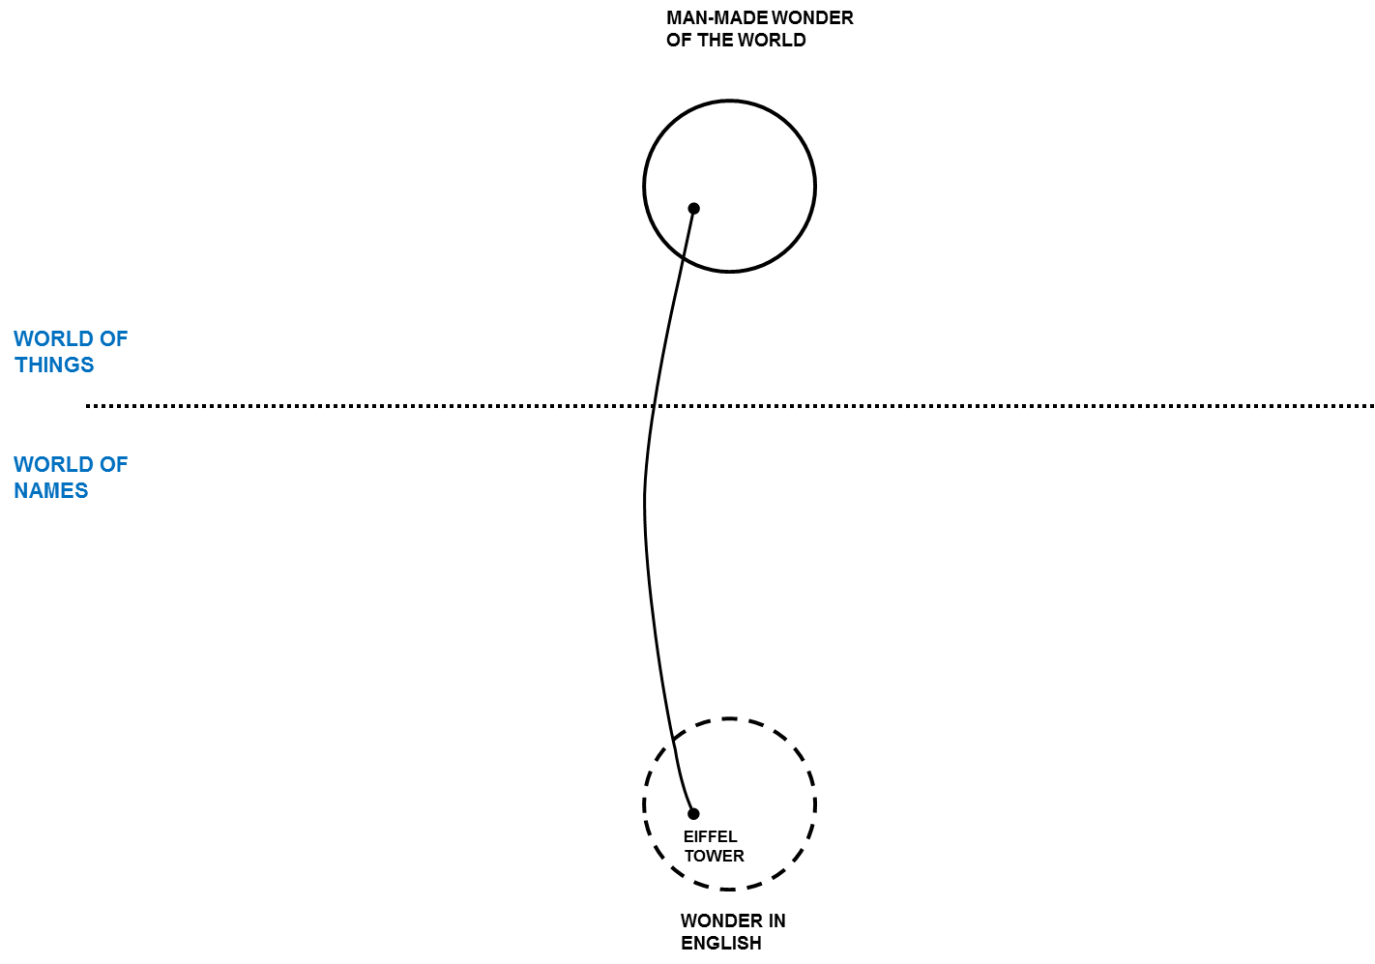

Figure

But how we think about it (the thing designated by the term “Eiffel tower”) or describe it may be different. Differences aside, there is something in the world that we are thinking of when the term “Eiffel tower” is used so we want to connect these different descriptions of the same thing – it is the “real thing” that connects us even though there is no way to have that real thing in our minds or models. We connect the dots through our concepts grounded in our mutual understanding of the world.

Concepts in SMIF may be about anything: “Real things” like the Eiffel Tower, Imaginary things like Unicorns, types of things, actual physical things, characteristics of things, relationships between things, rules, even names.

Once you define a concept in a model you can start adding to it, saying more about it – of course each thing you add is a new concept. A SMIF model becomes a connected graph of these concepts and concepts about concepts. Some of those concepts will also come from other models.

In Figure 3 quite a few additional pieces of information are added to say more about the Eiffel tower. We also bring in a second example, in this case the well-known Colosseum. Please note that the English term Colosseum identifies the same thing as the French term Colisée. Figure 3 can be used to illustrate the essential concepts of context and perspective in a way that practitioners easily understand.

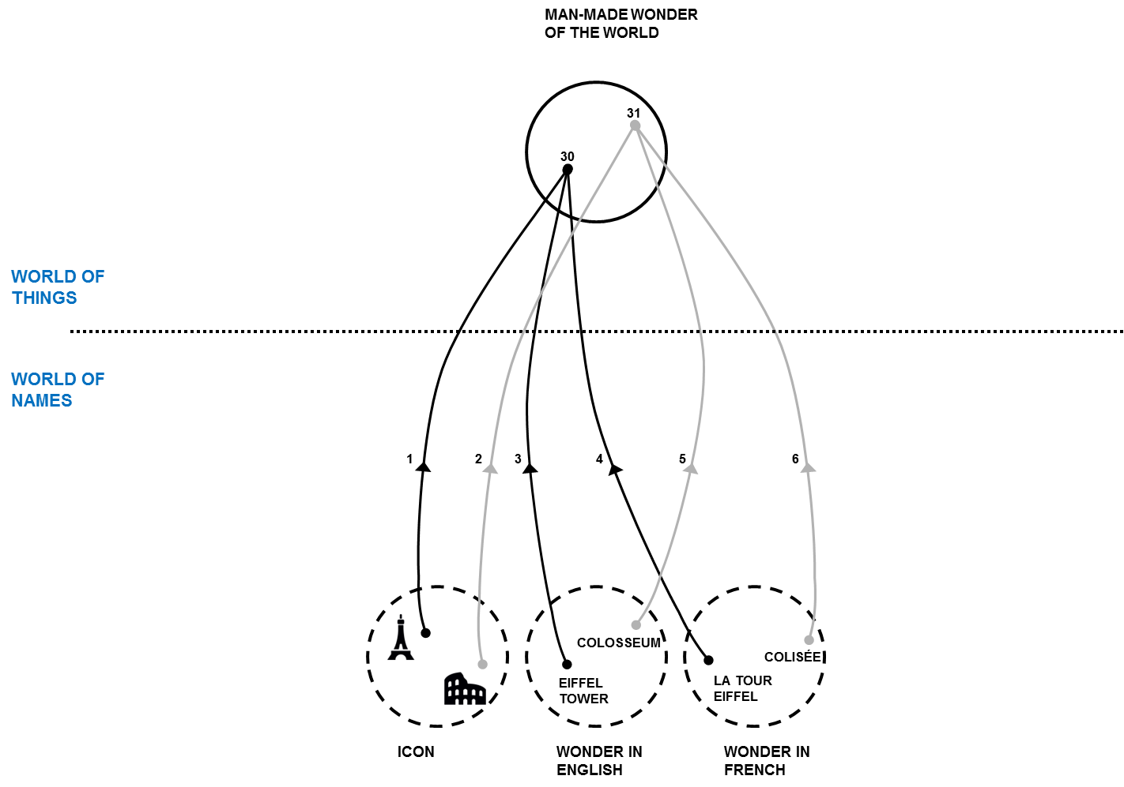

Figure

### Dictionary Concepts

In many modeling languages you need to know a lot about something to define it in a model. In SMIF, you can invent new concepts any time you like as a dictionary defined concept and may or may not provide further formalization. In defining such a new concept you may give it a name and it is best to give it a description. Other concepts are defined more contextually and may not require a name. For example, the concept that the Eiffel Tower was erected in 1889AD or that it is 324 meters tall (including the TV antenna) do not need extra names; they are just facts about the Eiffel tower expressed as relationships concerning the Eiffel tower and some other thing or value. Facts are concepts describing one or more other concepts. In the figures above, each line is a fact. However, facts do have “identity” so their provenance can be traced, crucial in trusting any “fact”.

## *Facts*

Facts are something that someone or something asserts to be true. The class of things that can be asserted are called “propositions” as they can be true or false. Once asserted these propositions are facts. Of course the relevance, trust or belief in facts is open to interpretation. SMIF provides information to evaluate the source and context of facts, trust can then be evaluated but this evaluation is outside of the scope of this specification. SMIF does not deal with “Truth” from a philosophical perspective.

Typical kinds of facts are relationships, constrains and rules. Relationships are “ground facts” about the actual things – constraints and rules are more general assertions about groups or classifications of things.

## *Context*

In this section we will use Figure 4 as the diagrammatic representation to illustrate contexts and perspectives.

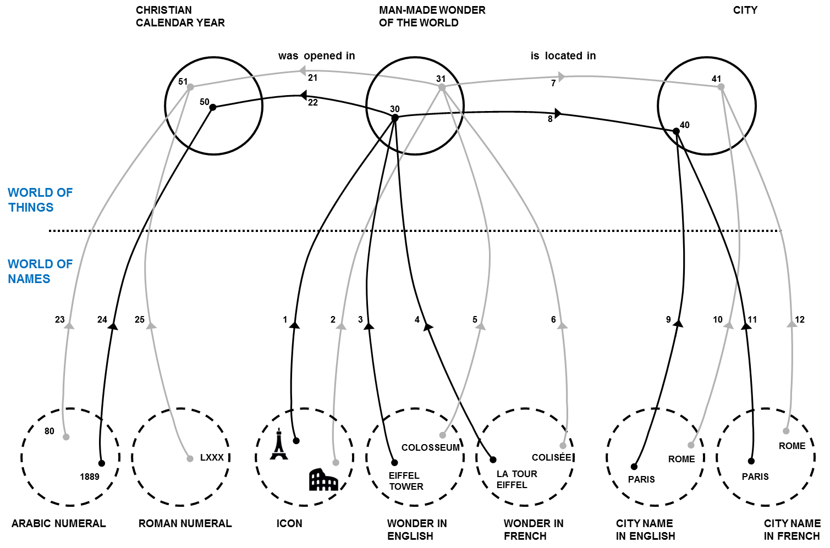

Figure

As descriptions of something are from a certain perspective, not all concepts are the same. You may trust some and not others, some may be true of a certain timeframe, and some may only be valid in specific conditions. A central problem in information federation is that the context of information from various information repositories is different and often implicit. Different authorities may or may not agree on facts, they may or may not use the same or conflicting terms, they may describe different aspects of the same thing. Each description, each concept, needs to be understood within the context in which it is defined and used. SMIF defines “context” as a “first class” concept – that means that dealing with context is part of using SMIF.

In SMIF, a context connects a set of facts with a set of things those facts apply to. The context *contextualizes* a set of concepts that it applies to. Facts and rules are defined in one or more context and apply to everything those contexts contextualize.

There is a fact that the Eiffel Tower is the tallest building in Paris. Who said that? Can you believe it? If I got that fact from Wikipedia, does that make it believable? The source of information is one of the contextual dimensions. What if a taller building were built in 2020? The fact that “the Eiffel Tower is the tallest building in Paris” would be true in the timeframe from 1889-2020. Timeframe can also contextualize a fact. From this example we can see that the applicability and interpretation of a fact is contextual and that multiple contexts may be applicable to any one fact. Your perspective defines what contexts are meaningful and trusted in a situation. SMIF defines context and provides annotating models with context and provenance, the interpretation of that information to form “trust” and “belief” is outside of this specification. Tools that build on SMIF may provide was to evaluate or quantify trust and belief based on the information SMIF provides.

## *Entities*

Individual things that exist in our world, or some conceived world, are entities. Examples of entities include Barack Obama, The Eiffel Tower, Hurricane Andrew, an agreement between Barack Obama and the country France, the mortgage for my house, etc. Entities include physical things (with a “special/temporal extent”) that do exist, may exist in the future or have existed in the past. Entities also include specific things we conceive, such as agreements between specific individuals. Entities have a “lifetime”, and they may change over that lifetime however that lifetime may or may not be known and we may have facts about an entity before, during and after its lifetime. An important aspect of entities is that they have some kind of identity that remains with the entity over its lifetime – even as aspects of that entity may change.

Entities also include types and classification. Thus the concept of frogs is also considered an entity. A specific frog would be an “individual entity”.

Entities may be differentiated from “Values”, below.

## *Values and Anything*

Values, such as the number 5 or the text “Frog” are “values”, they are information we use to describe things. Information and values form a tree that is distinct with “Entities”. Entities are anything that you can identify other than values. Above entities and values is the superclass “Anything”. All elements in SMIF derive from “Anything”

Numbers are the most common kind of such values – you can’t “create” the concept of “5”, it “just is” based on our accepted theory of numbers. Values are typically used as the object of properties (also called attributes) such as something’s size, mass or some other quantity. Numbers, strings and certain fixed enumerated values are considered value types.

## *Situations*

Various configurations, states and properties of things exist over some timeframe, as understood from some perspective. Such configurations of things are *situations*. A situation is a description of any configuration of things, including the logical, temporal and physical relationships between them. Situations can be large and comprehensive – like our solar system or as granular as your weight at a particular time. Facts about anything can be contextualized by a situation and that situation may, in turn, be contextualized – perhaps by a timeframe. Situations may be real or imagined, in the past, present or future.

Situations form the basis for relationships and facts in SMIF as any fact or relationship could be bound by a time dimension when it was true. As all situations are bound by some timeframe where they are true (regardless of whether that timeframe is known or not), situations are the link between “things” and time. When we look as a “snapshot” of the world, or of data, we are looking at a particular situation.

## Relationships

Relationships (a kind of situation) are concepts that logically connect other things and represent the primary semantic propositions of SMIF. For example, the height of the Eiffel Tower is a “Height” relation between the Eiffel Tower and the quantity “324 meters”. That my computer is on my desk may be a “supports” relation between my desk (as the support) and my computer (as the thing supported). While the set of relations describing something may change over time, each relation is considered atomic– the “parts” bound to the relation (the things they relate) don’t change, any change in the things related would be a new relation. Said another way, the related entities define the identity of the relationship.

Relations can involve any number of “properties” that define how other concepts are connected to the relation – in SMIF relationships may have any number of properties. Properties are the “ends” of the relationships. While most relationships have 2 ends, any number of ends may be represented.

Relationships are considered “atomic propositions” in SMIF and are either true or false. Relationships that are time sensitive should include time as one or their properties.

It should also be noted that in SMIF relations are “first class”, that is relations may have relationships to other things, including other relationships. Relationships quantifying the timeframe where other relationships are true are a very common form of relationships applying to relationships. Note that this provides for SMIF models that may represent “4D” concepts, where time is the 4th dimension.

## *Types*

Types categorize and describe sets of things. Everything in SMIF has at least one type and may have any number of other types as well. The set of types that categorize a concept may change over time and be specific to a context. Rules describe and may constrain the extent of a type. As in most modeling languages, types may specialize other types and form a hierarchy. A type may specialize any number of other types, thus supporting “multiple inheritance”.

### Types and Instances

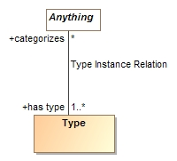The essential intent of types is that they categorize a set of things. A type provides the context for the rules and intent of what is categorized. The set of things categorized by a type is the “Type Instance Relation” where a type <categorizes> a set of things and.the things thus categorized <has type> of one or more types. The “Type Instance Relation” may be explicitly asserted in some context or may be inferred based on rules. One way or the other, the “Type Instance Relation” is the complete set of instances of a type.

In a conceptual model where we are modeling the “real world” a type is assumed complete unless otherwise constrained. For example; the type “Dog” categorizes all dogs, not just those that may be known to you or some computer system. Of course you may have subsets of all Dogs in a particular context that is known to you or a computer system – such as the set of Dogs in your house.

In some programming languages the term “Instance” may imply other things, such that a “Class” is a “Factory” for a set of instances or that something may be an instance of only one type. The term “Instance” as used in SMIF designates something categorized by a type and does not imply (or prevent) any implementation or other restrictions. For example; “Fido is an instance of Dog” only means that Fido <has type> Dog and that Dog <categorizes> Fido.

### Multiple inheritance and multiple classification

A type may specialize any number of other types, thus supporting “multiple inheritance”. In addition, a concept may have any number of types and these types may change over the lifetime of the concept (see Facets 5.11.3). Note that this is different from the typical “OO Language” where an instance may have only one type and that type is fixed. Multiple inheritance and multiple classification better capture true domain semantics.

Since the assumption is that a concept may have any set of types, it is necessary to sometimes declare that some types can’t be combined in the same concept – for this purpose as specific “Disjoint” constraint is used. For example, something can’t be a Frog and a Planet. The assumption is that any 2 types can be mixed unless they are specified as Disjoint. In the profile Disjoint may be specified with the <<disjoint with>> dependency or a UML generalization set.

### Situation Types & Properties

Situations have their own specialization of the type concept, one that defines– Properties. A property represents the state or behavior of something involved in a particular kind of situation – frequently expressed as a verb phrase. For example, in an “Employment” relationship for employer “has employee” Fred and the employee “has employer” Acme Industries. Each situation type defines the properties that can be involved with that kind of situation.

Properties have a set of potential rules that can be defined for them in various context. These include the types able to bind to the property, how many things can be bound, etc. We can also define a hierarchy of such properties.

Relationships define a set of properties for the related things. In a conceptual model properties use verb phrases to describe the related thing from the perspective of its opposite ends but the entire relationship defines a single fact with its own identity. The relationship serves as the connective tissue between these different ways to read the same fact. Note that this is different from some ontology languages like OWL, where independent “predicates” describe the same fact as an “inverse”. Since SMIF ascribes identity to facts it is important that these verb phrases are understood to be different “readings” of the same fact.

Properties are bound to individuals in a situation. Properties also serve the purpose of “roles”, “variables” and “arguments” in programming languages.

Examples:

* Barack Obama is bound to the “President” role in the Organization “United States of America” during the period January 20th, 2009 (Noon EST) to January 20th, 2016 (Noon EST).
* The “Eiffel Tower” is bound to the “height of” role and “324 meters” is bound to the “has height” property in the relationship “Height”.

**Note on naming properties**: In a conceptual model it is best practice to use verb phrases for the “ends” of a relationship. In physical models it is more common to use noun phrases.

### Facets

Some types are an essential part of what something is and its identity. For example a Dog “Fido” is born and dies a dog, you can’t take away Fido’s dogness (at least not today, we shall see how genetic engineering goes). On the other hand Fido may be a “Good dog” or a “Wild animal” or a “Pet” at various times. These “extra” classifications of Fido are not essential to Fido being Fido. In [BFO] this distinction is made in terms of “rigid” Vs. “non rigid” sortals (types). The non-rigid classifications are called “Facets” in SMIF.

Something can’t just be a Facet, it has to have some rigid non-faceted type as well, this rigid type is the foundation for the identity of individuals. Facets don’t create a new identity, they classify an existing one (sometimes in a specific context).

It is frequently desirable to specify what rigid types a Facet can classify. This is done by marking the generalization from the Facet to the rigid type “as facet” in the meta model or a <<classifies>> stereotype in the UML profile. This says that the facet must be a facet of this type and also implies that the subtype must be a facet. It is also possible to have a facet of a facet, where the rigid identity comes from a supertype of the more general facet.

Note that there are various ways to map facets to implementation technologies – in most cases each facet will be a different “technology object” that represents the different facet of the same underlying thing in the world.

There are specific kinds of Facets, “Roles” and “Phases” as defined below.

### Roles

A role is a facet that defines how something behaves or participates in some situation. Typical examples are “Teacher”, “Student”, “Pet”. In a conceptual model it is valuable to separate “what something is” from “what it is for” or “what it is doing”. Roles allow this important separation of concerns.

### Phases

A phase (or state) is a characteristic of something that exists for limited time(s). Phases are time-bound facets. Something takes on or loses a phase as a result of some event (including the passage of time). E,g, Teenager, living, closed invoice.

## Rules

Rules define some general proposition that hold within (must be considered true) within a context (including situations, types and relationships). There are various kinds of rules, some of which are defined in SMIF and some which are defined in SMIF models. Rules are used to define the constraints of entities, relationships and other concepts. Rules are also the basis for defining the mapping between different models.

A rule is something that can be asserted to “hold within” some context (including types and situations). That rule then applies to everything that is contextualized by that context. Context are the essential binding between rules (or any assertion of a proposition) and the things that rule applies to. There are types of rules, so rules also form a hierarchy.

### Constraints

Constraints are rules that define some condition that must be true, else the model is not valid. A constraint may be enforced for all time (at once = false) or at a particular instant in time elements (at once = true). SMIF does not infer any elements to attempt to satisfy a constraint, such inferences are done with rules or by external systems.

Examples of constraints include:

* Equivalence
* Disjointness
* Types of properties
* Multiplicity of properties
* Generalization (subclassing of properties and types)

SMIF can also express general constraints as patterns, such that all fish live in water.

### Mapping rules

An essential feature of SMIF is mapping between different representations of the same concept. Mapping rules are based on patterns – mapping a pattern in one model to a pattern in another model. These patterns are constrained by the SMIF type system and “representation rules” such that for each thing to be mapped, SMIF also expressed what (data focused) types can represent SOMF domain concepts.

The combination of representation rules and mapping patterns provide the basis for information federation.

## Expressions

SMIF provides for general expressions which are then used in other parts of SMIF, for example in rules. The SMIF expression meta model is minimal, the bulk of the functionality to be provided by function libraries. The built-in capabilities are:

* Constant reference
* Traversing relationships
* Testing equality
* Calling functions

The philosophy of SMIF expressions is to put almost all expression semantics into functions. A function library is anticipated as a future SMIF model.

## Characteristics, Quantity Kinds & Unit Types

While some relationships are between entities, others relate a characteristic of an entity to some value.

To provide for a semantic definition, in a conceptual model characteristics always have a domain-relevant type (not a data type, like “Int”). In the case of quantities (a characteristic that can be identified with a number and a Unit), there is always a unit type corresponding to some “quantity kind” such as temperature or mass. Units are, of course, critical in understanding what a quantity really means. Characteristics are defined with relationships where one of the properties is a value. The “object” of such a characteristic relationship is always a value type.

Based on the definitions in JCGM 200:2008 : A “Quantity Property Type” (e.g. Height) has a range of a “Quantity Kind” (e.g. Length) which is represented by a “Measurement Unit” (e.g. Meters) . An instance of a Measurement Unit is a “Quantity Value” (e.g. 324 Meters).

SMIF defines the modeling capability for defining quantities, quantity kinds and unit types. Models expressed in SMIF define libraries of quantity kinds and units, but these models are not part of the SMIF specification. Later specifications may provide Unit Type libraries.

## Terms and Naming

A SMIF concept can be named by any number of terms. A “Term” binds a string label to a concept in some context. A concept may have multiple terms in multiple context different domain taxonomies and/or natural languages can identify the same concept. Concepts can also be nominated as “preferred”. While terms are considered primarily for human consumption, concepts can also have various identifiers that are more meaningful in implementation technologies. The “URI” is the most common form of identifier. Concepts can also have multiple identifiers.

## SMIF Lexical Scope & Physical Representations

A SMIF model is an information resource and as such has structure and semantics as defined in the SMIF abstract syntax. Most of the SMIF model describes the modeled domain or subject. Other “lexical” (or syntax) aspects describe the model itself or elements of that model – its content, source and organization.

Only a small subset of that abstract syntax is relevant to the structure of the information, this structure is defined in the “Lexical Scope” portion of the model. The lexical scope structure is then mapped to various technology formats such as MOF-XMI or RDF. MOF-XMI is the normative representation.

Like most modeling languages, a SMIF model is “block structured”, that is certain elements contain other elements. The model structure is one form of context that may or may not be relevant to its interpretation, SMIF attaches no implicit semantics to model structure. Most users will not be concerned with the details of the lexical structure, but an understanding of it is important for implementers, as follows…

A key element is the abstract “*Lexical Scope*” which can define and/or import any context in any model. Referencing a context makes it visible within the lexical scope, importing a context asserts that external scope within the lexical scope. A lexical scope may also define Terms, which provide labels for concepts.

A package is a user defined lexical scope for organization purposes. There can be packages for various purposes which are defined as subtypes of Package. As a lexical scope and context, a package MAY be used for assertions.

A *Model* is a package with no parent, it is an independent data resource.. A model is identified as modeling a particular level of abstraction (Conceptual, Logical, Physical or Binding) and subject area.

## Patterns

Patterns describe a class of similar situations with some constant and some variable parts. Patterns utilize “pattern properties” as the variables and provide various rules for what those variables do or may represent. Pattern variables are combined with relationships within the pattern – things that are always true for all instances of the pattern. Relationships in patterns can reference both pattern variables as well as actual things. Patterns are used for rules, including mapping rules. Patterns may also be used for general constraints.

## Situation and pattern instances

Particular situations as well as patterns “bind” things to properties in relationships. Bindings bind an individual to a property in a situation. Each “end” of an instance of a relationship type is a binding.

Bindings are possible due to the SMIF concept identity. Every concept in SMIF has identity or a value: Every individual, relation, binding and type. For this reason, SMIF relationships may be made between anything. It may be noted that this is not “first order”, as in “first order logic” (FOL). Supporting a rich conceptual model and mappings requires concepts that are not first order. Portions of SMIF models may be mapped to first order languages using well known patterns to take advantage of their inference capabilities.

## Record Structures and Structured Types

Data schema (PDSs) and information models (LIMs) typically have specific data structures that hold information about something as a “snapshot” in time. In these kinds of structures that properties are “owned by” the structure, sometimes these properties are called “slots”. To provide for an accurate representation of “target” data structures SMIF allows the definition of “Records”. Unlike entities in conceptual model, records may directly contain properties. These records may then be matted to their conceptual counterparts.

To support records, SMIF defined Record Types and Records (an instance of a record type). Record types are intended for LIMs and PDSs but CDMs are not prevented from using records.

There is a general pattern that can be noted in SMIF, that of “something with properties”. SMIF defines an abstract “Structured Type” as the owner of properties. Anything that can have properties inherits, directly or indirectly, from “Structured Type”. This includes Situation Types, Relationship Types, Record Types, Patterns and Operation Types.

Bindings are used to bind a particular thing to a property within a situation.

## Views and Viewpoints

The separation of general concepts from viewpoints of that general model and then specific views of a model is well established. In evaluating existing schema and languages it has become apparent that the industry is reasonably good at defining viewpoints – that the existing languages are already viewpoints that can then express multiple views. What the industry has not been good at is connecting the viewpoints to the underlying concepts. The SMIF CDM is a representation of the underlying concepts. Our assumption is then that the views and viewpoints will be expressed in the LIM and PDS models that SMIF is mapped to. For this reason, SMIF is not attempting to define viewpoints. Existing technologies such as MOF and the OMG/MDA stack are already able to define such viewpoints. SMIF can map these viewpoints to common concepts – what they are viewpoints of.

# SMIF Conceptual Model & Abstract Syntax [Normative]

This section presents the normative specification for the SMIF conceptual model and metamodel. It begins with an overview of the metamodel structure followed by a description of each sub-package.

The SMIF MOF metamodel (abstract syntax) is derived directly from the SMIF conceptual model by removing the SMIF profile specific elements that would not be interpreted correctly by MOF – in particular the expression of restriction rules based on subsets and redefines. In addition, data types are mapped to the MOF counterpart. For this reason, there is only one model documentation where as there are two model artifacts – one for the conceptual model and one for the MOF metamodel.

#### Diagram: SMIF Packages

## SMIF Conceptual Model

### Diagram: SMIF Packages

848084482.emf

1. SMIF Packages

## SMIF Conceptual Model::Kernel

The kernel subsets the SMIF classes. The diagrams in this package illustrate the concrete classes that are used to define the SMIF language. Specifications for each class and association are defined in the corresponding package for that concept.  
Note that shaded classes are not instantiated in the kernel and may be "flattened".

### Diagram: Kernel Identifiers

-1589839955.emf

1. Kernel Identifiers

An identifier that can be represented as text. The text is in the "value" property.  
  
[IDEAS] Sign: An Individual that signifies a Thing.

### Diagram: Kernel Lexical Scope

-931048839.emf

1. Kernel Lexical Scope

### Diagram: Kernel Metadata

-1258527893.emf

1. Kernel Metadata

### Diagram: Kernel Properties

-281755597.emf

1. Kernel Properties

### Diagram: Kernel Relationships

-335604675.emf

1. Kernel Relationships

Relations are atomic situations that bind 2 or more properties as a fact.

### Diagram: Kernel Rules Summary

-522033972.emf

1. Kernel Rules Summary

This diagram shown a summary of the primary rules.

### Diagram: Kernel Top Level

-629609218.emf

1. Kernel Top Level

Diagram showing summary of top level classes and significant subtypes.

### Diagram: Kernel Types

-164944547.emf

1. Kernel Types

### Diagram: Kernel Values

-1906661175.emf

1. Kernel Values

## SMIF Conceptual Model::Expressions

Expressions define computations across SMIF models.

### Diagram: Expressions

2002426484.emf

1. Expressions

Expressions define computations

### Class Constant Reference

A calculation that returns a thing identified by <has value>.  
  
[FIBO] Constant  
[FUML] LiteralSpecification where subtype of literal is determined by the type of <has value>.   
-LiteralInteger->type is Integer or a subtype  
-LiteralReal-> type is not integer or a subtype  
-LiteralBoolean->type is Boolean  
-LiteralString->type is Text

#### Direct Supertypes

Expression Node

### Association Constant Value

Relationship defining a link to a constant value within an expression.

#### Association Ends

-451263861.emf has value : Thing [1]

A constant value referenced in an expression.

-451263861.emf referenced by : Constant Reference [*]

Referencing constant expression node.

### Class Equality

Returns TRUE if all <has equal> things have the same value or represent the same thing or set of things regardless of how they are represented.  
Equality will return TRUE or FALSE.

#### Direct Supertypes

Expression Node

### Association Equality Constraint

Relationship defining set of things that will be evaluated for equality.

#### Association Ends

-451263861.emf has equal : Thing [1..*]

Set of things that must have the same value or represent the same thing or set of things for Equality to return true.

-451263861.emf has equality : Equality [*]

Equality constraints for a thing.

### Class Evaluation

The evaluation of an expression. All references to an evaluation shall return the result of evaluating the <evaluates> expression node. All expression nodes referenced within an evaluation shall return the result of evaluating that expression node.  
An evaluation may be used in place of anything that requires the <resulting type> of the evaluation.

#### Direct Supertypes

Expression Context

### Association Expression Context

Context in which an expression will be evaluated.

#### Direct Supertypes

Extent of Context

#### Association Ends

-451263861.emf evaluates in : Context [0..1]

Context of evaluation and namespace resolution for an expression.

-451263861.emf contextualizes : Expression Context [*]

Expressions referencing a context.

### Class Expression Context

An abstract element defining the static or dynamic evaluation context and resulting type of an expression.  
An expression context that is referenced by another expression context inherits the referencing context by default.

#### Direct Supertypes

Identifiable Entity

### Association Expression Evaluation

Relationship defining the expression that will be evaluated by an evaluation.

#### Association Ends

968024134.emf evaluates : Expression Node [1]

The expression node "head" an evaluation evaluates.

968024134.emf evaluated by : Evaluation [*]

Evaluations of an expression node.

### Class Expression Node

An abstract class representing the computation of a value which is then bound to the context from which it is called. Each expression node has a type of the most general type it can return.  
  
An expression node may reference other elements. Where the other elements are also expression nodes they will be considered part of the referencing expression and evaluated in the context of that expression.  
  
The set of related expression nodes forms a "tree" for evaluation.  
  
[FIBO] Expression  
[UML] Expression

#### Direct Supertypes

Expression Context

#### Attributes

-412371193.emf expression text : Text [0..1]

Textual expression of the expression which is further refined by subtypes of expression.  
[UML] StringExpression

-412371193.emf expression text language : Text [0..1]

expression language used for the expression text

### Class Function Call

An element of an expression that performs some operation based on a function type and produces a result. I.e. plus(a,1).  
Arguments are bound to the function call via bindings.

#### Direct Supertypes

Expression Node, Structure

### Association Function Called

Relationship defining the function (a type) called by a function call.

#### Direct Supertypes

Extent of Type

#### Association Ends

968024134.emf calls : Function Type [1]

Function called

968024134.emf is used by : Function Call [*]

Function calls using a function declaration.

### Association Function Implementation

Relationship defining the implementation of a function by an expression.

#### Direct Supertypes

Expression Context

#### Association Ends

968024134.emf implemented by : Expression Node [0..1]

Expression which defines the implementation of a function.

968024134.emf implements : Function Type [0..1]

Function implemented by an expression

### Class Function Type

A declaration of a function which performs a calculation on arguments (properties) to produce a result (function result). I.e. the definition of plus(a:Number, b:Number).  
  
Functions are intended to be side-effect free and context free (they only depend on their arguments and don't change anything) but assertions to specify that certain functions are pure may be required,  
Note: FUNCTION ARGUMENTS ARE PROPERTIES of the function.  
  
[FUML] Operation where ownedParameter corresponds with <has property> and type corresponds with <resulting type>.

#### Direct Supertypes

Expression Context, Structure Type

### Class Object Operation Type

An operation bound to a specific "receiver" in the "Object Oriented" sense.  
[FUML] Operation

#### Direct Supertypes

Function Type

### Association OO Target

Relationship defining the "target" type of an object oriented function.

#### Association Ends

-451263861.emf receiver : Property Type [1]

The property that is the receiver of an object operation.   
[UML] class (of Operation)

-451263861.emf received by : Object Operation Type [*]

The Object Operation for which a receiver is defined.

### Association Result type

Relationship defining the type or types returned by an expression evaluation.

#### Association Ends

-451263861.emf resulting type : Type [1..*]

Type of the result of a function  
[UML] type (of an operation or expression).

-451263861.emf returned by : Expression Context [*]

Method returning a type.

### Class Traversal

Traversal from the current <evaluates in> context to another across a relation or other structure.  
  
A traversal is a structure such that the structure's bindings may hold other properties of a traversal constant as independent variables where <traverses through> is the dependent variable. The traversal shall be considered to have the type of the relation it is traversing. Traversing binary relations does not require any bindings.

#### Direct Supertypes

Expression Node, Structure

#### Attributes

-412371193.emf traverse to relation : Boolean [1] = false

Where traverse to relation is false, the traversal will return the bound element(s) of the <traverses through> property from the current context via any intermediate relationships.  
  
Where traverse to relation is true, the traversal shall return the structure/situation/relationship owning the property binding.  
  
By default, traverse to relation is false.

-412371193.emf inverse : Boolean [1] = false

Indicates that the traversal is defined based on properties that reference the current context. This results in traversing "backwards" across a property to an inverse property or the relation.

### Association Traverse Through

Relationship defining the property of the current context which will be traversed.

#### Association Ends

-451263861.emf traverses through : Property Type [1..*]

Property or properties through which a traversal traverses as the dependent variable(s).

-451263861.emf traversed by : Traversal [*]

Traversals through a property.

## SMIF Conceptual Model::Facets

The facet package defines facets, roles and phases. Types that "mix in" to other types in a specific context or timeframe.

### Diagram: Facets

509137135.emf

1. Facets

### Class Entity to Facet Binding

Facet of Entity binds a particular entity to a facet. In the case of a role, it states that an entity plays the role. In the case of a phase, it states that an entity has that phase and that it is a phase of that entity.  
Facet of Entity is a kind of contextual categorization in that the entity assumes all of the characteristics of the facet where the Facet of Entity is asserted. E.g. if Joe has a policeman role, Joe is a policeman.  
  
Facet of entity may only relate entities that have a type compatible with the type of the facet, as defined by a Facet Classification Rule.  
  
[FIBO] (for roles of actors) AgentInRole.  
[FIBO] (for roles of anything else) ThingInRole

#### Direct Supertypes

Relationship

### Class Phase

A phase (or state) is a static characteristic of something that exists for limited time(s). Something takes on or looses a phase as a result of some event. E,g, Teenager, living, closed invoice.  
A Phase is a situation in that there is a situation coincident with each phase.  
  
[Guizzardi] (Phased-Sortal): Let PS be a universal and let S be a  
substance sortal specialized (restricted by) PS. Now, let extw(~PS) = extw(S) \ extw(PS)  
be the complement of the extension of PS in world w. In this formula, the  
symbol \ represents the set theoretical operation of set difference. The  
universal PS is a phased-sortal iff for all worlds w ∈ W, there is a w ∈ W such  
that extw(PS) ∩ extw(~PS) ≠ ∅

#### Direct Supertypes

Facet, Situation Type

### Class Role

A role is a facet type that defines a specific purpose or behavior of a class of things. E.g. teacher, policeman, or employer.  
[FIBO] Role. Note that partyInRole or thingInRole are implied by classification of a thing.

#### Direct Supertypes

Facet

## SMIF Conceptual Model::Identifiers

Terms and identifiers provide for signs for (ways to identify) anything.

### Diagram: Identifiers

902474025.emf

1. Identifiers

An identifier that can be represented as text. The text is in the "value" property.  
  
[IDEAS] Sign: An Individual that signifies a Thing.

### Association Identification

Relationship defining an identifier for an entity.  
  
[IDEAS] namedBy: A couple that asserts that a Name describes a Thing.  
  
[ISO 1087] Designation

#### Association Ends

968024134.emf identifies : Identifiable Entity [1]

The entity an identifier identifies.  
  
[FIBO] identifies: is the relationship between something and that which provides a unique reference for it  
  
[ISO 1087] designator: representation of a concept (3.2.1) by a sign which  
denotes it

968024134.emf identified by : Identifier [*]

An identifier for an <Entity>.  
[FIBO] hasDenotation

### Class Identifier

An identifier is any value that is used to distinguish an entity from other entities. Note that any identifier may be contextualized by one or more context, including language context. Identifiers are a “sign” for an identity where identity is an abstraction of individuality that is the basis for identifiers.  
  
[IDEAS] Name: A Representation that identifies a Thing.  
[FIBO] Identifier

#### Direct Supertypes

Value

### Association Identifier in Namespace

Relationship defining the namespace within which a unique identifier is defined and unique.  
  
[ISO 1087] monosemy: relation between designations (3.4.1) and concepts (3.2.1) in a given language in which one designation only relates to one concept

#### Direct Supertypes

Definition

#### Association Ends

968024134.emf unique within : Namespace [1]

The namespace in which an identifier is defined and has a unique value.  
[FUML] memberNamespace

968024134.emf scopes identifier : Unique Identifier [*]

An Identifier defined within the scope of a namespace.  
[FUML] member

### Association Identifier Preference

Relationship defining the preferred identifier for an entity.  
  
[ISO 1087] preferred term: term (3.4.3) rated according to the scale of the term acceptability rating (3.4.14) as the primary term for a given concept (3.2.1)

#### Direct Supertypes

Identification

#### Association Ends

-451263861.emf has preferred : Identifier [0..1]

Default identifier to use for an entity.  
Where multiple identifiers are preferred in differing context any method for selecting the most preferred identifier is implementation specific and not specified by this standard.  
[FUML] NamedElement.name: Note: An Identifier that is <preferred for> an entity is equivalent to the name of a named element.

-451263861.emf preferred for : Identifiable Entity [0..1]

The entity an identifier is preferred for.

### Class IRI Identifier

A IRI/URI Identifier for an entity, as defined in [RFC3987].  
  
[FIBO] anyURI

#### Direct Supertypes

Technical Identifier, Unique Text Identifier

### Class Name

A word or set of words by which a person, animal, place, or thing is known, addressed, or referred to. Names are not necessarily unique.  
  
[IDEAS] Name: A Representation that identifies a Thing.

#### Direct Supertypes

Text Identifier

### Class Namespace

A namespace is a context that provides a way to make identifiers unique and identify exactly one entity. For example, the Virginia driver's license division provides unique driver's license numbers.  
  
Similar to [IDEAS] UniqueNamingScheme: A NamingScheme where different Names will not contain tokens of the same Representation Type.   
Note: SMIF identifiers are not instances of their namespace.  
  
[FIBO] IdentificationScheme: system for allocating identifiers to objects  
  
[ISO 1087] terminology 1: set of designations (3.4.1) belonging to one special language (3.1.3)  
  
[FUML] Namespace

#### Direct Supertypes

Context

### Association Naming Relationship

Relationship defining a human meaningfully name for an entity.

#### Direct Supertypes

Identification

#### Association Ends

968024134.emf names : Identifiable Entity [1..*]

An entity named by a name.

968024134.emf has name : Name [*]

A human meaningful name for an entity.  
[FIBO] hasName: that by which some thing is known; may apply to anything

### Class Technical Identifier

A technical identifier is defined within a technical system, information structure or system of systems for references and identity within that system or information element. Such identifiers may have no meaning outside of that system.  
  
Typical technical identifiers include inter document "refs", record numbers, etc. The system should be referenced as the namespace.

#### Direct Supertypes

Unique Text Identifier

### Class Term

A word, phrase or name used by stakeholders to uniquely identify entities.   
  
[ISO 1087] term: verbal designation (3.4.1) of a general concept (3.2.3) in a specific subject field (3.1.2) NOTE A term may contain symbols and can have variants, e.g. different forms of spelling.

#### Direct Supertypes

Name, Unique Text Identifier, Unique Text Identifier

### Class Text Identifier

A code or other simple value that can be represented as text, identifying something as defined in some namespace. Simple identifiers may be codes, names, numbers or compound values.

#### Direct Supertypes

Identifier

#### Attributes

-412371193.emf value : String

Text value of an identifier

### Class Unique Identifier

A unique identifier is an entity used to uniquely identify something. The identified thing is referenced by what the identifier <identifies>.  
Identifiers are defined and <unique within> a lexical scope as its namespace.  
Multiple identifiers may use the same word or text value (or other forms of values) in differing <unique within> namespaces such that the same word may have different meanings in different context.  
An entity may have any number of identifiers.

#### Direct Supertypes

Identifier

### Class Unique Text Identifier

An <Identifier> that is represented using text. e.g. a "word", "phrase" or "name".

#### Direct Supertypes

Text Identifier, Unique Identifier

## SMIF Conceptual Model::Lexical Scope

Lexical scope defines the structure of models and the ownership of model elements.

### Diagram: Lexical Scope

2046292961.emf

1. Lexical Scope

### Class Conceptual Package

A model of a real or possible world as conceived by the model authors.

#### Direct Supertypes

Package

### Association Definition

Relationship defining the set of elements defined within a lexical scope.

#### Direct Supertypes

Extent of Context

#### Association Ends

195754833.emf defines : Thing [*]

A model element defined within a lexical scope.  
Definition within a scope does not assert everything within a scope but the lexical scope may be independently asserted, thus asserting what it defines.  
[FUML] ownedElement, ownedMember

195754833.emf defined in : Lexical Scope [1]

Lexical scope defining model elements.  
[UML]owner

### Class Include

An "Include" is an external scope that is visible and asserted by the owning lexical scope.   
[FUML] PackageImport

#### Direct Supertypes

Lexical Reference

### Class Lexical Reference

A Lexical Reference is an external scope that is visible to but not necessarily asserted by the owning lexical scope.

#### Direct Supertypes

Context

### Class Lexical Scope

Lexical scope represents model content (the lexical structure of the model) that then models an area of concern. A lexical scope may define model elements representing anything.

#### Direct Supertypes

Namespace

### Class Logical Package

A model of information about systems independent of technical representation.

#### Direct Supertypes

Package

### Class Mapping Package

A model defining relationships between other models.

#### Direct Supertypes

Package

### Class Model

A root package. A model has no owner and may be directly referenced as an independent information resource. A model is defined in it's self.

#### Direct Supertypes

Package

### Class Package

A model element that provides a definitional scope for other model elements. A package may be represented as a "graph".  
  
[ISO 1087] concept system: system of concepts set of concepts (3.2.1) structured according to the  
relations among them  
  
[FUML] Package. FUML ownedMember corresponds with SMIF <defines>. FUML "nestedPackage" corresponds with "defines" where the element defined is a package.

#### Direct Supertypes

Lexical Scope

### Class Physical Package

A physical, technology specific, data schema representing information about a real or possible world.

#### Direct Supertypes

Package

### Association Prefix

Relationship defining the prefix for a package.

#### Direct Supertypes

Identification

#### Association Ends

968024134.emf has prefix : Prefix [0..1]

An abbreviation that can be used to identify a package.

968024134.emf prefix of : Package [1]

An abbreviation for a package.

### Class Prefix

A technical abbreviation for a package.

#### Direct Supertypes

Unique Text Identifier

### Association Scope of Reference

Relationship defining internal or external context that are referenced by a lexical scope using a lexical reference.

#### Association Ends

-451263861.emf Referenced scope : Context [1]

A referenced context, potentially in another model, that provides visibility to the elements in that context.  
[FUML] importedPackage

-451263861.emf referenced by : Lexical Reference [*]

References to a context.

### Association Scope Reference

Relationship defining references for a scope.

#### Association Ends

195754833.emf references : Lexical Reference [*]

A reference providing visibility of a lexical scope to an internal or external context.

195754833.emf extends scope : Lexical Scope [1]

A lexical scope that is extended by a lexical reference.  
[FUML] importingNamespace

### Association Statement

Relationship defining the set of elements defined within and asserted by a lexical scope.

#### Direct Supertypes

Definition

#### Association Ends

195754833.emf states : Thing [*]

<states> combines <defines> with <has assertion> to both define and assert an element within a lexical scope. <states> provides a more "structural" organization of concepts that are both defined and asserted in the same structure.  
  
<states> is a convenience for the common case where assertion and lexical containment are combined.

195754833.emf stated by : Lexical Scope [0..1]

<stated by> is a lexical scope that both defines and asserts a model element.

## SMIF Conceptual Model::Mapping

Mapping rules define how data represents concepts or how different data representations are related.

### Diagram: Facades

2075336209.emf

1. Facades

### Diagram: Mapping Rules

524478482.emf

1. Mapping Rules

### Class Computed Facade

A facade that is computed by calling external methods.

#### Direct Supertypes

Facade

#### Operations

2017777317.emf public push ()

An operation called to evoke the behavior associated with a new facade element being created or modified. Push asserts the more concrete type based on a reference type.

2017777317.emf public pull ()

An operation called to evoke the behavior associated with a facade representing existing elements. Pull asserts the reference type based on a more concrete type.

### Association Concrete Map End

Relationship to the more concrete end of a match rule.

#### Association Ends

-473869805.emf concrete end : Match Rule End [1]

One end of a mapping, to be used for more concrete end.

-473869805.emf match from : Match Rule [0..1]

Mapping rule owning a "concrete" end.

### Association Concrete Pattern Relation

Relationship between a mapping and a pattern of the more concrete concepts to be mapped.

#### Association Ends

195754833.emf concrete pattern : Mapping Pattern [1]

The pattern in a mapping that represents a pattern of the "more concrete" data type.

195754833.emf concrete mapping : Mapping [1]

Mapping for which a more concrete pattern is defined.

### Class Facade

An intermediary data type used to hold common mappings. Facades may be computed and/or have mapping rules.

#### Direct Supertypes

Record Type

### Association Map Rule Type Assertion

Relationship defining more concrete types that shall be asserted for an end of a match rule.

#### Association Ends

-451263861.emf asserted type : Type [*]

Type that will be asserted for the end that is more concrete than the defined type of a property or relationship. e.g. a unit type.

-451263861.emf asserted by : Match Rule End [*]

Map rule and that asserts a type

### Association Mapped Property

Relationship defining the property that is the source or target of a mapping

#### Association Ends

-451263861.emf maps property : Property Type [1]

Property that defines a set of elements to map to the other side of the mapping rule based on a pattern property. The set of elements shall be those bound to the property on evaluation of the mapping.

-451263861.emf property end : Property End [*]

Map rule end for a property

### Association Mapped Relationship

Relationship defining the relationship pattern that is the source or target of a mapping

#### Association Ends

-451263861.emf maps relationship : Relationship [1]

Defines a set of relationships to map to the other side of the mapping rule based on a relationship contained in the pattern.

-451263861.emf relationship end : Relationship End [*]

Relationship mapping end for a type

### Class Mapping

A mapping is a rule that defines how different representations of the same things correspond.  
Patterns define a set of related elements to be mapped.   
Types in a "concrete" pattern may be defined to be a representation (data about) a concept in a "reference" pattern.  
Map rules define how elements in each of the patterns are mapped, bidirectionally.  
A maps utilizing more specific types subsumes maps for more general types.  
Within a Mapping a Property Generalization Rule specifies that one pattern property is the subset of another.  
Note that the roles of "concrete" and "reference" may or may not reflect different levels of abstraction and in some cases the choice may be arbitrary.

#### Direct Supertypes

Rule

### Class Mapping Pattern

A pattern used within a mapping specification as a pattern of the more concrete or more abstract concepts.

#### Direct Supertypes

Pattern of Type

### Class Match Rule

A rule that the 2 ends represent the same things or information about a thing.  
Redundant mappings are ignored and identity is preserved across all mappings.

#### Direct Supertypes

Rule

#### Attributes

-412371193.emf coerce : Boolean

Where <coerce> has a value of TRUE a map rule will be evaluated even if the <reference end> is not type compatible with the <concrete end> type.  
Where <coerce> is FALSE or unstated a map rule will be evaluated only if the <reference end> is type compatible with the <concrete end> type.  
Type compatible shall be defined as one of: Being the same type, <concrete end> being a subtype of <reference end> (as defined by a type generalization rule), <concrete end> being a representation of <reference end> (as defined by a representation rule).  
Representation rules applied to a supertype apply to a subtype.

-412371193.emf default : Boolean

True if the map should be enforced only if no other maps or prior values exist for the related ends.

### Class Match Rule End

One end of a mapping from one thing to another that may be qualified with a condition.  
The set of elements to be mapped is the union of the sets of all mapped types and mapped variables that conform to the condition.  
Match rules are constrained to apply to only conforming types or types that represent the mapped ends (as specified by a representation rule).   
Representation rules applied to a supertype apply to a subtype unless a more specific representation rule is specified for the corresponding types.

#### Attributes

-412371193.emf condition : Expression Node

Condition that must be TRUE for the mapping rule to apply.

-412371193.emf computation : Expression Node

Computation computes a value for the mapping end based on the expression applied to the mapped property or relationship.   
Where computation is used inverse mapping is not specified - any inverse mapping is implementation specific.

### Class Property End

An end of a match rule where the end maps a property of the mapping pattern, the elements bound to that property for each match of the pattern will be mapped.

#### Direct Supertypes

Match Rule End

### Association Reference Map End

Relationship to the reference end of a match rule.

#### Association Ends

-473869805.emf reference end : Match Rule End [1]

One end of a match rule, to be used for more abstract end.

-473869805.emf match to : Match Rule [0..1]

Mapping rule owning a reference" end.

### Association Reference Pattern Relation

Relationship between a mapping and a pattern of the more abstract concepts to be mapped.

#### Association Ends

195754833.emf reference pattern : Mapping Pattern [1]

The pattern in a mapping that represents a pattern of the "more abstract" set of concepts.

195754833.emf reference mapping : Mapping [1]

Mapping for which a more abstract pattern is defined.

### Class Relationship End

An end of a match rule where the end maps to a relationship defined in the pattern, the instances of the relationship between the properties will be mapped.  
The relationship must be defined in one of the mapped patterns of the mapping (concrete pattern or reference pattern).

#### Direct Supertypes

Match Rule End

### Association Representation

More concrete type that represents information about the represented concept of a representation rule.

#### Association Ends

-451263861.emf represented by : Type [1]

The representation of a concept in a more specific form

-451263861.emf represents rule : Representation Rule

Rule defining a representation of a type.

### Class Representation Rule

A representation rule states that the <represented concept> has a representation defined by the <represented by> type.  
Representation rules are used to filter Map Rules such that only represented concepts may be mapped.  
A representation is usually complimented with one or more mapping rules.

#### Direct Supertypes

Rule

#### Attributes

-412371193.emf condition : Expression Node

Condition that must be TRUE for the mapping rule to apply.

-412371193.emf map all : Boolean

Specifies a direct mapping between instances of the types in both directions.  
<map all> is equivalent to a mapping with a rule mapping properties of each type but is lower precedence than other mappings - if types have a more specific map it will apply first.

### Association Represented Concept

More abstract type that is <represented by> a more concrete type of a representation rule.

#### Association Ends

-451263861.emf represented concept : Type [1..*]

A more general or abstract concept that is being represented.

-451263861.emf concept rule : Representation Rule

Rule defining a concept that is represented by another, more concrete, concept.

## SMIF Conceptual Model::Metadata

Metadata defines data about model elements (their source, definition or trust), which can be differentiated from model elements about the subject domain.

### Diagram: Metadata

819830099.emf

1. Metadata

### Association Assertion Statement

Relationship defining the original statement, speech act or information artifact that asserted something in a model.

#### Direct Supertypes

Metadata relationship

#### Association Ends

-451263861.emf was stated in : Statement [*]

Metadata representing the speech act, document or other record where a statement captured in a model was made.

-451263861.emf states : Thing

Statement made by a source of information.

### Class Definition

An informal or natural language definition of a something and potentially a reference to external definitions.  
A Definition may be in the context of a natural language to scope the language it is expressed in.  
  
[ISO 1087] definition: representation of a concept (3.2.1) by a descriptive statement which serves to differentiate it from related concepts  
  
[FUML] Comment (where body corresponds with "text definition").

#### Direct Supertypes

Metadata

#### Attributes

-412371193.emf text definition : Text

Text describing a something in natural language. The language may be indicated by a context of the definition.

-412371193.emf external reference : IRI Identifier

A reference to an external information resource that further defines something.  
[FIBO] ReferenceDOcument

-412371193.emf external term : Term

Specific term in an external resource that further defines something.

-412371193.emf summary description : Text

A short description of something.

### Association Definition Relationship

Relationship between a thing and its definitions.

#### Direct Supertypes

Metadata relationship

#### Association Ends

968024134.emf defines : Thing [1]

Some thing described by a definition.  
[FIBO] defines  
[FUML]annotatedElement

968024134.emf defined by : Definition [*]

An informal description of something.  
[FIBO] hasDefinition  
[UML] comment  
[FUML] ownedComment

### Class Information Source

Metadata defining the origin or provenance of a set of statements in a model or data.  
Note that the source could be a human, an organization, a mapping or other automated processes.

#### Direct Supertypes

Actual Entity

### Class Metadata

Information about the source, provenance or origin of information. Metadata may be a managed entity, providing for provenance.

#### Direct Supertypes

Record

### Association Metadata relationship

Relationship between something and metadata about that thing; data about data.

#### Association Ends

968024134.emf metadata about : Thing [*]

The subject of metadata, the entity described by the metadata.

968024134.emf has metadata : Metadata [*]

Metadata associated with (data about the information concerning) the subject entity.

### Association Record of a thing

Relationship between a thing and records (or information) about that thing.  
Note that in SMIF, things refer to the actual thing they represent, not data about it (unless the type is a record, in which case the "thing" is the data). This relationship recognizes that both a thing and data about the thing are things.  
  
[IDEAS] describedBy: A representedBy that asserts that a Description describes a Thing.

#### Association Ends

968024134.emf about : Thing [*]

The thing described by a record.

968024134.emf has record : Record [*]

A record about something.

### Association Source of Information

Relation defining an entity making a statement represented within a model. E.g. the person or organization that made a statement.  
  
[ISO 1087] source identifier: information in a terminological entry (3.8.2) which indicates the source documenting the terminological data (3.8.1)

#### Association Ends

968024134.emf made statement : Statement [1..*]

Metadata representing statements made by an authoritative source.   
Sources may be people, organizations, documents, information systems, etc.

968024134.emf has authoritative source : Information Source [1..*]

Metadata representing the authority behind a statement - who or what made the statement.

### Class Statement

Statements provide metadata as to the source of information - who or what said it.

#### Direct Supertypes

Metadata

#### Attributes

-412371193.emf statement date and time : Value Type

Metadata representing the date and time the statement was made or modified.

-412371193.emf version : Value Type

Metadata representing an identifier for a version of information.

-412371193.emf transaction id : Value Type

Identifier for an act or transaction creating or modifying information.

## SMIF Conceptual Model::Patterns

Patterns are templates for structures or compositions of things that may then be expressed as instances of the pattern.

### Diagram: Patterns

1441964904.emf

1. Patterns

### Association Defining Relative Property

Relationship connecting a property with a relative property such that the relative property defines additional semantics for the <relative to> property, within the context of the pattern.

#### Association Ends

968024134.emf relative to : Property Type [1]

Property for which a relative property in a pattern defines additional semantics.

968024134.emf is defined by : Relative Property [*]

A property of a pattern that defines additional semantics of the <relative to> property.

### Class Focus Property

A property representing the extent of the subject type within the context of the owning pattern.  
The type of the property is asserted be the same as the subject type of the pattern.

#### Direct Supertypes

Quantified Property, Type Pattern Property

### Association Match Rules

Relationship defining the match rules for a mapping.

#### Direct Supertypes

Rule Constrains, Statement

#### Association Ends

195754833.emf has map rule : Match Rule [*]

Map rule that is asserted by a mapping.

195754833.emf map rule of : Mapping [1]

Mapping containing a map rule.

### Class Part Property

A relative pattern property representing a part of the subject type. Additional relations and rules may be made about the part. A type with parts is by its nature a composition.  
The relationship(s) traversed by the path expression, resulting the relative part, define a composite relationship.

#### Direct Supertypes

Relative Property, Type Pattern Property

#### Attributes

-412371193.emf is boundary part : Boolean [0..1]

True if the property is on the boundary of the pattern and connectible (may have relationships) external to the pattern. e.g. "Port"

### Class Pattern

A pattern represents a set of assertions true about individuals or sets of individuals qualified by pattern properties.  
   
The structure of the pattern is defined by the properties and asserted (sub) situations (including relationships) that are asserted by the pattern.  
  
In many cases the relationships and rules defined for a pattern will reference pattern properties. These relationships will hold for instances of the pattern where things are bound to the pattern properties.  
  
[DTV] general situation kind: situation kind that is not an individual situation kind  
Note:This concept is defined in contrast to ‘individual situation kind’ not because there is any characteristic that distinguishes ‘general situation kind’ from ‘situation kind’.  
Note:A situation kind is a general situation kind if it can be exemplified by more than one Event in some possible world, even when it cannot have more than one Event in the possible world chosen to be the universe of discourse.  
  
[UML] StructuredClassifier. Also Similarity with TemplateSignature

#### Direct Supertypes

Situation, Situation Type

### Class Pattern of Type

A pattern of type defines a set of properties and relationships that must hold true for all instances of a type. Where the pattern includes parts, the subject type is a composition.  
Patterns augment the semantics of th subject type in the context of the pattern.

#### Direct Supertypes

Pattern

### Association Pattern Properties

Relationship defining properties within a pattern.

#### Direct Supertypes

Statement

#### Association Ends

195754833.emf owns property : Pattern Property [*]

A property defined within the context of a pattern that is used as part of the patterns definition.  
[UML] ownedAttribute

195754833.emf has owning pattern : Pattern [1]

Pattern owning a pattern property.

### Class Pattern Property

A pattern property is a part of a pattern that provides a contextual property within that pattern for rules and relationships to be bound to.  
A pattern property is a placeholder for all or a subset of the instances of the properties type.  
Properties of a relationship may be bound to a pattern property where the type of the pattern property is compatible with the type of the relationship's property type.  
  
[UML] Similarity with TemplateParameter

#### Direct Supertypes

Property Type

#### Attributes

-412371193.emf condition : Expression Node [*]

Condition that must be true for all things bound to a pattern property.

-412371193.emf explicit : Boolean

If true, Element must be explicitly asserted as the indicted type, not derived or inferred from a supertype or super property.

### Class Pattern Property Subset

In a pattern or mapping rule, defines a property that represents a subset of another property. The subset may be constrained by a more specific type, expressions or required cardinalities.

#### Attributes

-412371193.emf defaut : Boolean

True if the subset should be populated only if no other subsets have been populated.

### Class Pattern Relationship

A pattern relationship is part of the definition of a pattern, it extends a basic relationship in that it adds properties to determine the effect the relationship has on pattern instances.  
[UML] Connector. (type = has type). Each ConnectorEnd corresponds with a Structured Property Binding.

#### Direct Supertypes

Relationship

#### Attributes

-412371193.emf has strength : Pattern Element Strength

<strength> defines the behavior of an element with respect to a pattern - how it impacts the selection, evaluation or assertion of the pattern.

-412371193.emf explicit : Boolean

If true, Element must be explicitly asserted as the indicted type, not derived or inferred from a supertype or super property.

### Association Pattern Relationship

Definition of a relationship that must hold within all instances of a pattern.

#### Direct Supertypes

Statement

#### Association Ends

195754833.emf owns relationship : Pattern Relationship [*]

A relationship defined within the context of a pattern. The semantics of the relationship is further defined by "has strength".  
Note that a pattern may also assert other propositions, including other rules and relationships.  
[UML] ownedConnector

195754833.emf has owning pattern : Pattern [1]

Pattern owning a pattern relationship.

### Class Quantified Property

A quantified property defines a set of things resulting from the extent of the property type filtered by the quantifier. The resulting set may then be used in relationships or other assertions within the owning pattern.

#### Direct Supertypes

Pattern Property

#### Attributes

-412371193.emf quantifier : Quantifier [1]

A quantified property defines a quantification within a pattern. The quantifier defines the set of things that will populate the pattern property for all instances of the pattern. Default is "All".  
  
e.g. for all people p: People is the context and P is the quantified property. In SMIF the quantified property would typically be named <quantifier> <type>. So the above quantified property would be named "all people". The quantified property will be asserted to have the quantified type.

### Class Relative Property

A relative property defines additional semantics of the <relative to> property in the context of the owning pattern.

#### Direct Supertypes

Pattern Property

#### Attributes

-412371193.emf path expression : Traversal [0..1]

Path expression computes a value for the pattern element based on the expression applied to the related property or relationship.   
Where computation is used inverse mapping is not specified - any inverse mapping is implementation specific.

-412371193.emf has strength : Pattern Element Strength [0..1]

<has strength> defines the behavior of an element with respect to a pattern - how it impacts the selection, evaluation or assertion of the pattern.

### Association Subject of Pattern Relationship

Relationship defining the subject pattern of a type specific pattern.

#### Direct Supertypes

Assertion

#### Association Ends

968024134.emf asserts pattern : Pattern of Type [0..*]

A pattern asserted for all instances of a type. Where the pattern includes parts, the type defines a composition.

968024134.emf subject type : Type [1]

The type which is the context of a pattern of type. The pattern is "about" the subject type.

### Class Type Pattern Property

Type Pattern property is an abstract supertype that provides for a restriction that parts and focus properties must be owned by a pattern of a type.

#### Enumeration Pattern Element Strength

Pattern Element Strength values define the behavior of an element with respect to a pattern - how it impacts the selection, evaluation or assertion of the pattern.

package SMIF Conceptual Model::Patterns

public enum Pattern Element Strength

{Select, Assert, Default, Exists}

##### Literals

478276256.emf Select

Select is used in query and mapping patterns, all elements of the classified type that match the pattern are selected as instances of the pattern.  
Select may be considered a qualified "All". Select does not assert the existence of something, it determines the existence of a pattern match such that other assertions may be made.  
Relationships between properties with <quantifier>=Select must hold between the selected properties for the pattern to be asserted.

478276256.emf Assert

The element will be asserted as required for a valid pattern. Assert is the default.

478276256.emf Default

The element will be asserted only if no other values are asserted within the pattern or as pre-existing assertions.

478276256.emf Exists

Existing element that will be used to compute other values but does not otherwise impact the pattern.

#### Enumeration Quantifier

The set of quantifiers for pattern variables

package SMIF Conceptual Model::Patterns

public enum Quantifier

{None, There Exists, Exactly One, Most, All}

##### Literals

478276256.emf None

A quantifier where no instance of the type may fill the role. E.g. "there may not exist".

478276256.emf There Exists

The existential quantifier - at least one. A logical "supertype" of "One of" and "Most"

478276256.emf Exactly One

The existential quantifier limited to exactly one of a potentially larger set

478276256.emf Most

A stratified existential quantifier with a default for a "typical" value - example: <Most> people have 2 arms.  
For logics that do not support "most", most may be interpreted as "There exists".

478276256.emf All

The universal quantifier - the quantified property is a stand-in for all elements of the existent of the quantified type

## SMIF Conceptual Model::Properties

Properties define the most granular connections between entities or values. Properties may be used as the ends of relationships, to represent individual characteristics or as elements of a data structure.

### Diagram: Properties

1387659996.emf

1. Properties

### Class Annotation Property

An annotation property is a specialization of property where the referenced elements represent metadata about the related proposition, structure or information (or model element) rather than a fact or condition of the domain being represented.  
For an annotation property, <is of type> describes instances of the structured type for which the property is defined.  
Typical uses of annotations include provenance of information, when a record was created, etc.

#### Direct Supertypes

Characteristic Type

### Association Bound Individual

Relationship defining the thing bound to a subject based on a bound property - the "object" of the property binding.

#### Association Ends

-451263861.emf binds : Thing [1]

The thing bound to a property in a specific situation. E.g. if the weight of truck-XYZ is 4500 LBS, the bound individual would be "4500 LBS".  
[FUML] value

-451263861.emf bound in : Property Binding [*]

Bindings in which a thing participates.

### Association Bound Property

Relationship defining the property type that defines the semantics of a property binding. E.g. if the weight of truck-XYZ is 4500 LBS, the bound property could be "has weight".

#### Direct Supertypes

Extent of Type

#### Association Ends

-451263861.emf has binding : Property Binding [*]

Bindings referencing a property.

-451263861.emf bound by : Property Type [1]

The property a binding binds a thing to.  
[FUML] definingFeature

### Association Bound Subject

Relationship defining the subject of a bound property. Where the subject is a relationship, the relationship becomes transparent and the applicable subject(s) are the other ends of the relationship. E.g. if the weight of truck-XYZ is 4500 LBS, the bound subject would be Truck-XYZ".

#### Association Ends

968024134.emf has binding : Property Binding [*]

Bindings asserted for properties within a situation.

968024134.emf bound to : Identifiable Entity [1]

The subject of a property binding.  
[FUML] owningInstance (note that in SMIF the owner and subject may not be the same). Where the are the same, the semantics are the same as FUML.

### Class Characteristic Binding

A characteristic of a specific thing, e.g. the color of Pump-1234 in the <bound to> entity. A characteristic is a "first class" element and may participate in relationships and have annotations.  
  
[IDEAS] measureOfIndividual: A typeInstance that asserts an Individual is an instance of a Measure - i.e. the Individual "has" a property corresponding to the Measure.  
  
[ISO 1087] characteristic: abstraction of a property of an object (3.1.1) or of a  
set of objects  
  
[Guizzardi] quality(x) =def ∃!U qualityUniversal(U) ∧ (x::U)

#### Direct Supertypes

Actual Situation, Property Binding

### Class Characteristic Type

A kind of characteristic of a type of thing may have, e.g. paint may have a color. Characteristic kind is the type of characteristic bindings which are "first class" elements and may participate in relationships and have meta-characteristics.  
  
[IDEAS] Property: An IndividualType whose members all exhibit a common trait or feature. Often the Individuals are states having a property (the state of being 18 degrees centigrade), where this property can be a CategoricalProperty (qv.) or a DispositionalProperty (qv.).  
  
[ISO 1087] type of characteristics: category of characteristics (3.2.4) which serves as  
the criterion of subdivision when establishing concept systems (3.2.11)  
NOTE The type of characteristics colour embraces characteristics (3.2.4) being red, blue, green, etc. The type of characteristics material embraces characteristics made of wood, metal, etc.  
  
[FIBO] Simple Property: Simple Properties are assertions about things in a class, which may be framed in terms of some simple type of information.   
  
  
[Guizzardi] qualityUniversal(U) =def intrinsicMomentUniversal(U) ∧ ∃!x QS(x) ∧ assoc(x,U)

#### Direct Supertypes

Property Type, Situation Type

### Association Properties Relationship

Relationship defining the set of properties defined for a type.  
Where the <property of> type is a relationship type, the "subject" of the property is the other ends (properties) of the relationship.  
Where the <property of> type is not a relationship, the subject of the property is the <property of> type.

#### Association Ends

968024134.emf has property : Property Type [*]

A property of a structured type such that there may be bindings of a thing to instances of the structured type with reference to the property which defines the semantics of the bound thing withing the context of the structure.  
[FUML] feature  
[UML] memberEnd. attribute (of classifier).

968024134.emf property of : Type [0..1]

Type for which a property is relevant. The domain of the property.   
[FUML] featuringClassifier

### Class Property Binding

A property value binding binds a particular thing (the value) to a situation based on a defined property.  
  
For relations (which are structures), this is also known as an "association end".  
  
Where <binds> is an expression evaluation, the property value shall evaluate to the evaluation of the expression.  
  
Where <binds> is a property, the property value shall be the property values bound to that property in <bound to> situation.  
  
The bound to thing must conform with the <is of type> type of the property. If the bound individual conforms to the "requires type" of the property, the <is of type> of the bound thing will be asserted.  
  
The type of the <bound to> structure must (directly or indirectly) have the type the <bound by> properties <property of> type.  
  
[FUML] Slot (Noting that in SMIF the binding may or may not be owned by the subject, depending on the subtype of property).

#### Direct Supertypes

Thing

### Class Property Type

A property type defines the way in which instances of a type participate in (or, are involved in) instances of another type (including relationships). Sometimes called a variable, argument or role.  
In a conceptual model the terms associated with a property kind are typically "verb phrases" defining how instances of the involved type participate in the situation or relationship.  
In a record (data structure) the property is a "slot" of a record and may have a term which is a noun or verb phrase.  
So that constraints of a type flow to relationships involving that type: All propositions that hold within a type referenced by <is of type> hold within the structured type referenced by <property of>. I.e. the structured type is in the context of the types of its properties.  
In a function, a property is a function argument.  
  
[Guizzardi] MomentUniversal(U) =def Universal(U) ∧ ∀x (x::U → Moment(x))  
  
[FUML] Parameter where owner is operation. Otherwise Property.  
[UML] Property. LAll typed elements in SMIF are Property Types. redefinedProperty and subsets corresponds with a GeneralizationConstraint.

#### Direct Supertypes

Type

## SMIF Conceptual Model::Relationships

Relationships are primitive facts about anything, relating individuals through properties of the relationships. Relationships have their semantics described by a relationship type. The ends of relationships are defined by "structured property type", a relationship may have any number of "ends".

### Diagram: Relationships

1840254907.emf

1. Relationships

Relations are atomic situations that bind 2 or more properties as a fact.

### Class Relationship

A relationship defines a condition involving related things. A relationship may be asserted within a context as true or false within that context. Each relationship type has a number of bindings of which do not change for the life of the relationship..   
A relationship may be true or false within its context (including a timeframe) but is atomic in its truth value.  
Relationships may participate in (be bound to) other relationships and as such bindings involving a relationship may change over time. That is, relationships are "first class" objects.  
  
[IDEAS] tuple: A relationship between two or more things.  
Note: SMIF allows one end of a relationship.

#### Direct Supertypes

Actual Situation, Structure

### Class Relationship Type

A relationship type defines a type of condition, the relationship, involving related things. A relationship may be asserted within a context as true or false within that context. Each relationship type has a number of <has property> "structured property type" properties which describe the role of the related things with respect to the relationship, values of which uniquely do not change for the life of the relationship.   
A relationship may be true or false within its context (including a timeframe) but is atomic in its truth value.  
Relationships may participate in (be bound to) other relationships and as such bindings involving a relationship may change over time.   
The terms for properties of a relationship in a conceptual model are typically verb phrases, connecting the relationship with the related types.  
  
[FIBO] Mediating Thing  
  
[IDEAS] TupleType: The Powertype of tuple.  
  
[FUML] Association where memberEnd corresponds with <has property>. Note that SMIF relationships are "first class" and may also be considered to correspond to an association class where there are any properties or other relationships referencing the subject relationship.  
[UML] AssociationClass (note that "end ownership" is meaningless in SMIF).

#### Direct Supertypes

Situation Type, Structure Type

## SMIF Conceptual Model::Rules

Rules define constraints or behaviors that are asserted in specified context.

### Diagram: General Rules

-1592699881.emf

1. General Rules

### Diagram: Property Constraints

696642590.emf

1. Property Constraints

This diagram focuses on rules about properties.

### Diagram: Rules in Context

-354185556.emf

1. Rules in Context

This diagram shows how rules are propositions that may be asserted within any context to apply to any other context, thus realizing the "open world assumption".

### Diagram: Rules Summary

1195746072.emf

1. Rules Summary

This diagram shown a summary of the primary rules.

### Diagram: Type Constraints

759495079.emf

1. Type Constraints

This diagram focuses on rules about types (note that property types are also types).

### Class Conditional Rule

A rule with a general expression as a condition that applies to what the rule <constrains>. Where asserted, the condition must be true.  
[UML] Constraint where "context" corresponds with <holds within> and "constrainedElement" corresponds with "constrains". "specification" corresponds with "condition".

#### Direct Supertypes

Rule

#### Attributes

-412371193.emf condition : Expression Node [1]

Condition that must be TRUE for the rule to "fire". All other values are FALSE.

### Class Covering Constraint

A constraint that the extent (<categorizes> things) of the <constrains> type is equivalent to the union of the extents of the <is covered by> types.  
[UML] GeneralizationSet with isCovering=TRUE. "constrains" corresponds with the common "general" of each Generalization". "is covered by" corresponds with each "special" of each generalization.

#### Direct Supertypes

Type Constraint

### Association Covering Constraint

Relationship defining the types covered by a covering constraint.

#### Association Ends

968024134.emf is covered by : Type [*]

A type covered by a covering constraint.  
  
The <constrains> type must be a direct supertype of all <is covered by> types.

968024134.emf has covering : Covering Constraint [*]

Covering constraints of a type.

### Class Disjoint

Disjoint is a rule that the things denoted by what the rule <constrains> do not and may not denote any of the same set of things.  
When applied to a context (including types) all elements contextualized are included in the set of disjoint individuals.  
  
[FIBO] Mutually Exclusive sets  
  
[IDEAS] PartitionOfSetOfDisjointIndividuals: A FusionOfSetOfIndividuals whose fusioned Type is a SetOfDisjointIndividuals.  
  
[UML] [UML] GeneralizationSet with isDisjoint=TRUE. "constrains" corresponds with "is covered by" of each "special" of each generalization. Note the SMIF does not require that disjoint elements have a common supertype, one may be inferred for UML mapping.

#### Direct Supertypes

Rule

### Class Enumerated

The contextualized elements of the <constrains> context is a closed (enumerated) set, it can not be extended. A.K.A. "Closed World Assumption". Elements may not be asserted by any context other than the one specified in <holds within>.  
  
[FIBO] Selections of Things  
[FUML] Wen constraining a type, corresponds with [FUML] "Enumeration". SMIF enumerations are not limited to literals. The "ownedLiteral" corresponds with all elements owned by <holds within>.

#### Direct Supertypes

Rule

### Class Equivalent

Equivalent is a rule that the things the rule <constraints> denote the same set of things. When applied to a context (including types) each thing the context contextualizes is included in the set of equivalent things.  
  
Related to*: [ISO 1087] synonymy: relation between or among terms (3.4.3) in a given language representing the same concept (3.2.1)  
  
Related to*: [ISO 1087] equivalence: relation between designations (3.4.1) in different languages representing the same concept (3.2.1)  
  
* SMIF relates concepts, not terms. synonymy may also be represented by multiple terms for the same concept.

#### Direct Supertypes

Rule

### Class Facet Classification Constraint

A Facet Classification Constraint asserts that the specialized type is "non rigid" with respect to the general (rigid) type - that is the <has specific> type may change over the lifetime of instances of the <has general> type. The <has specific> type will be inferred to be a Facet. e.g. "Registered voter" is a facet of a person.   
  
[FIBO] isPlayedBy

#### Direct Supertypes

Generalization Constraint

### Association Generalization

Relationship defining the general type of a generalization constraint.  
  
[ISO 1087] generic concept: concept (3.2.1) in a generic relation (3.2.21) having the narrower intension (3.2.9)

#### Association Ends

968024134.emf has general : Type [1]

The general type in the Generalization rule.  
  
[ISO 1087] concept (3.2.1) in a generic relation (3.2.21) having the broader intension (3.2.9)  
  
[FUML] General (Where redefines is false or not defined)  
[FUML] RedefinableElement.redefinedElement (Where redefines is true)

968024134.emf has specialization : Generalization Constraint [*]

Specialization rules for a type.

### Class Generalization Constraint

A Type Generalization Constraint is a taxonomic relationship between a more general <has general> type and a more specific <has specific> type. Each instance of the specific type is also an instance of the general type. The specific type inherits the properties and rules of the more general type.   
The extent (<categorizes> property) of the specific type is the same as or a subset of the extent of the more general type.  
Note that "multiple inheritance" is supported.  
  
[IDEAS] superSubtype: A couple relating two Types which asserts that one type is a subset of the other.   
  
[ISO 1087] generic relation: genus-species relation relation between two concepts (3.2.1) where the intension (3.2.9) of one of the concepts includes that of the other concept and at least one additional delimiting characteristic (3.2.7)  
  
[FIBO] Inheritance  
  
[UML] Generalization  
  
[Guizzardi] (Specialization relation): Let F and G be two universals such that F is a specialization of G. Then, for all w ∈ W we have that extw(F) ⊆ extw(G)

#### Direct Supertypes

Type Constraint

#### Attributes

-412371193.emf redefines : Boolean

Defines the generalization as a redefinition, subsuming the more general type.  
  
Where <redefines> is true the more specific type subsumes the more general type in the definition context. In this case the more general and more specific sets are equivalent. A type may be redefined multiple times, as long as it is unambiguous which definition applies for a particular instance.  
  
Where <redefines> is false or not defined the more specific type represents a subset of the more general property.  
  
Redefinition is most often used with properties (as defined in UML) but may also be applied to other types.

### Class Multiplicity Constraint

A Multiplicity constraint constrains the number of bindings <multiplicity of> types (including property types) may have in a particular instance of the constrained type.   
  
For a property type, The number of instances bound to a property for the set of instances bound to <with respect to> shall be limited by the minimum and maximum number of the multiplicity.   
  
For non-property types, the multiplicity shall apply to the extent of the type as described by <classifies>.  
  
[IDEAS] superSubType  
  
[FUML] MultiplicityElement: Note: Multiplicity Constraint constraining a type has semantics included in to UML MultiplicityElement.

#### Direct Supertypes

Type Constraint

#### Attributes

-412371193.emf mininum number : int [0..1]

Minimum number in a set as constrained by a multiplicity.  
[FUML] MultiplicityElement.lowerValue

-412371193.emf maximum number : int [0..1]

Maximum number in a set as constrained by a multiplicity.  
[FUML] MultiplicityElement.upperValue

-412371193.emf at once : Boolean = true

When at once is true, the constraint applies for each snapshot in time but not across snapshots (e.g. a car can have at most one driver at a time). When at once is false the constraint applies across all time (e.g. a person has exactly one birth mother across all time).

-412371193.emf is sufficent : Boolean

One of the set of sufficient conditions that will infer the type designated in <constrains>.

### Association Multiplicity Reference

Multiplicity may be defined between things. E.g. there are 2 wheels on a motorcycle. This is most often required where relationships have more than 2 ends.   
Multiplicity reference defines the "from" side of such a multiplicity (e.g. the motorcycle).

#### Association Ends

-451263861.emf with respect to : Type [*]

One or more types or properties that define the "from" side of a multiplicity.   
  
Where with respect to is undefined and <multiplicity of> is a property, all properties that are <property of> the same structured type as <multiplicity of> shall be considered the set of <with respect to> properties. I.e. all the "other ends" of a relationship.  
  
<with respect to> provides for complex multiplicities across n-ary situations, data structures and relationships.

-451263861.emf respect of : Multiplicity Constraint [*]

Multiplicity constraints using a property or type as a <with respect to> reference.

### Association Multiplicity Target

Relationship defining the type a multiplicity rule applies to. Note that properties are types and may also have multiplicity constraints.

#### Direct Supertypes

Rule Constrains

#### Association Ends

968024134.emf multiplicity of : Type [1]

The type or property that is the subject of a multiplicity constraint.

968024134.emf has multiplicity : Multiplicity Constraint [*]

Multiplicity constraint of a type or property.

### Class Property Constraint

Abstract supertype for constraints that constrain properties types.

#### Direct Supertypes

Rule

### Class Property Transitivity Constraint

A transitive property defined by <constrains> interlinks two individuals A and C whenever it interlinks A with B and B with C for some individual B.   
For example "larger than" is transitive in that if Joe is larger than Sue and Sue is Larger then Sam, then Joe is larger than Sam.

#### Direct Supertypes

Property Constraint

### Association Property Type

Relationship defining the type of a property.

#### Association Ends

968024134.emf is of type : Type [1]

A required type of a thing bound to a property.  
Note that the type may be inferred based on the value of <prerequisite type>.

968024134.emf properties of type : Property Type Constraint [*]

Properties typed by a type

### Class Property Type Constraint

A property type constraint defines the type(s) of a property.  
All elements bound to a property must have the type <is of type>. <is of type> may be pre-existing or inferred based on the value of <prerequisite type>.  
Note that Property Type Constraint is a rule independent of the definition of a property to allow for the type of a property to be refined in a more restrictive context.  
  
[FUML] TypedElement.type: Note: A property type constraint applied to a property has the same semantics as a UML TypedElement.

#### Direct Supertypes

Property Constraint

#### Attributes

-412371193.emf prerequisite type : Boolean

If true, <is of type> is a prerequisite - the bound thing must be of the given type for the property to be bound. A non prerequisite type will cause a binding to infer <is of type>, provided all prerequisite types have been satisfied.

### Class Rule

A rule is a proposition that constrains one or more entities by limiting possible conditions or producing some effect.  
Note that rules may or may not be defined in the same context that they hold within or constraint. This support the "open world assumption" that a rule may be asserted outside of the scope of the rule or what the rule is constraining.

#### Direct Supertypes

Proposition

### Association Rule Constrains

Relationship defining the entity constrained by a rule. Where no constrained entity is specified, all entities are constrained with the scope of <holds within> are constrained.

#### Association Ends

968024134.emf constrains : Identifiable Entity [0..1]

The entity or entities constrained by a rule.   
Where a rule constrains a context, all things contextualized by the context shall be subject to the rule.  
Where there are no <constrains> for a rule, the rule applies globally - to the universal context.

968024134.emf constrained by : Rule [*]

Rules applying to an entity.

### Association Rule Subsumption

Relationship defining rule subsumption. When a rule subsumes another the subsumed rule will not apply (fire) if the <subsumed by> rules applies (fires).

#### Association Ends

968024134.emf subsumes : Rule [*]

When a rule subsumes another the subsumed rule will not apply (fire) if the <subsumed by> rules applies (fires).  
Where rules are also patterns, a rule may specialize another which will subsume the specialized rule as well as include the generalized rule parts as parts of the specialized rule.

968024134.emf subsumed by : Rule [*]

When rule is <subsumed by> another the subsumed rule will not apply (fire) if the <subsumed by> rules applies (fires).

### Association Specialization

Relationship defining the specific type of a generalization constraint.

#### Direct Supertypes

Rule Constrains

#### Association Ends

968024134.emf has specific : Type [1]

The specific type in a generalization rule.  
[ISO 1087] generic concept: concept (3.2.1) in a generic relation (3.2.21) having the narrower intension (3.2.9)  
[FUML] specific

968024134.emf has generalization : Generalization Constraint [*]

Generalization rules for a type

### Class Type Constraint

A constraint of a type, including Relationships types.

#### Direct Supertypes

Rule

### Association Unique Set

Relationship defining the set of properties that uniquely identify an instance of the constrained type.

#### Association Ends

-451263861.emf has unique : Property Type [1..*]

The set of involved properties within a type that uniquely identify an individual.

-451263861.emf has uniqueness constraint : Uniqueness Constraint [*]

Uniqueness constraints for a property.

### Class Uniqueness Constraint

A constraint that, within the <constrains> type the rule applies to, the set of instances bound to the set of types in the "has unique" relation must be unique and serves to define the "identity" of each individual.   
Note: Uniqueness may be used to define a "key".

#### Direct Supertypes

Type Constraint

#### Attributes

-412371193.emf is primary identity : Boolean

A uniqueness constraint that can be interpreted as a "primary key", the identity of an entity.

## SMIF Conceptual Model::Situations

A situation is a particular configuration of things and their relations including spatial, temporal, and logical connections between those things valid over a period of time. Situations form the basis of all complex, time dependent entities.

### Diagram: Situations

-1039290111.emf

1. Situations

### Class Actual Situation

A specific situation that has, is or will happen.  
  
[DTV] Occurrence: state of affairs that is a happening in the universe of discourse.

#### Direct Supertypes

Actual Entity, Situation

### Class Situation

A situation is an identifiable entity composed of an arrangement of individuals, assertions and the relations between them over a time interval. Situations are propositions and may be asserted as true or false in some context. Things may be bound to a situation (i.e. play a role in the situation) via properties. Things bound to a situation may change over time, unless otherwise constrained. As an identifiable entity, situations may participate in other situations and relationships by being bound to properties of those situations or relationships with bindings, thus situations are “first class” entities in a SMIF model.  
The roles or behaviors things (any entity or value) may play in a situation are identified as properties of the situation's type.  
  
[SBVR] "State of affairs"

#### Direct Supertypes

Context, Lexical Scope, Proposition, Temporal Entity

### Class Situation Type

A situation type defines a kind of identifiable arrangement of individuals, assertions and the relations between them over a timespan. As an identifiable entity, situations may participate in other situations and relationships by being bound to properties of those situations or relationships with bindings, thus situations are “first class” entities in a SMIF model.  
The roles or behaviors things (any entity or value) may play in a situation are identified as properties of the situation type.  
Entity types and roles may also be situation types.  
Syn. Type of a state of affairs.  
A situation type may have properties such that instances, may bind things to structures based on properties.  
Things may be bound to a structure (i.e. play a role in the structure) via properties. Things bound to properties of a structure may change over time, unless otherwise constrained.  
  
[DTV] situation kind: state of affairs that may or may not happen in some possible world

#### Direct Supertypes

Entity Type

## SMIF Conceptual Model::Structures

Structures provide for things with properties (or variables) that are part of their logical or physical composition.  
  
Records represent structured data, usually used for logical or physical data models, not conceptual models.

### Diagram: Records

44407808.emf

1. Records

### Diagram: Structures

-1474556365.emf

1. Structures

### Class Record

A record of the condition of an entity at a point in time - this includes facts, speech acts and DBMS records.   
Records are typically used in data representations, not conceptual models.  
  
[IDEAS] A Representation that describes a Thing

#### Direct Supertypes

Actual Situation, Structure

### Class Record Type

Type of the record of the condition of an entity at a point in time - this includes facts, speech acts and DBMS records.   
A record type may involve variant and invariant types as variables. Those that are enumerated in a "uniqueness constraint" are invariant (independent variables) uniquely identify the situation which is the subject of the fact type where as the other variables may change over time (dependent variables).  
Record types may be grounded in atomic relations by using invariant conditions.  
Record types represent typical "data structures".

#### Direct Supertypes

Situation Type, Structure Type

### Association Record types for a type

Relationship defining types of records for a type.

#### Association Ends

968024134.emf about type : Type [0..1]

Thing for which a record exists

968024134.emf recording typs : Record Type [*]

Record for a thing.

### Class Structure

A structure can "own" property bindings and is the abstract supertype of structured values and records.  
The only purpose for structure in the model is to differentiate records (which are identifiable entities) form structured values.

#### Direct Supertypes

Identifiable Entity

### Class Structure Property Binding

A structured element binding defines a value for a particular property of a particular structure.   
Similar to an OWL triple, a structure property binding does not have independent identity.  
[UML] ConnectorEnd (when used in a pattern).

#### Direct Supertypes

Property Binding

### Class Structure Type

Structure type is any type that can "own" properties - record types, relationships and structured value type.

#### Direct Supertypes

Entity Type

### Class Structured Property Type

A structured element type is a property definition defined as a composite part of a structured type - most often used in data structures and relationships.  
  
[FIBO] Relationship Property  
[FUML] StructuralFeature

#### Direct Supertypes

Property Type

## SMIF Conceptual Model::Top level

The top level objects provide the foundation for all objects in a SMIF model

### Diagram: Top Level

303019813.emf

1. Top Level

Diagram showing summary of top level classes and significant subtypes.

### Class Actual Entity

An actual entity is an identifiable and individual person, specific object, process, agreement, etc. Actual Individuals do not have to be physical but do not include types, categories or values.  
A more specific class of thing (e.g., Person) is intended to refine the classification of the individual thing.  
Individuality (or selfhood) is the state or quality of being an individual; particularly of being separate from other individuals and possessing identity. Actual entities typically have a lifetime and some individuals may change over that lifetime. Individuals may have parts that together help define the individual but may change over time.   
"Actual" does not imply current existence.  
  
[BFO] "Endurant" in [BFO] and other ontologies  
[ISO 1087] individual concept: concept (3.2.1) which corresponds to only one object   
  
[UML] Loose correspondence with "InstanceSpecification". SMIF instances are direct instances of their types, there is no "indirection" through value specification as their is in UML.  
  
[Guizzardi] (individual concept)  
Let M = 〈W, D〉 and U = U w W D w ∈ ( ) .  
An individual concept i in M is function from W into U, such that i(w) ∈ D(w) in all worlds. For a given model structure M we define I as a set of individual concepts defined for that structure.

#### Direct Supertypes

Temporal Entity

### Association Assertion

The relationship between a context and the propositions asserted within that context. The <asserts> proposition is asserted for all things contextualized by the <holds within> context.

#### Association Ends

968024134.emf asserts : Proposition [*]

Proposition that is asserted (must be true) for anything contextualized by a context.  
As types are a context, types may assert a proposition for their instances.

968024134.emf holds within : Context [*]

Context in which a proposition is asserted (required to be true). Anything contextualized by the context is subject to the proposition.

### Class Context

A <Context> is a grouping of <Anything> where the set of grouped things is defined by <contextualizes>.   
A <Context> also <has assertion>s that hold for all things the context <contextualizes>.  
Subtypes of <Context>, such as <Type> ascribe more semantics to the context as well as the things it <contextualizes>.  
  
A context provides a binding between a set of propositions and the things those propositions apply to.  
  
[ISO 1087] concept field: unstructured set of thematically related concepts (3.2.1)

1402939201.emf

1. Context Detail

#### Direct Supertypes

Identifiable Entity

### Association Extent of Context

The association between a context and the set of things contextualized by that context, defining the extent of the context, a set.  
  
[ISO 1087] extension: totality of objects (3.1.1) to which a concept (3.2.1)  
corresponds

#### Association Ends

968024134.emf contextualizes : Thing [*]

The set of things contextualized by a <Context>, or "in" the <Context> and therefor subject to the <asserts> propositions of the <Context>.

968024134.emf in context of : Context [1..*]

A <Context> that contextualizes a thing making what it <contextualizes> subject to the propositions referenced by <has assertion> of the context.  
A thing may be <in context of> one or more context.  
[FIBO] hasContext

### Class Identifiable Entity

An identifiable entity is any identifiable thing other than values, this includes individuals, types, axioms, situations, speech acts, information structures, etc.  
Identifiable entities always have some kind of identity and may have identifiers. Note that identity is an abstraction that may have representation in models as any number of identifiers, also known ad a "sign".

#### Direct Supertypes

Thing

### Class Proposition

A proposition is statement, or condition with a truth value (true or false) that can be determined or asserted with some level of confidence (assessment of confidence being outside of this specification).  
All "facts", statements, speech acts, relationships and rules are propositions.  
Propositions may be asserted to be true within a context which they <holds within>.  
For a situation, the proposition is true if the situation is actual (i.e., takes place, obtains).  
  
[SBVR] the state of affairs is posited by the proposition and if the state of affairs were actual, the proposition would be true

#### Direct Supertypes

Identifiable Entity

### Class Temporal Entity

A temporal is anything that has a timespan. Temporal things may have temporal relationships with other temporal things.  
  
Note that relationships defined for [DTV] Time Intervals may be specified for <temporal Entity> but are not specified in SMIF.

#### Direct Supertypes

Identifiable Entity

### Class Thing

Any thing or value that does or may exist in any possible world. Thing is the supertype of all types and may therefore participate in unbounded relations.  
Instances of Thing are referred to as "a thing" in this model.  
  
[IDEAS] Thing  
[OWL] Thing  
[ISO 1087] object: anything perceivable or conceivable  
[FIBO] Thing  
[Guizzardi] Thing  
[FUML] Element

1920960338.emf

1. Anything Detail

## SMIF Conceptual Model::Types

Types provide for ways to categorize anything based on what it is, the roles it plays or the phases it may be in.  
Something may be categorized by any number of types (multiple classification assumption).

### Diagram: Type-instance

1117517236.emf

1. Type-instance

### Diagram: Types

-768137945.emf

1. Types

### Class Entity Type

A type of an identifiable entity. All concrete entity instances must have at least one entity type. Entity type may be mixed with other types to fully define an entity.  
  
[FUML] Classifier  
  
[Guizzardi] A Rigid Universal.  
(Rigid Universal): A universal G is rigid (or modally constant) iff for any w,w ∈ W 3. extw(G) = extw(G) Putting definitions 4.1 and 4.3 together, we have that for any rigid universal G the following is true 4. ext(G) = extw(G), for all w ∈ W A rigid universal is one that applies to its instances necessarily, i.e., in every possible world. Every substance sortal G is a rigid universal. Examples of non-rigid Sortals include universals such as Boy and Adult Man in the example  
discussed above, but also Student, Employee, Caterpillar and Butterfly, Philosopher, Writer, Alive and Deceased. Actually, these examples of sortals are not only non-rigid, but they are anti-rigid. Non-rigidity is the simple logical negation of rigidity, i.e., a universal is non-rigid if it does not apply necessarily to at least one of its instances. In contrast, a universal is antirigid if it does not apply necessarily to all its instances. An example of a non-rigid universal is Seatable. Suppose the instances of Seatable include a  
particular chair x and a particular crate c. In this case, whilst x instantiates Seatable necessarily, this is not the case for c: a crate can cease to be steady to afford sitting but still be the same crate.  
Non-rigidity and anti-rigidity of universals are defined formally in the  
sequel:

#### Direct Supertypes

Type

### Association Extent of Type

The relation between a type and the things that type categorizes, the instances which defines the extent of the type, a set.  
  
[IDEAS] typeInstance: A couple that asserts that a Thing is a member of a Type.  
  
[Guizzardi] (Extension functions): Let W be a non-empty set of  
possible worlds and let w ∈ W be a specific world. The extension function extw(G) maps a universal G to the set of its instances in world w. The extension function ext(G) provides a mapping to the set of instances of the  
universal G that exist in all possible worlds, such that ext(G) = U w∈W w ext (G)

#### Direct Supertypes

Extent of Context

#### Association Ends

968024134.emf categorizes : Thing [*]

The set of things described by a type, the "extent" of the type.  
The thing a type <categorizes> is subject to the <has assertion> propositions of the type.  
[FIBO] classifies

968024134.emf has type : Type [1..*]

A type that holds for something.  
Things may have multiple types and these types may change over time.   
[FIBO] isClassifiedBy

### Class Facet

A facet is a "mix in" type that defines an aspect of something but does not define the identity or "fundamental" (A.K.A. "Rigid") type of that thing, but some potentially transient role, phase or other way to classify it. Something must have at least one type that is not a facet to define that things identity.  
Facets do not define independent identity of the referent but technology implementations may create independent objects to represent a facet.  
An instance of a facet must also have a type that is not a facet to provide the identity of the instance.  
The type(s) a facet may categorize may be constrained by a Facet Generalization Constraint. E.g. Policeman is a role of a person.  
  
[Guizzard] (Non-Rigid Universal): A universal G is non-rigid iff for a w ∈ W There is an x such that x ∈ extw(G), and there is a w∈ W such that x ∉extw(G)

#### Direct Supertypes

Type

### Class Intersection Type

An intersection is a type that has an extent which is the complete intersection of the extents of all supertypes. Intersection is a stronger statement than a subtype as a subtype may not be a complete intersection.  
  
[MathWorld] The intersection of two sets A and B is the set of elements common to A and B. This is written A intersection B, and is pronounced "A intersection B" or "A cap B."

#### Direct Supertypes

Type

### Class Type

A <Type> is a categorization of <Anything> based on specific criteria. The specific criteria may or may not be formalized in a model.  
A <Type> <categorizes> a set of <Anything> which comprises the "extent" of the type.  
A <Type> is a <Context> where the things it <categorizes> are <in the context> of the <Type>.  
  
[IDEAS] Type: A set (or class) of Things.   
[ISO 1087] general concept: concept (3.2.1) which corresponds to two or more objects (3.1.1) which form a group by reason of common properties  
[FIBO] Classifier: a standardized classification or delineation for something, per some scheme for such delineation, within a specified context  
[FUML] Type

#### Direct Supertypes

Context, Lexical Scope

#### Associations

-451263861.emf has supertype []

Supertypes(s) of a type as defined by generalization rules.  
  
All statements made about the supertype are true for the subtype. The extent (categorizes) of the subtype is a subset of the extent of the supertype.  
  
Has supertype is a a derived association based on generalization rules.

### Class Union Type

A Union is a type that has an extent which is the complete union of the extents of all types that specialize the Union.   
  
[FIBO] Logical Unions  
  
[MathWorld] Given two sets A and B, the union is the set that contains elements or objects that belong to either A or to B or to both. We write A È B

#### Direct Supertypes

Type

## SMIF Conceptual Model::Values

The values package defines the concepts of values and quantities expressed in units.

Values may be differentiated from entities in that values have no independent lifetime or "identity" other than the value its self. E.g. the number 5 "just is" and can't be changed. Properties and relations referencing values can, of course, change but the values are constant.

The failure to properly express units in data models often results in errors, inefficiencies and risk. Translation and federations between models, schema and data sources that is not cognizant of the units used would be even more error prone and risky. For example, what does “Speed limit 50” mean? For these reasons the SMIF language provides specific support for specifying quantity kinds and unit types in conceptual, logical and physical models. The SMIF mapping rules may then perform the appropriate unit conversions.

The foundation of information specification in SMIF at all levels is the type system. Types specified for all properties and relations involving values must match the types of the related values. The concepts of units and values as defined in "VIM" [JCGM 200-2008] is used as the basis for defining the types used in SMIF to guarantee type safety of quantities across different representations. Since many existing models and schema do not include well defined units some effort may be required to find and then specify the implicit units based on documentation, SME interviews or inspection of data or source code. It is recommended that the units used by external models and schema be determined prior to attempting federation and integration of information based on those models or schema.

**VIM [JCGM 200-2008] concepts of quantities and units**

VIM defines

* quantity: property of a phenomenon, body, or substance, where the property has a magnitude that can be expressed as a number and a reference [ed. to a unit]
* kind of quantity (kind): aspect common to mutually comparable quantities
* measurement unit (unit): real scalar quantity, defined and adopted by convention, with which any other quantity of the same kind can be compared to express the ratio of the two quantities as a number

**SMIF concepts of quantities and units**

SMIF uses the VIM concepts to define "quantity values" and types to capture the quantity kind and unit. Types are defined for each Unit. The goals for this type based approach are:

* That it is clearly grounded in semantics as defined in VIM
* That a type may be used to specify the range of a property or relation involving unit based values.
* That a quantity value (e.g. 5 grams) be representable as a simple number with a type.
* That there is a clear type hierarchy starting with a representationally independent type in a conceptual model (e.g. mass) that can be further specialized to a specific unit in a logical model (e.g. grams) and further specialized to be represented by a physical data type (e.g. “double”).
* That external models and schema may have unit specifications asserted without changing the schema.
* That a quantity of an entity be able to be referenced without a specific quantity value being known (e.g. John’s weight).
* That systems of units such as [ISO-80000] or [OMG QUDV] (A part of SysML) be able to be directly referenced as the definition of a unit.

SMIF defines three types to realize the above goals: Quantity Kind, Unit Type, Base Unit Type. SMIF also defines Quantity Values, which are instances of unit types.

In VIM a quantity has a magnitude that is expressed as a number and a reference. The SMIF quantity value is the numeric value of such a quantity where the reference is specified by the “unit reference” property of the quantity value’s type. The quantity value’s type is a “Unit Type”. The Unit type has attributes for converting a unit to a base unit, a symbol and a unit reference. Based on VIM the unit reference may be “a measurement unit, a measurement procedure, a reference material, or a combination of such” and is specified with a description that contains reference information. In summary, the reference of a SMIF quantity value is determined indirectly through its unit type. A quantity value has exactly one unit type and exactly one Quantity Kind. A quantity value expressed in any unit of the same quantity kind may be converted to any other unit of the same quantity kind.

This type-based sapproach allows specification of a property at the conceptual (quantity kind) logical (unit type) or physical (unit type with a numeric type) levels. Such specifications use the same type-based approach used for other aspects of the models. Given this information a SMIF implementation may correctly and reliably convert between compatible types regardless of representation. Please see the specification of the value types, attributes and relationships for more detail.

**Example:**

* A specification for a road segment has a property “Speed limit”.
* The type of this property in a reference conceptual model is “Speed:Quantity Kind”.
* A unit “Kilometer per Hour:Unit Type” is defined as a subtype of “Speed:Quantity Kind” with a “unit reference” of “[ISO-80000.4] Kilometer per Hour”. Note that quantity kinds and unit types would normally be defined in reference models that correspond to a “system of units”.
* Miles per hour is also defined as a subtype of Speed.
* A physical schema defines “Speed-KPH: Integer”.
* A SMIF mapping rule maps “Speed limit” to “Speed-KPH” and asserts a type of “Kilometer per Hour” on the “Speed-KPH” end.
* A data file defines a road “Route One” with a speed limit of 100:KPH-Int.
* When converted to a U.S. application this speed limit of route one can be viewed as 62:MPH-Int.

### Diagram: Values

-2016488076.emf

1. Values

### Class Base Unit Type

One unit type of a quantity kind may be marked as the base unit within a system of units. The base unit provides the basis for conversions between units of the same quantity kind. The base unit always has a ratio of one and an offset of zero.  
  
Type of a [JCGM 200:2008] measurement unit that is adopted by convention for a base quantity   
  
[FIBO] (type of) Base Unit: a measurement unit that is defined by a system of units to be the reference measurement unit for a base quantity  
  
There ma be at most one base unit for a quantity kind within a system of units.

#### Direct Supertypes

Unit Type

### Class Quantity kind

[JCGM 200:2008] A Quantity Kind is an aspect common to mutually comparable quantities represented by one or more units. Units with a common quantity kind may be algorithmically converted to any other unit of that quantity kind. e.g. temperature.  
  
Quantity kinds are a supertype of unit types which are then a type of all quantity values, Quantity values are mutually comparable with all other quantity values categorized by the same quantity kind.  
  
[FIBO] QuantityKind: a categorization type for “quantity” that characterizes quantities as being mutually comparable

#### Direct Supertypes

Value Type

### Class Quantity Value

A quantity value is a numeric magnitude with a unit type that may be used as the value of a quantity property as defined by [JCGM 200:2008]. The reference of the quantity is defined by the "unit reference" property of the Unit Type.  
  
Each quantity value has exactly one subclass of a Quantity Kind as a type.  
  
In a physical model a quantity value must have a type that specifies its unit (e.g. "Gram") and may have a data type specifying its numeric representation (e.g. "Double").  
  
[JCGM 200:2008] A quantity is a property of a phenomenon, body, or substance, where the property has a magnitude that can be expressed as a number and a reference.   
  
Note: A quantity as defined here is a scalar. However, a vector or a tensor, the components of which are quantities, is also considered to be a quantity.  
  
[IDEAS] ScaleMapping: A CoupleType whose members are all the couples linking MeasurePoints to RealNumbers. The CoupleType (i.e. the set of couples) represents the scale.  
  
e.g. 5cm is an instance of the unit type "Centimeter"  
  
[FIBO] QuantityValue: number and measurement unit together giving magnitude of a quan-tity  
  
[Guizzardi] (quale): A point in a n-dimensional quality domain can  
be represented as a vector v = x1xn where each xi represents each of the  
integral dimensions that constitute the domain. A multidimensional quale is  
therefore the vector representing the several quality dimensions that are  
mutually dependent in a quality domain.

#### Direct Supertypes

Value

#### Attributes

-412371193.emf value : Numeric

Numeric value of a quantity

### Association Referenced System of Units

Relationship between a system of units and the set of unit types defined within that system.

#### Direct Supertypes

Extent of Context

#### Association Ends

968024134.emf defined within system : System of Units [0..1]

The system of units in which a unit is defined and is the basis for ratio and offset.  
  
By default the system of units is "si": http://www.iso.org/iso/iso_catalogue/catalogue_ics/catalogue_detail_ics.htm?csnumber=30669

968024134.emf unit of system : Unit Type [*]

Unit type defined within a system of units

### Class Structured Value

A value that may have sub-elements (owned properties) defined as "structure property type".

#### Direct Supertypes

Structure, Value

### Class Structured Value Type

A structured value type is a type of value that has parts represented as properties - also used for "data types" and forms.

#### Direct Supertypes

Structure Type, Value Type

### Class System of Units

[JCGM 200:2008] A set of base units and derived units, together with their multiples and submultiples, defined in accordance with given rules, for a given system of quantities.  
  
[FIBO] SystemOfUnits: a set of measurement units associated with a system of quantities, together with a set of rules that assign one measurement unit to be the base unit for each base quantity in the system of quantities and a set of rules for the derivation of other units from the base units

#### Direct Supertypes

Context

### Class Unit Type

A Unit type is a type of a quantity value referencing a specific unit. A Unit Type a required type of a property representing a quantity.   
  
Each quantity value has a reference as defined by the "unit reference" property of the quantity value's type.  
  
[JCGM 200:2008] A Unit is a real scalar quantity, defined and adopted by convention, with which any other quantity of the same quantity kind can be compared to express the ratio of the two quantities as a number. e.g. Degrees Centigrade, Miles.  
  
Each unit type represents refinement of a quantity kind using generalization and is thus substitutable for that quantity kind. Typically quantity kinds are used in conceptual models and unit types in physical or logical models.  
  
Unit types may only subtype quantity kinds or other units.  
  
Note that unit types are not units, but the type of quantity values expressed in a common unit as defined in [JCGM 200:2008].  
  
[IDEAS] MeasureCategory: A MeasureType whose members are recognized types of MeasureInstance.

#### Direct Supertypes

Value Type

#### Attributes

-412371193.emf ratio : Real

The multiplier by which to multiple the referenced unit to convert to the base unit within a system of units.

-412371193.emf offset : Real

The difference between zero in the referenced unit and zero in the base unit after the ratio is applied within a system of units.

-412371193.emf symbol : String

The accepted symbol for the unit referenced by the unit type

-412371193.emf unit reference : Definition [0..1]

The unit reference is the reference to a unit shared by all quantities values that are instances of a unit type.  
  
[JCGM 200:2008] A reference can be a measurement unit, a measurement procedure, a reference material, or a combination of such. For magnitude of a quantity.  
  
Typical references include ISO 8000 and OMG QUDV.

### Class Value

A Value is an atomic. immutable piece of information without a specific lifetime or identity independent of the value. Values include numbers, strings and other atomic "primitive" data. Values also include structured values, which are immutable.  
  
In UML values may be defined by the name of an instance specification with a value type.  
  
[IDEAS] Representation: A SignType where all the individual Signs are intended to signify the same Thing.

#### Direct Supertypes

Thing

### Class Value Type

A type categorizing values where a value is an atomic piece of information without a specific lifetime or identity independent of that value. Values include numbers, strings and other atomic "primitive" data.  
  
[IDEAS] RepresentationType: A Type that is the Powertype of Representation.  
  
[FUML] DataType

#### Direct Supertypes

Type

# Foundational Assumptions (Normative)

## Multiple representations of overlapping concepts

A base assumption of SMIF is that there are and will be multiple information resources that represent information about the same and overlapping things in different ways. These different representations may use different definitional languages (e.g. XML Schema, SQL, RDF, UML) and well as different domain terminology and human languages (e.g. Risk, Danger, Achtung, Risque). Our task is to federate (combine) information from multiple sources as well as express information from one source in another form.

## Models may include “ground facts”

Any structured set of information about anything is considered a “model”. This usage of the term model is consistent with the ontological usage but is an expansion of the term as typically used in UML and similar modeling languages. “Ground facts” are facts about individuals (real things) in the real world or some imagined world. E.g. “George weighs 155 pounds” is a ground fact.

Abstractions such as types, constraints and rules are not considered ground facts. SMIF models may include ground facts as well as more abstract concepts.

## Conceptual Models

For a SMIF implementation there will exist a conceptual model that contains all the concepts to be interpreted and various mappings to physical or logical data representations. It should also be noted that representation may or may not be fully physical, some representations may, in turn, have various syntaxes. For example, there are multiple syntaxes for RDF. We are treating all these layers of representation the same with the assumption there is an isomorphic transform between elements in the same representation family (e.g. the RDF logical model and RDF in Turtle or JSON-LD Syntax). The conceptual model will be a “hub” or “pivot point” to integrate multiple representation models. We do not assume any one hub model but expect that some conceptual models will be broadly applicable. For physical representations to be mapped, there must be some CDM hub in common.

Conceptual models are intended to be models of the world – real world things (or possible worlds we can conceive). Facts about real world things are represented by data models in a data representation form but these facts also have a concept counterpart.

There are many possible implementation choices for concept models. Implementations may use the conceptual model only as a “virtual” rule set and have no physical representation of information about concept instances. Implementations may instantiate a physical representation corresponding directly to the conceptual model.

There is no assumption of any single or distinguished conceptual model. concept model is a role for a model, some conceptual models may be derived from existing representations – particularly model based representations such as UML or OWL. Of course, some models will make better conceptual hubs than others.

## Identity and identifiers

There are different forms of identity and identifiers. The distinguishing characteristic of entities is that they have identity (they can be distinguished from other things in some way). Entities may or may not have identifiers for those identities. There is the identity of the “real world” thing that some representation is stating facts about and there is the identity of the representation (the data or assertion - facts or statements). An identifier for a thing is called its “sign”. The sign of the real-world thing and the sign of data about that thing are not the same. Most representation models have representation identifiers but sometimes confuse these as signs for (identifiers for) the real world thing. Further, anything may have multiple identifiers – however many technologies only have one. “Keys” tend to be signs for real things, but this is not consistent.

## Facts & propositions

The term “fact” as used here is based on “fact modeling” but does not necessarily mean that something is “true”, a fact is some proposition that is asserted in some context - it may or may not be true and that truth may be contextual. Other terms could be “assertion” or “statement”. Facts are based on Propositions – anything that can be true or false. Once a proposition is asserted it is considered a fact in that context.

## Representations of a concept

Where there exists some concept of something in a model there is a representational data element representing facts about this concept. The concept is also a representation in some respects, but this representation is playing the role of representing the real-world thing, not a data structure.

### Represents Relation

“Represents” rules provide the basis for the relation between a representation and a concept. Both ends or the represents relation require an identity for the entity being represented. Thus “represents” depends on the ability to identify both the representation and concept. See 8.14.7.

The represents relation asserts that the representation element represents information about the concept. The information is not assumed to be complete or consistent. For various types of concepts this implies:

* **Individuals:** That the representation individual is a sign for facts (data) about the concept individual. Individuals are identifiable instances where the extent of the sign represents a single “thing” in the world. Types, context, relations and values are not individuals.
* **Types**: That the representation type describes a concept type. The extent of the representation type may be a subset of the extent of the concept type.
* **Context**: That the representation context has data about all or a subset of the domain context.
* **Relations**: That the relation semantics holds true for the bound elements of both the representation and concept

## Representation identifiers

An information resource (i.e. a repository or DBMS) contains a set of facts, such a resource may change over time so the set of facts may also change. At a particular time an information resource has a fixed set of facts. Within an information resource a particular fact has an identity and any number of identifiers for that identity. Identifiers are used to match identity within and between information resources.

Anything in an information resource (some repository of information) has an identifier. The form and structure of that identifier is technology dependent and not determined in this specification but it must be representable as a text string. Given an identifier any entity or fact must be traceable to its origin. An information model may provide additional provenance information as part of a transaction and/or resource source reference but the semantics of that provenance is not assured unless the source is also a SMIF model.

Identical representation identifiers, within the same resource, are assumed to identify the same thing. Identical identifiers within different resources may be interpreted as identifying the same concept. Such identifiers are frequently called UUIDs or GUIDS and may be expressed as an IRI.

### Example physical identifiers

id="opensource:ttp-62ff7599-e1db-414f-b742-908def2ec219"

external reference=" http://www.omg.org/spec/UML/2.5"

timestamp="2014-11-06T17:46:28.913306+00:00"

## Sources

All concepts come from some source outside of the conceptual system (even if this is a rule or inference operating in the conceptual system). Concepts have a *source*. All sources produce concept representations via some rule (inferences are considered rules). A representation of a concept (represents relation) is one such rule. Thus all concepts may be traced to their source as it existed at a particular time and was interpreted or computed based on a rule at that time.

Since facts come from an identifiable source, that source and any internal structure may be used as a hint in producing the fact identifier. For resources with internal structure, this would typically be the Resource followed by a set of Packages followed by some name, ID or path of the representation fact.

The same source may result in multiple concepts. A representation concept is unique to a source but may be declared as equivalent to other representations concept.

Source information utilizes [MOF].

## Ownership

Representation information shall be “owned” directly or indirectly by a model, this ownership shall correspond with the structure of the source where such structure is important in interpreting the concept. A SMIF statement is owned, the ownership of the statement has no semantic interpretation with relation to what the concept means unless there are statements about the owning context. Ownership of the concept may have a semantic interpretation as to the authority, scope or timeframe of the concept.

Ownership is one dimension of “context”, a concept may be contextualized by any number of context. Context may impact the interpretation of or trust in a concept. The context set of an owner in included in the context sets of concepts it owns.

## Lifetime and context of facts

Logically concepts and facts are never “deleted”, they may become irrelevant or dated as would be determined by statements about the concept. Implementations may optimize a knowledge base by deleting facts that have been determined to be irrelevant for all purposes of the knowledge base (i.e. they would never impact the truth of any computation or query). Deletion of facts is not, in general, recommended (deletion is so 20th century).

Example: the fact “Thomas Woodrow Wilson is president of the United States” was true “March 4, 1913 through March 4, 1921”. We accept it will always be true that this fact was true in this timeframe, so there is no sense in “deleting” the fact. The timeframe fact “March 4, 1913 through March 4, 1921” is a fact about the fact: “Thomas Woodrow Wilson is president of the United States”. Another fact about this fact is that its source resource was <http://www.whitehouse.gov> on January 14th, 2015 at 9:05PM-EST. This “source” fact is classified as an “Annotation” which represents metadata.

Note that the above implies that there may be more than one Ffact that says exactly the same thing, but they may come from different sources or be stated in different context or timeframes. Or, different sources or context may assert conflicting facts about the same thing. Trust is a function of the interpretation of a set of facts, including their source, timeframe and context. Interpretation is time dependent (i.e. transactional), with respect to a given set of context operating on a given knowledge base at a given time. (Note that a knowledge base may include all or part of the contents of other repositories and that repositories may be physical or virtual). A knowledge base could be as small as one or more files on your tablet or as large as Google or Wikipedia.

# Mapping to OWL 2 (normative)

Examples are given below that show the transformation of UML modeled in SMIF to an exported OWL 2 ontology. The OWL ontologies are presented in OWL Functional Syntax.

The first diagram below, for a simple UML class, shows the ontology is transformed as the package containing the UML class. Subsequent diagrams do not show the package in the diagram for the sake of brevity.

## Class

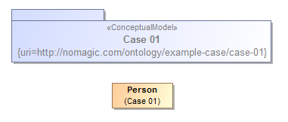

Ontology(<http://nomagic.com/ontology/example-case/case-01>

Declaration(

Class(:Person)

)

AnnotationAssertion(rdfs:label :Person "Person"@en)

)

## Class Generalization

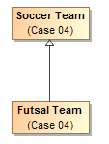

Ontology(<http://nomagic.com/ontology/example-case/case-04>

Declaration(

Class(:FutsalTeam)

)

Declaration(

Class(:SoccerTeam)

)

AnnotationAssertion(rdfs:label :FutsalTeam "Futsal Team"@en)

SubClassOf(:FutsalTeam :SoccerTeam)

AnnotationAssertion(rdfs:label :SoccerTeam "Soccer Team"@en)

)

## Class with Datatype Property

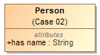

Ontology(<http://nomagic.com/ontology/example-case/case-02>

Import(<http://www.omg.org/spec/PrimitiveTypes/20100901>)

Declaration(

Class(:Person)

)

Declaration(

DataProperty(:hasName)

)

Declaration(

AnnotationProperty(<http://purl.org/dc/terms/description>)

)

Declaration(

Datatype(xsd:string)

)

AnnotationAssertion(rdfs:label :Person "Person"@en)

SubClassOf(

:Person

ObjectIntersectionOf(

DataMaxCardinality(1 :hasName xsd:string)

DataMinCardinality(1 :hasName xsd:string)

)

)

AnnotationAssertion(rdfs:label :hasName "has name"@en)

DataPropertyDomain(:hasName :Person)

DataPropertyRange(:hasName xsd:string)

AnnotationAssertion(<http://purl.org/dc/terms/description> <http://www.omg.org/spec/PrimitiveTypes/20100901#String> "An instance of String defines a piece of text. The semantics of the string itself depends on its purpose, it can be a comment, computational language expression, OCL expression, etc. It is used for String attributes and String expressions in the metamodel."@en)

)

## Class with Self-Referential Object Property

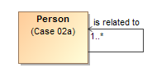

Ontology(<http://nomagic.com/ontology/example-case/case-02a>

Declaration(

Class(:Person)

)

Declaration(

ObjectProperty(:isRelatedTo)

)

AnnotationAssertion(rdfs:label :Person "Person"@en)

SubClassOf(

:Person

ObjectIntersectionOf(

ObjectMinCardinality(1 :isRelatedTo :Person)

)

)

AnnotationAssertion(rdfs:label :isRelatedTo "is related to"@en)

ObjectPropertyDomain(:isRelatedTo :Person)

ObjectPropertyRange(:isRelatedTo :Person)

)

## Class with Object Property

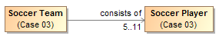

Ontology(<http://nomagic.com/ontology/example-case/case-03>

Declaration(

Class(:SoccerPlayer)

)

Declaration(

Class(:SoccerTeam)

)

Declaration(

ObjectProperty(:consistsOf)

)

AnnotationAssertion(rdfs:label :SoccerPlayer "Soccer Player"@en)

AnnotationAssertion(rdfs:label :SoccerTeam "Soccer Team"@en)

SubClassOf(

:SoccerTeam

ObjectIntersectionOf(

ObjectMaxCardinality(11 :consistsOf :SoccerPlayer) ObjectMinCardinality(5 :consistsOf :SoccerPlayer)

)

)

AnnotationAssertion(rdfs:label :consistsOf "consists of"@en)

ObjectPropertyDomain(:consistsOf :SoccerTeam)

ObjectPropertyRange(:consistsOf :SoccerPlayer)

)

## <<Anything>> with Datatype Property



Ontology(<http://nomagic.com/ontology/example-case/case-03a>

Import(<http://www.omg.org/spec/PrimitiveTypes/20100901>)

Declaration(

DataProperty(:hasName)

)

Declaration(

AnnotationProperty(<http://purl.org/dc/terms/description>)

)

Declaration(

Datatype(xsd:string)

)

SubClassOf(

owl:Thing

ObjectIntersectionOf(

DataMaxCardinality(3 :hasName xsd:string)

DataMinCardinality(2 :hasName xsd:string)

)

)

AnnotationAssertion(rdfs:label :hasName "has name"@en)

DataPropertyRange(:hasName xsd:string)

AnnotationAssertion(<http://purl.org/dc/terms/description>

<http://www.omg.org/spec/PrimitiveTypes/20100901#String> "An instance of String defines a piece of text. The semantics of the string itself depends on its purpose, it can be a comment, computational language expression, OCL expression, etc. It is used for String attributes and String expressions in the metamodel."@en)

)

## <<Anything>>with Self-Referential Object Property



Ontology(<http://nomagic.com/ontology/example-case/case-03b>

Declaration(

ObjectProperty(:isRelatedTo)

)

SubClassOf(

owl:Thing

ObjectIntersectionOf(

ObjectMinCardinality(1 :isRelatedTo)

)

)

AnnotationAssertion(rdfs:label :isRelatedTo "is related to"@en)

)

## <<Anything>> with Object Property



Ontology(<http://nomagic.com/ontology/example-case/case-03c>

Declaration(

Class(:Liquid)

)

Declaration(

ObjectProperty(:isDissolvedBy)

)

AnnotationAssertion(rdfs:label :Liquid "Liquid"@en)

SubClassOf(

owl:Thing

ObjectIntersectionOf(

ObjectMinCardinality(1 :isDissolvedBy :Liquid)

)

)

AnnotationAssertion(rdfs:label :isDissolvedBy "is dissolved by"@en)

ObjectPropertyRange(:isDissolvedBy :Liquid)

)

## Class with Object Property without Range

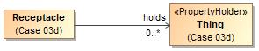

Ontology(<http://nomagic.com/ontology/example-case/case-03d>

Declaration(

Class(:Receptacle)

)

Declaration(

ObjectProperty(:holds)

)

AnnotationAssertion(rdfs:label :Receptacle "Receptacle"@en)

AnnotationAssertion(rdfs:label :holds "holds"@en)

ObjectPropertyDomain(:holds :Receptacle)

)

## Class with Subproperty

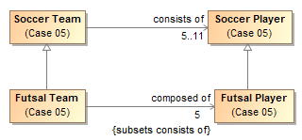

Ontology(<http://nomagic.com/ontology/example-case/case-05>

Declaration(

Class(:FutsalPlayer)

)

Declaration(

Class(:FutsalTeam)

)

Declaration(

Class(:SoccerPlayer)

)

Declaration(

Class(:SoccerTeam)

)

Declaration(

ObjectProperty(:composedOf)

)

Declaration(

ObjectProperty(:consistsOf)

)

AnnotationAssertion(rdfs:label :FutsalPlayer "Futsal Player"@en)

SubClassOf(:FutsalPlayer :SoccerPlayer)

AnnotationAssertion(rdfs:label :FutsalTeam "Futsal Team"@en)

SubClassOf(:FutsalTeam :SoccerTeam)

SubClassOf(

:FutsalTeam

ObjectIntersectionOf(

ObjectMaxCardinality(5 :composedOf :FutsalPlayer) ObjectMinCardinality(5 :composedOf :FutsalPlayer)

)

)

AnnotationAssertion(rdfs:label :SoccerPlayer "Soccer Player"@en)

AnnotationAssertion(rdfs:label :SoccerTeam "Soccer Team"@en)

SubClassOf(

:SoccerTeam

ObjectIntersectionOf(

ObjectMaxCardinality(11 :consistsOf :SoccerPlayer) ObjectMinCardinality(5 :consistsOf :SoccerPlayer)

)

)

AnnotationAssertion(rdfs:label :composedOf "composed of"@en)

SubObjectPropertyOf(:composedOf :consistsOf)

ObjectPropertyDomain(:composedOf :FutsalTeam)

ObjectPropertyRange(:composedOf :FutsalPlayer)

AnnotationAssertion(rdfs:label :consistsOf "consists of"@en)

ObjectPropertyDomain(:consistsOf :SoccerTeam)

ObjectPropertyRange(:consistsOf :SoccerPlayer)

)

## Class with Universal Quantification Constraint on Property I

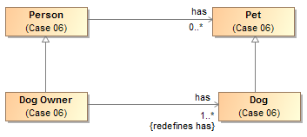

Ontology(<http://nomagic.com/ontology/example-case/case-06>

Declaration(

Class(:Dog)

)

Declaration(

Class(:DogOwner)

)

Declaration(

Class(:Person)

)

Declaration(

Class(:Pet)

)

Declaration(

ObjectProperty(:has)

)

AnnotationAssertion(rdfs:label :Dog "Dog"@en)

SubClassOf(:Dog :Pet)

AnnotationAssertion(rdfs:label :DogOwner "Dog Owner"@en)

SubClassOf(:DogOwner :Person)

SubClassOf(

:DogOwner

ObjectIntersectionOf(

ObjectMinCardinality(1 :has :Dog)

ObjectAllValuesFrom(:has :Dog)

)

)

AnnotationAssertion(rdfs:label :Person "Person"@en)

AnnotationAssertion(rdfs:label :Pet "Pet"@en)

AnnotationAssertion(rdfs:label :has "has"@en)

ObjectPropertyDomain(:has :Person)

ObjectPropertyRange(:has :Pet)

)

## Class with Universal Quantification Constraint on Property II

This example differs from the previous example primarily in that the superclasses “Person” and “Pet” are from a different package than their subclasses “Dog Lover” and “Dog,” respectively. This is reflected in the OWL ontology by the import of this namespace.

The superclasses “Person” and “Pet”, defined in the package “Case 06”, are a different color and a lighter shade than the classes defined in the package “Case 07”. This is to distinguish them from the classes defined in this package. MagicDraw’s AutoStyler plugin can automatically set the properties for classes and other UML elements “defined elsewhere,” that is in a package not containing the defining diagram for the UML element (See section 2.2, Automatic Styling of Concept Models.).

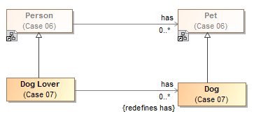

Ontology(<http://nomagic.com/ontology/example-case/case-07>

Import(<http://nomagic.com/ontology/example-case/case-06>)

Declaration(

Class(<http://nomagic.com/ontology/example-case/case-06#Person>)

)

Declaration(

Class(<http://nomagic.com/ontology/example-case/case-06#Pet>)

)

Declaration(

Class(:Dog)

)

Declaration(

Class(:DogLover)

)

Declaration(

ObjectProperty(<http://nomagic.com/ontology/example-case/case-06#has>)

)

AnnotationAssertion(rdfs:label :Dog "Dog"@en)

SubClassOf(:Dog <http://nomagic.com/ontology/example-case/case-06#Pet>)

AnnotationAssertion(rdfs:label :DogLover "Dog Lover"@en)

SubClassOf(:DogLover <http://nomagic.com/ontology/example-case/case-06#Person>)

SubClassOf(

:DogLover ObjectIntersectionOf(

ObjectAllValuesFrom(<http://nomagic.com/ontology/example-case/case-06#has> :Dog)

)

)

)

## Class with Existential Quantification Constraint on Property

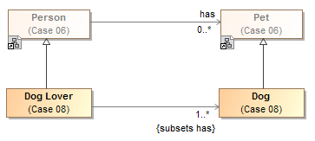

Ontology(<http://nomagic.com/ontology/example-case/case-08>

Import(<http://nomagic.com/ontology/example-case/case-06>)

Declaration(

Class(<http://nomagic.com/ontology/example-case/case-06#Person>)

)

Declaration(

Class(<http://nomagic.com/ontology/example-case/case-06#Pet>)

)

Declaration(

Class(:Dog)

)

Declaration(

Class(:DogLover)

)

Declaration(

ObjectProperty(<http://nomagic.com/ontology/example-case/case-06#has>)

)

AnnotationAssertion(rdfs:label :Dog "Dog"@en)

SubClassOf(:Dog <http://nomagic.com/ontology/example-case/case-06#Pet>)

AnnotationAssertion(rdfs:label :DogLover "Dog Lover"@en)

SubClassOf(:DogLover <http://nomagic.com/ontology/example-case/case-06#Person>)

SubClassOf(

:DogLover

ObjectIntersectionOf(

ObjectMinCardinality(1 <http://nomagic.com/ontology/example-case/case-06#has> :Dog) ObjectSomeValuesFrom(<http://nomagic.com/ontology/example-case/case-06#has> :Dog)

)

)

)

## <<Anything>> with Self-Referential Subproperty



Ontology(<http://nomagic.com/ontology/example-case/case-11>

Declaration(

ObjectProperty(:contains)

)

Declaration(

ObjectProperty(:holds)

)

AnnotationAssertion(rdfs:label :contains "contains"@en)

SubObjectPropertyOf(:contains :holds)

AnnotationAssertion(rdfs:label :holds "holds"@en)

)

## <<Anything>> Holder with Subproperty

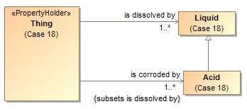

Ontology(<http://nomagic.com/ontology/example-case/case-18>

Declaration(

Class(:Acid)

)

Declaration(

Class(:Liquid)

)

Declaration(

ObjectProperty(:isCorrodedBy)

)

Declaration(

ObjectProperty(:isDissolvedBy)

)

AnnotationAssertion(rdfs:label :Acid "Acid"@en)

SubClassOf(:Acid :Liquid)

AnnotationAssertion(rdfs:label :Liquid "Liquid"@en)

SubClassOf(

owl:Thing

ObjectIntersectionOf(

ObjectMinCardinality(1 :isCorrodedBy :Acid)

)

)

SubClassOf(

owl:Thing

ObjectIntersectionOf(

ObjectMinCardinality(1 :isDissolvedBy :Liquid)

)

)

AnnotationAssertion(rdfs:label :isCorrodedBy "is corroded by"@en)

SubObjectPropertyOf(:isCorrodedBy :isDissolvedBy)

ObjectPropertyRange(:isCorrodedBy :Acid)

AnnotationAssertion(rdfs:label :isDissolvedBy "is dissolved by"@en)

ObjectPropertyRange(:isDissolvedBy :Liquid)

)

## Class with Subproperty without a Range

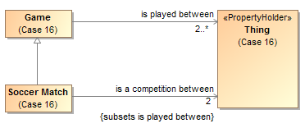

Ontology(<http://nomagic.com/ontology/example-case/case-16>

Declaration(

Class(:Game)

)

Declaration(

Class(:SoccerMatch)

)

Declaration(

ObjectProperty(:isACompetitionBetween)

)

Declaration(

ObjectProperty(:isPlayedBetween)

)

AnnotationAssertion(rdfs:label :Game "Game"@en)

SubClassOf(

:Game

ObjectIntersectionOf(

ObjectMinCardinality(2 :isPlayedBetween)

)

)

AnnotationAssertion(rdfs:label :SoccerMatch "Soccer Match"@en)

SubClassOf(:SoccerMatch :Game)

SubClassOf(

:SoccerMatch

ObjectIntersectionOf(

ObjectMaxCardinality(2 :isACompetitionBetween) ObjectMinCardinality(2 :isACompetitionBetween)

)

)

AnnotationAssertion(rdfs:label :isACompetitionBetween "is a competition between"@en)

SubObjectPropertyOf(:isACompetitionBetween :isPlayedBetween)

ObjectPropertyDomain(:isACompetitionBetween :SoccerMatch)

AnnotationAssertion(rdfs:label :isPlayedBetween "is played between"@en)

ObjectPropertyDomain(:isPlayedBetween :Game)

)

## Class with Necessary and Sufficient Property

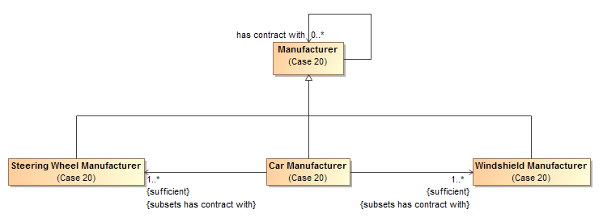

Ontology(<http://nomagic.com/ontology/example-case/case-20>

Declaration(

Class(:CarManufacturer)

)

Declaration(

Class(:Manufacturer)

)

Declaration(

Class(:SteeringWheelManufacturer)

)

Declaration(

Class(:WindshieldManufacturer)

)

Declaration(

ObjectProperty(:hasContractWith)

)

AnnotationAssertion(rdfs:label :CarManufacturer "Car Manufacturer"@en)

EquivalentClasses(

:CarManufacturer

ObjectIntersectionOf(

ObjectMinCardinality(1 :hasContractWith :SteeringWheelManufacturer) ObjectSomeValuesFrom(:hasContractWith :SteeringWheelManufacturer)

)

)

EquivalentClasses(

:CarManufacturer

ObjectIntersectionOf(

ObjectMinCardinality(1 :hasContractWith :WindshieldManufacturer)

ObjectSomeValuesFrom(:hasContractWith :WindshieldManufacturer)

)

)

SubClassOf(:CarManufacturer :Manufacturer)

AnnotationAssertion(rdfs:label :Manufacturer "Manufacturer"@en)

AnnotationAssertion(rdfs:label :SteeringWheelManufacturer "Steering Wheel Manufacturer"@en)

SubClassOf(:SteeringWheelManufacturer :Manufacturer)

AnnotationAssertion(rdfs:label :WindshieldManufacturer "Windshield Manufacturer"@en)

SubClassOf(:WindshieldManufacturer :Manufacturer)

AnnotationAssertion(rdfs:label :hasContractWith "has contract with"@en)

ObjectPropertyDomain(:hasContractWith :Manufacturer)

ObjectPropertyRange(:hasContractWith :Manufacturer)

)

## Class With Property Having Unspecified Multiplicity

UML allows the cardinality of a property to be left unspecified. The concept modeling profile interprets unspecified cardinalities as being zero to many (“0..*”).

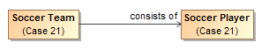

Ontology(<http://nomagic.com/ontology/example-case/case-21>

Declaration(

Class(:SoccerPlayer)

)

Declaration(

Class(:SoccerTeam)

)

Declaration(ObjectProperty(:consistsOf))

AnnotationAssertion(rdfs:label :SoccerPlayer "Soccer Player"@en)

AnnotationAssertion(rdfs:label :SoccerTeam "Soccer Team"@en)

AnnotationAssertion(rdfs:label :consistsOf "consists of"@en)

ObjectPropertyDomain(:consistsOf :SoccerTeam)

ObjectPropertyRange(:consistsOf :SoccerPlayer)

)

# Annex A: UML Conceptual Modeling Profile Semantics (normative)

This section defines the UML profile for conceptual modeling and mapping. In order to improve UML’s suitability for modeling real-world concepts, this profile interprets standard UML with semantic extensions, as detailed below:

## Introduction

A concept model can be expressed in UML with the concept modeling profile. The profile defines the interpretation of UML concepts used, extends UML concepts with “stereotypes” and makes some UML semantics more specific to concept modeling. While there are some extensions, every effort is made to use “generic UML” class diagrams, as they are well understood and supported. It only provides stereotypes to extend UML to make concept models more expressive. For example, without complex OCL constraints, UML normally has no way to express that, in the context of some class, some values must be of some type, all values must be of some type, or that the property chain *has father • has brother* is equivalent to the property *has uncle*. Other examples of extensions include Roles and Phases to describe how entities may be classified in different context or over time. These extended notions are introduced here, in subsequent sections. Readers are referred to the UML specification and the many books and courses on UML for an in-depth treatment of generic UML.

This section is intended to define the semantics of UML used in this specification to represent concept models. The subset of UML used for concept modeling is primarily that known as “Class models”, the most commonly used part of UML. Our scope further narrows what we utilize to exclude behaviors and methods – elements used for object oriented design. Those elements may be present, but they are ignored for the purposes of concept modeling.

The goal of a concept model is to unambiguously define durable conceptualizations of the real or an imaginary world. One can think of a concept model as describing a "subject area", which can be as small or large as desired (e.g., the concepts across the entire financial industry, or merely the concepts within one organization). Concepts are, of course, the foundation of a concept model. Concepts are how we think about the world. They are modeled as combinations of classes, datatypes, enumerations, associations, and properties. A related goal of a concept model is to be as non-technical and business-friendly as possible. That means that names for concepts should contain spaces rather than what’s called “CamelCasedWords” or “Underscore_Separated_Words”. It is the job of the transformations to convert those names into lexemes that are acceptable to more technical tooling.

A concept model owned by subject matter experts is more durable than a data model or logical information model designed with a particular system in mind. Thus, one definition of concepts and properties can be represented by multiple logical information models, each optimizing for different technical goals. Note that there are multiple interpretations of “logical model” that span from almost conceptual to near a data schema. Conceptual models can be used to help federate any of these levels of abstraction.

A concept model is not an information or data model. When someone think about concepts, they think about real-world things, not data structures or even natural language text about those things. These real-world concepts become the pivot points around which we define and relate the many terms, languages and data structures that describe those things. For example, every Person *has biological mother* one Person, which is essential to being a Person. Such concepts provide criteria that narrow the definition of *what* a Person concept *is*, it does not specify that a system should store every person’s mother. What is contextual is our knowledge of that or our need to know it, which is the subject of an information model. For another example, it would be reasonable for a concept model to assert that an eye has a measurable visual acuity, but not to define how visual acuity will be represented within a computer as bits and bytes, or how often visual acuity will be stored within a database. Such technical concerns should be elaborated in a data model, which has elements that can be well defined by a concept model. Note, however, that things such as tables and columns *are* valid concepts in their own right – as “data things”, but they are different from the real-world concepts they might represent.

Concept models can be modular. A concept model may refer to things in a number of other concept models. This is useful for refining another organization's concept model, separately maintaining overlapping concepts between organizations or disciplines, or more easily managing smaller subject areas.

A concept model consists of a network of concepts with a simple essential structure. That structure is the definition of classes, relations between them and their characteristics. Classes represent abstractions of “things” in our world – including physical things like trees or people and “made up” things like agreements.

Other concepts connect those things - the relations between things are UML associations that have properties. Things have characteristics such as weight or color. Things can also have properties that are attributes of a class. This basic network of classes, associations, and properties forms the foundation of the concept model and defines the conceptual framework and vocabulary of a domain. Each of these concepts may have names, which form the vocabulary of a domain of interest. Various assertions are then made about these concepts and their connections that further refine the semantics of those concepts – multiplicities of relationships, specializations between concepts, essential properties of things, etc.

One of the fundamental ways we understand and organize concepts is their arrangement into hierarchies, where general concepts are specialized to form more specific concepts within a specific context or with more specific characteristics. A concept model can arrange all the fundamental elements into conceptual hierarchies using generalization relationships. In contrast, another kind of hierarchy is a structural data hierarchy – where data elements contain other data elements. As the purpose of a concept model is not representing data, data hierarchies are not part of a concept model, they are typically part of logical information models that represent concepts. To allow for the many viewpoints that can exist for any concept, a concept can be in many generalization hierarchies at the same time.

The following section defines how UML with conceptual extensions is used to represent the foundational network of concepts using classes, associations, and properties. Additional constraints, expressed as rules, are then attached to this basic framework to enhance semantic expression and the ability of automation to federate and analyze information about those concepts.

### Classes

Classes specify, or classify, a set of things, according to some set of rules or understanding. Classification is the essential mechanism of conceptualization we use. Classes specify a set of things belonging to that class – this is called the class’s *extent*. Each element of the class is an *instance* of that class –it is something the class classifies. Classifications may be arranged in hierarchies.

In the UML concept model, a class is diagramed as a box with a name at the top. In some cases, a definition is also shown next to the box in a “note” form.

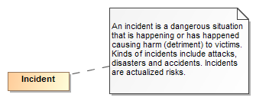

Figure Example of a Class

The above example shows the class “Incident” and its definition. It should be noted that a class is *a way* to classify something. It is natural to classify something multiple ways. For example, we may classify a situation as also being a danger or, to someone else, an opportunity to do harm. This is different from many technology models (e.g. Java) that only allow something to be classified in one way and the classification is fixed. *The basic assumption of a concept model is that unless specified otherwise, something may be classified in any number of ways and those classifications may change over time*.

### Instances

While not usually used in the definition of the concept model, instances can also be shown in UML and are utilized to illustrate examples or to define well known instances, like the “United States of America”. Since the model is conceptual, instances of classes are proxies, or “signs”, for the “real thing” in the world – not data about them or other technology artifacts.

Instances are also shown as a box, but have a “:” separating the name of the instance from its classes.

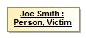

Figure Instance Example

The above example shows a information about an instance named “Joe Smith” that is classified as a “Person” and a “Victim”.

### Class Generalization

Since Aristotle, classes have been arranged in hierarchies – from most general concepts to more specific ones. In UML this is shown as a Generalization – an arrow with a solid line from the more specific concept to the more general. The more general class is known as the *Superclass* (or *Supertype*) and the more specific the *Subclass* (or *Subtype*). Generalization has some specific semantic rules:

* Everything that is true about the superclass must be true about all its subclasses
* The extent of the subclass is a subset of the extent of the superclass
* All properties and associations that apply to instances of a class also apply to instances of all its subtypes

In a concept model, a class may have any number of superclasses or subclasses. In contrast, some technologies (Like XML Schema) limit the number of superclasses to one.

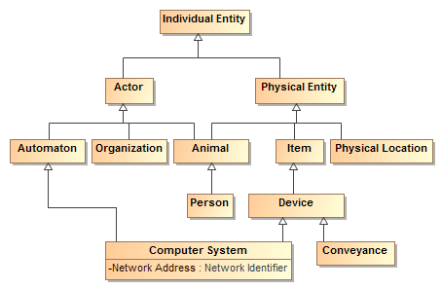

Figure Class Hierarchy Example

The above example shows a class hierarchy with multiple levels.

***Note that all properties and associations defined for all superclasses of a class apply to that class. For that reason a complete understanding of a class and its potential properties must include such superclasses.***

A generalization is a subsumption relationship between a more general class and a more specific class. Every instance of the specific class is also an instance of the subsuming general class. Because of this subsumption relationship, the specific class inherits all of the necessary conditions of the more general classifier.

For a simple example, if we define “Futsal Team” as a subclass of “Soccer Team”, then the set of individuals in “Futsal Team” must be a subset of the set of individuals in “Soccer Team”.



Figure Simple Generalization Example

There are four variations on generalization described in the following subsections. The first variation corresponds to the example above: overlapping and incomplete subclasses. That variation is the default in both UML and concept modeling.

#### Overlapping and Incomplete Subclasses

This variation is the default in both UML and in concept modeling. In this variation, an instance can be a member of the superclass and / or any number of subclasses. In this sense, the classification of instances is “incomplete”—sometimes an instance is classified by one or more specific subclasses, and sometimes it is not.

For example, the diagram below shows four instances (represented by white diamonds). One is an instance of “Manufacturer”, one is an instance of “Windshield Manufacturer”, one is an instance of “Car Manufacturer”, and one is an instance of both “Windshield Manufacturer” and “Car Manufacturer”.



Figure An example of incomplete subclasses

In both standard UML and in concept modeling, incomplete and overlapping subclasses are shown with either no notation, or with the equivalent notation {incomplete, overlapping} near the generalization arrow.

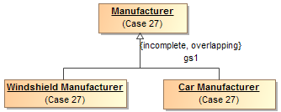

Figure Incomplete and overlapping subclasses in standard UML notation

#### Disjoint and Incomplete Subclasses

This variation means that an instance can only be classified by at most one of the disjoint classes. Disjoint classes cannot have any overlap in their instances.

The diagram below shows three instances. One is an instance of “Cat”, one is an instance of “Dog”, and one is an instance of “Animal”. An instance classified as both “Cat” and “Dog” is impossible because there is no overlap between the two classes. In the most basic terms, an instance of a “Cat” cannot be an instance of a “Dog”, and vice versa.



Figure Disjoint Subclasses

The following diagram shows an example of disjoint subclasses in standard UML notation. It shows that “Dog”, “Cat”, and “Mouse” are all subclasses of “Animal”. In addition, the standard UML {incomplete, disjoint} notation declares all of the subclasses to be incomplete and disjoint. Intuitively, an instance of the subclass “Dog” is an instance of the superclass “Animal”, but it cannot also be an instance of the “Cat” or “Mouse” subclasses. It is incomplete because there can be many more kinds of animals.

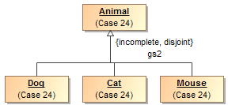

Figure Incomplete and disjoint subclasses in standard UML notation

The profile also supports a dependency stereotyped as «Disjoint With» to specify that anything can be disjoint, even if they are not subclasses of a common super type. disjoint subclasses. For example, the class Animal has three disjoint subclasses, Cat and Dog.

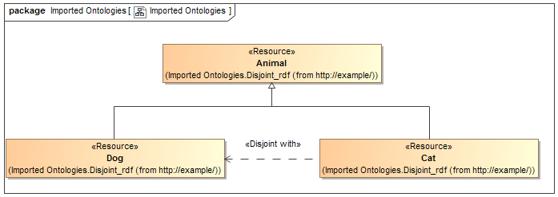

Figure Alternative «Disjoint With» Stereotype

#### Complete and Overlapping Subclasses

This variation means that an instance can only be classified by at least one of the subclasses; it cannot be classified by only the superclass. Keep in mind that an instance of a subclass is indirectly an instance of a superclass at the same time.

For example, the following diagram shows three instances. One is an instance of “Windshield Manufacturer”, one is an instance of “Car Manufacturer”, and one is an instance of both “Car Manufacturer” and “Windshield Manufacturer”. Note that there can be no instance of “Manufacturer” that is not also an instance of one of the subclasses.



Figure An example of complete subclasses

The diagram below shows an example of complete and overlapping subclasses in standard UML notation. The diagram shows that “Steering Wheel Manufacturer”, “Car Manufacturer”, and “Windshield Manufacturer” are all subclasses of “Manufacturer”. In addition, the standard UML {complete, overlapping} notation declares that the subclasses are complete and overlapping.

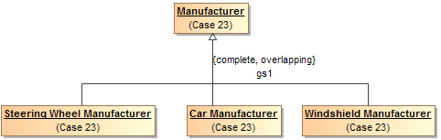

Figure Complete subclasses in standard UML notation

#### Disjoint and Complete Subclasses

This variation means that an instance can only be classified by one of the subclasses. The instance cannot be classified as only the superclass, and it cannot be classified by two subclasses at the same time.

For example, in the subsequent diagram, two instances are shown. One is an instance of “Windshield Manufacturer”, and one is an instance of “Car Manufacturer”. There can be no instance of “Manufacturer” that is not also an instance of one of the subclasses, and there can be no instance that is classified as both a “Windshield Manufacturer” and a “Car Manufacturer” at the same time.



Figure Disjoint and complete instances

The diagram below shows an example of disjoint and complete subclasses in standard UML notation. The diagram shows that “Steering Wheel Manufacturer”, “Car Manufacturer”, and “Windshield Manufacturer” are all subclasses of “Manufacturer”. In addition, the standard UML {complete, disjoint} notation declares that the subclasses are complete and disjoint.

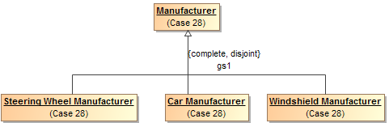

Figure Disjoint and complete subclasses in standard UML notation

### Properties

Properties represent qualities inherent in something, such as size, weight or a time. Each property has a “type” for the kind of value that represents that quality. A property is a characteristic that an individual can have, or, as explained in a subsequent section, an individual *must* have to qualify as a particular concept.

Most properties are relations between concepts, usually expressed as a verb phrase, such as "Heart *comprised of* Chamber" or "Geographic Region *identified by* Address". This kind of property is generally drawn as a UML association end, as part of a UML association.

Some properties are relations with data types, such as a standard UML Date, usually expressed as a prepositional phrase, such as "Person *born on* Date" or a noun phrase, such as “Person *birth date* Time Point”. This kind of property is generally drawn as a UML attribute, within an attribute compartment of the most general classifier that can have that quality.

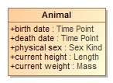

Figure Example of Properties

The above example shows that an animal has the qualities of birthdate, death date, physical sex, height and weight. Note that these is no assumtion that these qualities may be known, required or that different data sources may or may not agree on them – just that an animal has these qualties. Instances of properties are facts about the entity they describe. In concept models, attributes are only used for qualities, never to relate different entities.

A much smaller number of properties represent metadata, usually expressed as a noun phrase, such as "Anything *description* String" or "Anything *see also* URI". To represent metadata, this profile provides a stereotype called «Annotation Property» that can be applied to a standard UML property in a concept model.

Note that because every class ultimately specializes the special class «Anything», when that <<Anything>> has properties, those properties can be used by instances of any class. Moreover, classes or subclasses can have constraints on the values of properties that only hold from that class and below in the generalization hierarchy. See subsequent sections for further explanation.

### Associations

Associations describe facts about how entities are related. Associations are shown as lines between the classes that have related instances. At each end of the line is an “association end” property – the association end describes how the instances of the class on the far end relate to those of the near end. If there are limits to how many instances may be related, these are also shown. Since an association has at least two ends, the association may be read in any direction, but is the same “fact”. The properties involved are considered “inverse properties”. The association end properties are typically verbs or verb phrases, but in some cases, such as when an association is reified as a class, the association ends can become noun phrases. In either case the name denotes the intent of the class *at the other end of the line*.

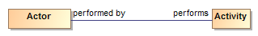

Figure Association Example

The above example says that there are relations between actors and activities such that the *actor performs the activity* and the activity is performed by the actor. These are considered two ways to “read” the same fact. Like any fact, relations may be true for some period of time or in some specific situation.

As can be seen in the example the ends of associations are typically verb phrases which can then be read as <the actor> performs <the activity>. In other cases the ends are nouns in which case they represent a role being played. If a role were used above instead of “performed by” it could read: <activity> has performer <actor> (the *has* in this sentence being implied by english grammar).

This combination of classes and associations with ends forms the basis for nouns and verbs common to human language. The terms used for the nouns and verbs should be both consistent with their semantics and resonate with stakeholders – sometimes this is a bit of a challenge.

In some cases the ends of the relation are sufficent to define it, in other cases it makes more sense to give the association a name and its own definition. Associations and association ends, like classes, can be part of a hierarchy.

Note that unspecified multiplicities are interpreted as unconstrained: having a minimum cardinality of 0 and a maximum cardinality of “*”.

### Property and association end hierarchies

Like class hierarchies, attributes and association ends (we will just call both properties from now on) can also be arranged in hierarchies of more or less specific properties. In UML, property hierarchies are represented using either “Subsets” or “Redefines”. What a property subsets or redefines is shown next to its name in in the diagram (Note that by convention this is not shown on summary diagrams, only the primary definition of the property). If a property completely subsumes the other in a particular context it uses a “Redefines” – that is the redefining and redefined properties have the same set of values. If the more general concept can also be used in the context a “Subsets” is used.

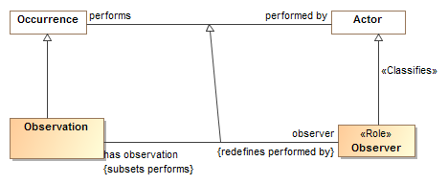

Figure Example of Association End Hierarchy

The above example shows that the “has observation” and “observer” properties are specializations of the “performs” and “performed by” concepts. The property “observer” redefines “performed by” – that is, an Observation always has an observer, never a “performed by” any other kind of actor. Likewise “has observation” specializes “performs” but an instance of Observer can perform other activities as well. Note the generalization between the associations is implied, but is shown in this example for clarity.

Where a redefined or subset property has no name, it is an indication that the property type and/or multiplicity is merely constrained in some way. No new properties or associations are actually defined for a constraint (more on this below).

### Association Classes

In a concept model any “fact” may have properties. Of particular importance is the “provenance” of the fact – where the fact came from and thus how much it can be trusted. Facts can also be time-bound, true for some period or only valid within some context. Where an association may have additional specific properties or may participate in other relationships, an “association class” is used. As implied by its name, an association class has both the properties of an association and the properties of a class. More complex associations between things use association classes. An association class is diagrammed as an association line and a class box with a dashed line between the association line and its class. While the association line and box may seem somewhat visually distinct – they are the “same concept”.

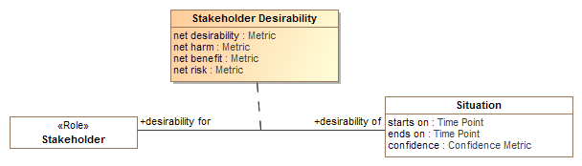

Figure Association Class Example

The above example shows the “Stakeholder Desirability” relation. Between any situation and any stakeholder there can be some metrics as to how much that stakeholder desires or wants to avoid that situation. The Stakeholder Desirability association class represents these as properties of the association: net desirability, net harm, net benefit and net risk – which can all be poitive or negative reflecting a benefit or harm, respectivly.

### Annotation

This profile provides a way to comment on any element using *annotations*. One can annotate classes, properties, and models using an open-ended system of *annotation properties*. An annotation property defines information about the model (metadata), not about the subject domain. A property can be made an *annotation property* using the **«**Annotation Property» stereotype on a UML property.

Every «Annotation» is a textual value for an «Annotation Property»*.* An annotation describes some subject using an annotation property and a (usually textual) value. An annotation should specify a tagged value called “value for” that refers to an «Annotation Property».

For example, the following diagram illustrates several UML comments stereotyped with **«**Annotation**»**

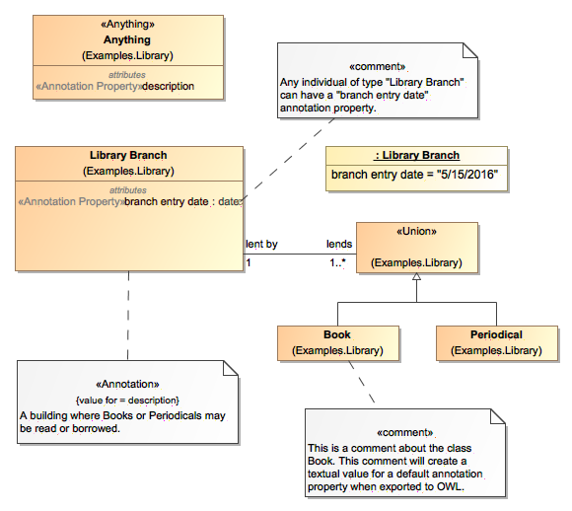

Figure Annotation Examples

### Specific kinds of classes

There are additional concept modeling specific stereotypes documented in the reference section that further define the semantics of a class. Some of these stareotypes are very important for understanding the concept model and are further explained here. These are roles, phases and quantity kinds.

#### Anything

The stereotype «Anything» can be applied to any class to make it special. Every such special class is equivalent to one topmost class (⊤) of which all other classes are subclasses. Thus, a property of a class marked as «Anything» is inherited by all subclasses. In addition, while the name of a such a marked class is irrelevant, consistently naming such classes “Anything” in all concept models avoids any confusion with normal classes.



Figure «Anything» Example

#### Union

A «Union» is a class that has an extent (set of instances) which is equivalent to the union of the extents of all types that specialize the Union (Subclasses). Specializing types shall include subtypes and types that realize the union. The union can be either named or unnamed. When it is unnamed, it can only be used at the domain or range of a property.

Note: UML realizations are included to support unions across external models because UML generalization cannot be used across external models due to the ownership of generalization.

An anonymous union class always implies a complete subclass generalization.

The following diagram states that an instance of a Person may have a value of type Cat or Dog for the *cares for* property. The diagram also states that an instance of a Cat or a Dog may have a value of type Person for the *cared for by* property.

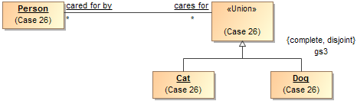

Figure A union class

#### Intersection

An «Intersection» is a class that has an extent (set of instances) equivalent to the intersection of the extents of all supertypes. Intersection is a stronger statement than a subtype, as a subtype may be a subset of the intersection. An instance of all the supertypes implies an instance is also an instance of the intersection type.

For intersection, The SMIF profile considers UML generalization and UML realization equivalent. This is due to ownership and legacy considerations in UML. Generalization is the preferred representation.

Note: Realizations are included to support unions across external models. UML generalization can not be used across external models due to the ownership of generalization.

#### Facets, Roles, Phases and <<Classifies>>

Some types may be considered the “fundamental” type of something that is essential to its being and identity for its entire lifetime; this is the default assumption of most classes. Other types classify something in a specific context or for a period of time, SMIF calls these “Facets”. Examples of facets are “Roles” and “Phases” that something may have over its lifetime. The facets an instance is classified with may change over time and may be only valid within a particular context or viewpoint. Facets are defined with a <<Classifies>> generalization to another type, the type of thing that can be so classified. For example, “Policeman” can classify a “Person”.

Context specific types such as Roles and Phases are classifications and expected to be used in this more contextual and dynamic fashion; these types may be assigned to or removed from an instance over time or in a context.

For an instance to be classified with a classification, it must also have the type of what the classification <<classifies>>. To use the example above, a “Policeman” can’t classify a Toaster since the toaster is not a person. Please see the “Role” and “Phase” discussion for more usage scenarios of <<Classifies>>.

**Implementation note**: most programming languages do not allow for direct representation of multiple classifications, multiple inheritance or context. A common implementation pattern is to represent classifications, roles and phases as independent objects related to the object they classify. An example of this is the iUnkown pattern in .NET.

The following stereotypes define additional classification semantics.

#### Roles

Roles are facet classes that are expected to be dynamic and contextual, such as teacher, victim or president. A role is defined using a class with the <<Role>> stereotype and, optionally, a <<Classifies>> generalization. Implementation technologies should interpret roles as classifications that may be added to or removed from an instance over time and may be defined in a particular context. A role is usually required to be a role of some particular other class, for example a teacher is expected to be a role of a person (at least until a computer takes her job). The constraint of what a role must be a role of is defined using a <<Classifies>> stereotype of a generalization. A role will also frequently have a relationship with something where the multiplicity is at least one. For example, a person is a parent if they have at least one child.

Many implementation languages don’t have the capacity to represent roles, so roles are sometimes implemented is the single and unchangeable “type” of a class or DBMS table. The problem with this is that the same individual may not be connected across all their roles. Specifically representing roles allows the same individual to play multiple roles and for these roles to change – this better reflects the reality of the world and the way we think about it.

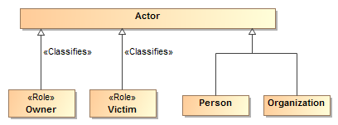

Figure Role Example

The above example shows that an actor can be a person or organization and that either could be classified as being able to play the Owner and/or a Victim role.

Roles help to decouple concepts in models and specifically allow an instance to “play” multiple roles at the same time or over time. Roles, when combined with quantification constraints, clearly define the semantics of roles. For example, we could say that a victim must be a victim of some incident and an owner must own something.

By convention, properties typed by roles may have the same name as the role, this can be read as “has <role>”, e.g. “has victim”, however full verb phrases may be more appropriate in some situations.

#### Phases

Phases are facet classes that are expected to classify an instance over a specific span of time, such as a teenager, “legal adult” or “Paid Invoice”. A teenager is a person between the ages of 13 and 19 (inclusive) – perhaps “legal adult” is of age 19 or older – we may also want to consider people living or dead, thus “alive” and “dead” would be phases of a lifeform. Phase may be considered a synonym for the “State” of something.

A phase is defined as a class with the <<Phase>> stereotype. Like roles, phases use the <<Classifies>> stereotype of a generalization to define what a phase must be a phase of.

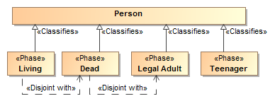

Figure Phases of a person

Also like roles, phases help to decouple concepts in models and specifically allow an instance to “be in” multiple phases (or multiple roles) at the same time or over time. If an instance cannot be in two phases at the same time or be in a role and a phase a “disjoint with” constraint can be used to state that restriction. For example, “Dead” is disjoint with “Legal Adult” and “Living”. Only a “Legal adult” can commit to a contract.

#### Quantity kinds and units

Fundamental to understanding and describing something is physical and other qualities such as temperature, length and color. Many data models fail to capture units of measure explicitly which can and has[3] resulted in dramatic systems failures. A concept for somethings weight should properly be typed by a measure of weight, not an “int” or “real” – which are just ways to represent numbers without knowing what they mean. Of course there needs to be numbers, but in relation to their units.

Figure 24 "Area" Example of quantity kinds and units

In that there are different units that can represent the same kind of measure, such as degrees Celsius and degrees Fahrenheit can represent the same temperature – an abstraction is used above like units. The abstraction for a measurable unit is called a <<Quantity Kind>>. Examples of quantity kinds include Length, mass, temperature, frequency, etc.

As any element of measurement data must be specific to a specific unit in a specific data exchange, the <<UnitType>> stereotype is used to define a unit for a quantity kind. A <<Represents>> stereotype of generalization (Diagrammed as a green arrow) is used to say that the unit represents the quantity kind.

In the example above, the “Area” quantity kind (indicated by a black shaded class) can be represented by (the green lines) “Square Meter”, “Square Feet” or an “Acre”. One unit may be nominated as the “Base Unit” and will be used to express conversion factors between the units. As per SI specifications, the Square Meter is the base unit.

Figure 25 - "Animal" example of using quantity kinds.

By convention quantity kinds are used in fully conceptual models whereas units are used in data models. The “Animal” example shows quantity kinds being used to define properties of animals.

### Assertions about concepts

Above we defined the network of essential concepts as classes, relationships and properties. Additional assertions may be made about those concepts using both UML foundational and extended profile capabilities. The following define the kinds of assertions that can be made. Note that the term “property” applies to both simple properties and the ends of associations.

#### Property Ownership

The concept modeling profile of UML interprets the owner (defining class) of a property *definition* as the subject of that property (its domain) and the context in which that property must conform to certain constraints.

Constraints may be placed on a property. These constraints can include multiplicity, which includes a minimum cardinality and a maximum cardinality, a type for the property, existential quantification, and universal quantification. When an instance is a member of a class, all of that class’ constraints must be met.

Property ownership is not interpreted as “slots” in an object. Property values may or may not be independent of the instance that defined them, thus supporting an OWL/RDF, or “open world”, interpretation of properties and associations.

#### Cardinality

Cardinality defines how many value of a property may exist for a particular subject instance. For example, how many ages can a person have? The obvious answer is that a person can have at most one age at any one point in time. Thus cardinalities represent the number of instances at any one time – regardless of how it is represented.

UML allows the cardinality of a property to be left unspecified, in which case it defaults to 1..1. The concept modeling profile interprets unspecified cardinalities as 1 (one) based on UML defaults. Note that conceptual models do define what you may or must know or what the requirements of a data model are – they define what must be true about the world as it is conceived.

### Constraining properties and associations

A cardinality of one or more defined for a property requires that an instance of the related element must exist for an instance of the domain (owning class) of that property or association end to be valid. For example, a living person must have exactly one living brain. This is known as an *existential quantification* (∃) or qualified constraint in first order logic. Existential quantification is defined using UML cardinality and, potentially, *subsets*.

An existential quantification can be stated for a newly defined property or an existing one. For a newly defined property this is done by simply stating cardinality greater than one. For example, a phone must have at least one button with a “has buttons” association end and a cardinality of “1..*”. When a new property is being defined it is given a name. If an existing property is being constrained (without a new property being defined) it subsets or redefines the existing property and does not need a name. In the concept modeling profile of UML, any cardinality requiring one or more creates an existential quantification constraint.

A property is not limited to a minimum and a maximum cardinality (known as multiplicity) for just one type. A property can have a multiplicity for a superclass, while at the same time having a more specific multiplicity for one or more subclasses of that superclass. This type of constraint is an assertion that, among other possible values, the number of values of one of these subclasses is between some minimum and maximum cardinality.

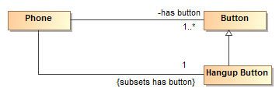

Figure Phone constraint: A phone must have a hangup button

For example, we may say a phone must have one or more buttons with a “has button” property but exactly one of those buttons must be the “hang up button”. We would then define an unnamed property with the type “hang up button” that subsets the “has button” property with a cardinality of 1. If we wanted the Hangup Button to also define a new property, we would give that property a name.

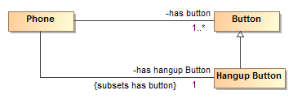

Figure Hangup button with new property

In the concept modeling interpretation of UML, subsetting or redefining a property without giving the new property a different name (or leaving off the new property name altogether) creates a constraint without defining a new property.

As {subsets} or {redefines} with an omitted name is not well defined in UML, in the concept modeling profile it is used to state that a subset of values must meet the stated cardinality and type constraints of the subsetting property. It does not define an instantiable property of the domain, although it does indicate a context in which this constraint holds: the owning class and its subclasses.

The diagram below shows an existential quantification constraint on the global property “is conferred by” (from the Anything “Thing). The multiplicity is such that at least one of the instances of the property constraint must be one of the types in the union.

**Note that the property adding the constraint is unnamed. This is equivalent, in this case, to naming this property the same as the property being constrained (“is conferred by” from the Anything “Thing”).**

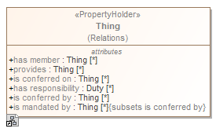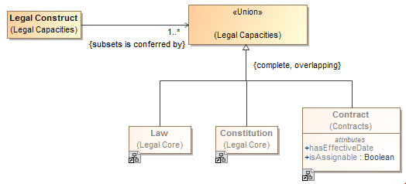

Figure Constraining a global property

### Tightening a property’s type

Sometimes it is necessary, in the context of some class, to constrain *all* the values of a property to a particular type. When defining a new property, the type of that property asserts that all values of that property must be of the given type. This is known as a *universal* quantification or *for-all* constraint (∀) in first order logic. This kind of constraint is an assertion that only values of the specified type are valid, and the number of values must be between some minimum and maximum multiplicity.

Where all values of a property must be of a given type in a specialized property, UML *{redefines}* is used as part of the definition of the property. If the redefined property is given a name, a new property with the quantification is defined. If the redefined property does not have a name, the existing property is constrained in the more specialized context (usually a subclass).

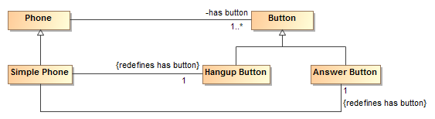

Figure Example of redefines

The example above shows a “simple phone” that has exactly two buttons and they must be an answer button and a hangup button. Since redefines is used, no other buttons are allowed.

The diagram below shows the introduction of a new property “consists of”, defining a universal quantification constraint on the property. The constraint states that, in the context of Soccer Team and any of its subclasses, all values of this property must be of the type “Soccer Player” and that there must be between 5 and 11 values of this property.

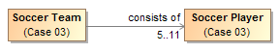

Figure Example of cardinality range

The diagram below shows a universal quantification constraint on the property “observer”. Where any occurrence can be performed by any actor, an observation must be performed by an entity in the role of observer.

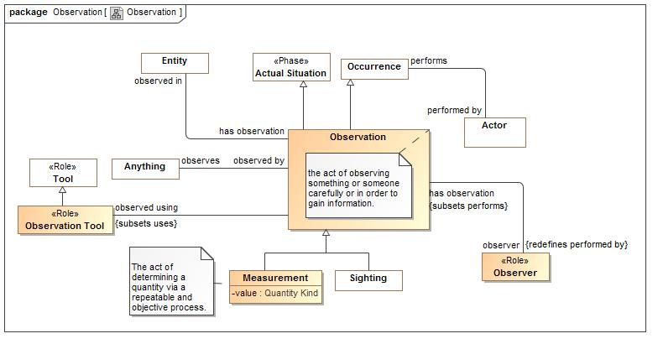

Figure Observation Example

### Inferring a type from its properties

A property's multiplicity or type is declared in the context of an owning class or a special «Anything» class. These declarations are always *necessary* conditions for an instance to be a member of the owning class, or, in the case of «Anything», for an instance to be valid at all.

Another kind of condition is known as *necessary and sufficient*. A class with at least one necessary and sufficient condition is known as a *defined* class, which means the differentiating characteristics of the class that make it distinguishable from its parent and sibling classes are defined. Note that using a necessary and sufficient condition on a property with a minimum cardinality of zero is not meaningful.

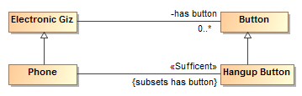

Figure Phone example for sufficient

The diagram above defines a phone as *any “electronic giz” that has a hangup button*. The existence of a hangup button is sufficient to know something is a phone.

In the concept modeling interpretation of UML, a property that has the «Sufficient» stereotype applied to it indicates that when an instance satisfies the multiplicity and type constraints for all the sufficient property’s’ values, not only is a *necessary* condition for being an instance of the class met, it is a *sufficient* condition.. This necessary and sufficient condition could allow an inferencing engine to classify that instance as a member of the class that owns the property. All <<sufficient>> constrains of the class and all superclasses must be met for an instance’s type to be inferred.

In the concept modeling interpretation of UML, a property that has the «Sufficient» stereotype applied to it indicates that when an instance satisfies the multiplicity and type constraints for all the sufficient property’s’ values, not only is a *necessary* condition for being an instance of the class met, a *sufficient* condition is also met. This necessary and sufficient condition allows an inferencing engine to classify that instance as a member of the class with that condition. Once an instance is classified automatically, the conditions on any other properties that have the «Sufficient» stereotype, including those inherited from superclasses, merely become *necessary* conditions the instance must meet to be a *valid* member of the owning class. An instance satisfying the constraints of all the «Sufficient» properties is enough for an inferencing engine to automatically classify an instance.

The diagram below shows that when an instance with the property “has contract with” satisfies specific multiplicity (“1..*”) and type constraints (of type ‘Steering Wheel Manufacturer” and “Windshield Manufacturer”) for the property’s values, the instance meets necessary and sufficient conditions to be a member of the class “Car Manufacturer”. Therefore, an inferencing engine would classify this as an instance of the class “Car Manufacturer”. As discussed above, an instance meeting all of these necessary and sufficient conditions is enough to classify the instance. The conditions on the values of these properties become necessary conditions on an instance for it to be a valid member of class “Car Manufacturer.” Also, an instance meeting all of the necessary and sufficient conditions is enough to distinguish instances of the class “Car Manufacturer’ from its parent class “Manufacturer.”



Figure An example of necessary and sufficient condition

### Property Chain

A property chain is useful for composing a property from two or more other properties that are put together in a chain. It defines the property with reference to the other properties. The property chain allows you to navigate from a starting class (the one with the stereotype «Equivalent Property») through a chain of properties that take a path through the same or multiple other classes.

A property chain is an ordered list of linked properties, therefore, it should have two or more “chain” tagged values.

|  |  |
| --- | --- |
| Note | * An existential or universal quantification restriction *cannot* have or be a part of a subproperty chain, although the property it restricts *can*. * A sub-property *can* have or be part of a subproperty chain for another property. |

The following example describes a Person class that has two subclasses “Female Person” and “Male Person”, and four properties “has parent”, “has father”, “has uncle”, and “has brother”. The stereotype of the property “has uncle” will be **«Equivalent Property»,** and the tagged value is **chain = has father, has brother**. (Note that the «Equivalent Property» stereotype is suppressed in this diagram, but the tagged values are not.)

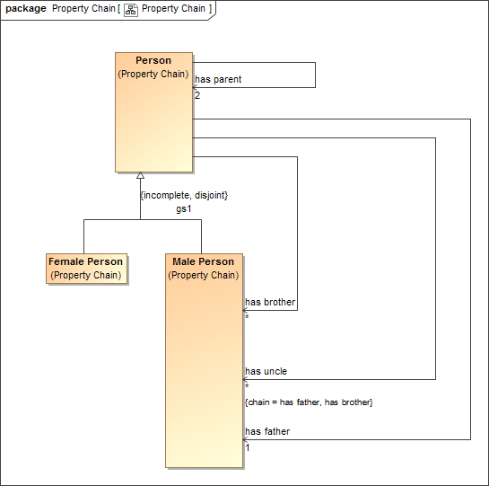

Figure Property Chain Example

### Equivalent Property

An «Equivalent Property» allows you to represent equivalent properties in a model. You can make a property equivalent to two or more other properties by applying the stereotype **«Equivalent Property»** to the referenced properties and the tagged value “**equivalent to**” the equivalent properties.

|  |  |
| --- | --- |
| Note | * An existential or universal quantification restriction *cannot* have or be an equivalent property, although the property it restricts *can*. * A sub-property can have or be an equivalent property. |

The following figure shows the equivalent properties in a diagram.

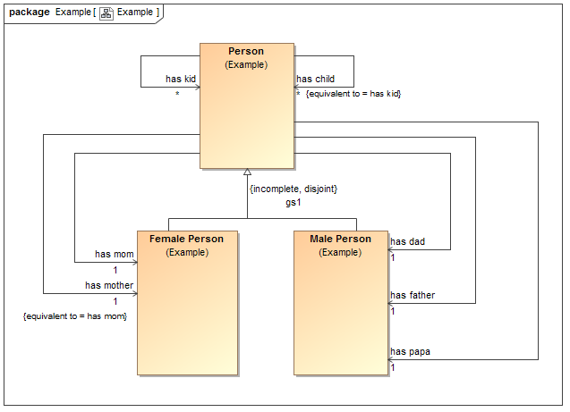

Figure Equivalent properties Example

In the example, the property “has mother” is equivalent to the property “has mom”.

### Equivalent Class

An «Equivalent Class» stereotype applied to a generalization can specify equivalence between two classes. Class equivalence expresses a generalization relationship stereotyped as **«Equivalent Class»**. Tools should draw this with a double-headed arrow.

The following figure shows two equivalent classes in a diagram.

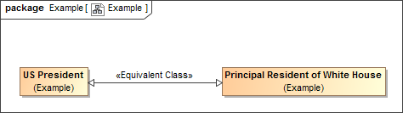

Figure Two Equivalent Classes in the Concept Modeler

In the example, the equivalence class arrow defines that the two classes are semantically equivalent to each other.

## SMIF Profile::SMIF Concept Modeling Profile Reference

The conceptual modeling profile defines the conceptual modeling capabilities of SMIF in UML.

### Diagram SMIF Conceptual Modeling Profile

430546471.emf

**Figure 1 SMIF Conceptual Modeling Profile**

### Stereotype Annotation

An <<Annotation>> comment provides a textual "body" as a "value for" one <<Annotation Property>> describing the annotatedElement(s).

Base Classes

* Comment

Tag Definitions

958301894.emf value for : Annotation Property [1]

<value for> is the property for which the <<Annotation>> is providing a value.

### Stereotype Annotation Property

An <<Annotation Property>> is a kind of <<Resource>> that asserts a property represents metadata rather than assertions about the subject domain.

Base Classes

* Property

Direct Supertypes

* Resource

### Stereotype Anything

<<Anything>> is a class that represents anything and is equivalent to all other classes of anything in any other model or logic. The defined class is equivalent to SMIF:Anything, OWL:Thing and other "top level" classes.

Because of this equivalence, every class in every model virtually inherits from Anything, just as all OWL classes virtually inherit from owl:Thing.

<<Anything>> classes may be used to define "global properties".

Base Classes

* Classifier

### Stereotype Base Unit Type

<<Base Unit Type>> is a kind of <<Unit Type>> that marks one unit type of a quantity kind as the base unit type within a model. The base unit type provides the basis for conversions between units of the same quantity kind. The base unit always has a ratio of one and an offset of zero.

Base Classes

* Classifier

Direct Supertypes

* Unit Type

### Stereotype Classifies

A classification defined by a <<Classifies>> generalization or realization is a "mix in" or "non rigid" classification of an entity beyond any fundamental entity type.

An instance must be typed by the classifies supertype for it to also be classified as the classifies subtype. A classification may be contextual, such as within a relation, situation and/or time frame. Instances may have any number of types and classifications may change over time.

Classification is used in defining what a <<Role>> may be a role of, and for phases, what a <<Phase>> is a phase of.

Classifications may be added to or removed from an individual over time and in different context.

Base Classes

* Generalization

### Stereotype Concept Model

A <<Concept Model>> is a kind of <<Model>> that represents concepts in a real or possible world. Instances of elements in a concept model are "real world" things, not data about those things.

Base Classes

* Package

Direct Supertypes

* Model

### Stereotype Disjoint With

A <<Disjoint With>> dependency is an assertion that two model elements do not and may not denote any of the same set of entities.

When applied to a classifier, every element of the classifier's extent (set of instances) is included in the set of disjoint things.

Base Classes

* Dependency

### Stereotype Enumerates

An <<Enumerates>> dependency asserts that the supplier of the dependency is a type and the client of the dependency is a package containing a complete set of possible instance specifications. In this way, <<Enumerates>> is more general than a UML Enumeration because it can enumerate more than just UML data types.

Base Classes

* Dependency

### Stereotype Equivalent Class

A <<Equivalent Class>> generalization is an assertion that two classes have the same extents (set of instances). Unlike ontological languages it is not assumed that the two elements are consistent, as statements from different context may or may not agree.

Base Classes

* Generalization

### Stereotype Equivalent Property

<<Equivalent Property>> is a declaration that a property is equivalent to one or more other properties (using "equivalent to") or is equivalent to a chain of other properties (using "chain"). <<Equivalent Property>> with at least one value for the "equivalent to" property is an alternative way of expressing <<Equivalent To>>, without introducing additional lines on a diagram.

Either "equivalent to" or "chain" must have a value.

Base Classes

* Property

Tag Definitions

958301894.emf chain : Property [*]

An ordered list of properties forming a "property composition" expressing a traversal path that is equivalent to the stereotyped property. This is similar to a "property chain".

Due to potential "missing information" in creating a chain, a chain may or may not be able to be determined from asserting the chained property. Such a determination is defined in the mapping rules for that property in a particular context.

Note that a chain may also be defined with mapping rules.

958301894.emf equivalent to : Property [*]

A set of properties that the <<Equivalent Property>> is equivalent to. Note that equivalence can also be declared with a <<Equivalent To>> dependency.

### Stereotype Equivalent To

An <<Equivalent To>> dependency is an assertion that two model elements represent the same thing or the same set of things. Unlike ontological languages it is not assumed that the two elements are consistent, as statements from different contexts may or may not agree.

Base Classes

* Dependency

### Stereotype External Reference

<<External Reference>> provides traceability to the source of a "fact" in a model based on some external information resource. This references helps to facilitate provenance. Reference is a statement about the model data and has no semantic implication. Source reference may impact the trust in a statement but the evaluation of trust is outside of this specification.

External reference is combined with the owned comment(s) to create SMIF descriptions as defined in the SMIF meta model..

Base Classes

* Element

Tag Definitions

958301894.emf external reference : String

Specifies the location URL of the external resource. The format must comply with [RFC3987].

958301894.emf external term : String

The external term or location of the information in the source. The form of expression of the term or term path is dependent on the referenced technology.

### Stereotype Has Value

A <<Has Value>> dependency asserts that the client of the dependency is a type and the supplier of the dependency is an instance specification that defines acceptable values for one or more properties of that type. Each slot of the instance specification is a possible value for a corresponding property in the type.

<<Has Value>> corresponds to one or more OWL property restrictions containing a "hasValue" constraint.

Base Classes

* Dependency

### Stereotype Information Model

An <<Information Model>> is a kind of <<Model>> that represents

a model for some purpose, independent of technical implementation. An information model may contain logical models or data models, as well as other logical viewpoints.

Base Classes

* Package

Direct Supertypes

* Model

### Stereotype Intersection

An <<Intersection>> is a class that has an extent (set of instances) equivalent to the intersection of the extents of all supertypes. Intersection is a stronger statement than a subtype, as a subtype may be a subset of the intersection. An instance of all the supertypes implies an instance is also an instance of the intersection type.

For intersection, The SMIF profile considers UML generalization and UML realization equivalent. This is due to ownership and legacy considerations in UML. Generalization is the preferred representation.

Note: Realizations are included to support unions across external models. UML generalization cannot be used across external models due to the ownership of generalization.

Base Classes

* Classifier

### Stereotype Is In Context

<<Is In context>> is an assertion that the client of the dependency is in the context of the supplier of the dependency. All assertions and rules defined in the supplier context apply to the client and everything in the context of the client (i.e., it is transitive). Packages, classes, situations and instances are typical contexts. Note that <<Is In Context>> is the default interpretation of a dependency, if no stereotype is specified it will be interpreted as <<Is In Context>>.

Base Classes

* Dependency

### Stereotype Model

<<Model>> is stereotype of package that may have an id (see <<Resource>>) and/or a namespace prefix (like the "dc" in "dc:title").

Base Classes

* Package

Tag Definitions

958301894.emf namespace prefix : String

A hint as to an appropriate abbreviation for a model that may be used in some technology mappings, such as XML. The prefix should be short and contain only letters and numbers and must start with a letter. e.g., "dc" in "dc:title".

Direct Supertypes

* Resource

### Stereotype Phase

A <<Phase>> (a.k.a. "State") is a classification of an entity based on change of that entity over time. A <<Phase>> <<Classifies>> the types that may have that phase (e.g., "Teenager").

A phase is a "non rigid sortal", a type that may change over the lifetime of an entity.

Base Classes

* Class

### Stereotype Quantity Kind

<<Quantity Kind>> is an aspect common to mutually comparable quantities represented by one or more units. Units with a common quantity kind may be algorithmically converted to any other unit of that quantity kind. e.g. temperature.[ JCGM 200:2008].

SMIF takes a wider view of quantity kinds to include conversions that may be contextual and time dependent, such as currencies.

Base Classes

* Classifier

Direct Supertypes

* Value Type

### Stereotype Resource

A <<Resource>> is anything that can be referenced by an identifier in a model, ontology or vocabulary. This identifier is often an IRI.

Base Classes

* NamedElement

Tag Definitions

958301894.emf id : String

A unique identifier for any resource.

When defined for a Package, id has the format defined in [RFC3987]. In this case, it is equivalent to UML:URI, and setting one will set the other.

### Stereotype Role

A <<Role>> is a classification of an entity based on that entity's behavior, participation in a situation, or capabilities. A <<Role>> <<Classifies>> the types that may play that role. e.g., "Teacher" <<classifies>> “Person”.

A role is a "non rigid sortal", a type that may change over the lifetime of an entity.

Base Classes

* Class

### Stereotype Sufficient

Specifying <<Sufficient>> for one or more of a type's properties means that an instance having an acceptable cardinality of values for all of those properties implies that the instance is an instance of that type.

Base Classes

* Property

### Stereotype Synonym

<<Synonym>> defines an alternate name for the annotated elements of the comment. The alternate name is the body of the comment.

The alternate name will not be the "preferred name" of the element.

Base Classes

* Comment

### Stereotype Union

A <<Union>> is a class that has an extent (set of instances) which is equivalent to the union of the extents of all types that specialize the Union (Subclasses). Specializing types shall include subtypes and types that realize the union.

Note: UML realizations are included to support unions across external models because UML generalization can not be used across external models due to the ownership of generalization.

[MathWorld] Given two sets A and B, the union is the set that contains elements or objects that belong to either A or to B or to both.

Base Classes

* Classifier

### Stereotype Unit Type

A <<Unit Type>> is a <<Value Type>> with an <<External Reference>> that represents a type of a quantity value referencing a specific unit. A Unit Type is a required type of a property representing a quantity.

[JCGM 200:2008] A Unit is a real scalar quantity, defined and adopted by convention, with which any other quantity of the same quantity kind can be compared to express the ratio of the two quantities as a number. e.g. Degrees Centigrade, Miles.

Each unit type represents refinement of a quantity kind using generalization and is thus substitutable for that quantity kind. Typically, quantity kinds are used in conceptual models and unit types in physical or logical models.

Unit types may only subtype quantity kinds and numbers.

Note that unit types are not units, but the type of quantity values expressed in a common unit as defined in [JCGM 200:2008].

Each instance of a unit type shares a common unit (as defined by standards) with a reference defined by "external reference" and "external term".

Base Classes

* Classifier

Tag Definitions

958301894.emf offset : Real

The difference between zero in the unit and zero in the base unit after the ratio is applied to the base unit as defined within the same model.

958301894.emf ratio : Real

The multiplier by which to multiply the unit to convert to the base unit as defined within the same model.

958301894.emf symbol : String

The accepted symbol for a unit. e.g. "g" for "Gram".

Direct Supertypes

* External Reference
* Value Type

### Stereotype Value Type

A <<Value Type>> is a type representing an atomic unit of information without independent identity. Values include numbers, strings and enumerations. In some cases values may have internal structure.

Quantity kinds and units are also values. Values may stereotype any classifier. UML data types, including primitives and enumerations, are implicitly values.

Base Classes

* Classifier

## UML Profile – SMIF Rules & Model Mapping Semantics

Rules provide a general framework for stating the consistency of and between SMIF models and elements. The primary use of consistency rules is for mappings between data models and conceptual models however a <<Rule>> may be used to assert consistency within a model, for example to represent generic assertions such as “all birds have feathers”. Rules are declarative in nature.

Mapping rules define how a particular data model or schema <<*Represents>>* information about the concepts defined in conceptual models. This facilitates an “n-way” mapping of information represented using different data models. Since conceptual models are not data models they do not have any particular representation for “data instances” of that model. Instances of a conceptual model would be the real things in the real world. The real-world concepts are the “pivot points” between the data representations. Of course implementations may automate data models that correspond closely to the conceptual model, but that is outside of this specification.

Due to the various ways to represent information, mappings can become complex. The UML representation of mappings simplifies these mappings as much as possible. Note that details of the mapping relations are defined in the profile specification.

### Structure of Rule Specifications

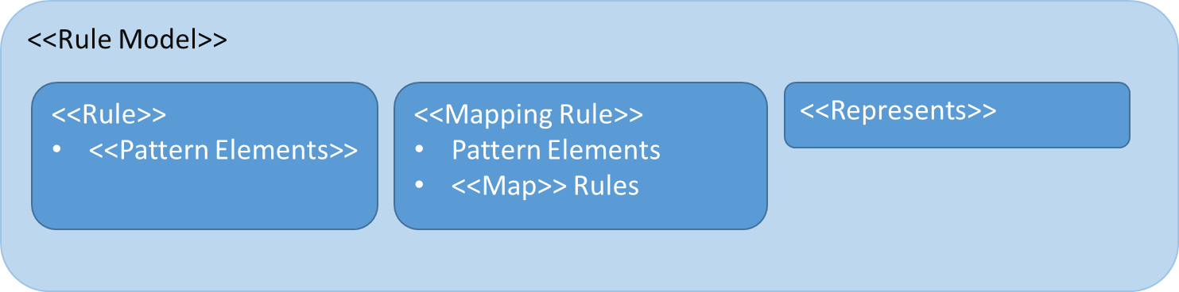

Figure . Structure of Rule Specifications

There is an expected structure for defining rules. This normally starts with a <<Rule Model>> package that contains other rules. Note that any “namespace” can contain rules, including classes. By default, rules will hold within the namespace they are defined in but another namespace may be specified by setting the <holds within> tag of a rule. Packages stereotyped as <<Rule Model>> are considered to hold universally within any model in which they are in context. Within a rule context, such as a <<Rule Model>> there may be generic rules marked as <<Rule>>, <<Represents>> rules or <<Mapping Rule>>s.

<<Rule>>s and <<Mapping Rule>>s contain <<Pattern Element>>s that define the pattern of the rule. Pattern elements can be UML “Parts” (which are properties), connectors and connector ends. There are various stereotypes for pattern elements to further define their effect on the pattern. A <<Mapping Rule>> may also contain <<Map Rules>> which specify how different pattern elements may represent the same facts. Mapping rules are bi-directional and can may changes between “either side” of the mapping.

The difference between a <<Rule>> and a <<Mapping Rule>> is that a <<Rule>> simply states something that must hold (be true) within a model. For example, that fish can swim. A <<Mapping Rule>> creates a correspondence between different representations of the same facts using <<Map>> rules.

### Rule Model

<<Rule model>> is a stereotype of Package to indicate that the contents should be asserted as rules.

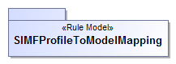

Figure Example Rule Model

The package SMIFProfileToModelMapping is a rule model and will hold within any model in which it is included.

### Representations

The foundation of mapping is the <<Represents>> dependency between classes. Represents says that a particular type found in a logical or physical model represents information about a real or abstract concept in a conceptual model. By default, <<Represents>> does not implement a mapping, it defines what elements can be mapped and thus restricts mappings. For simple “one-one” mappings there is an optional tag for <<Represents>> to <<map-all>> known instances of one Class to another.

Example

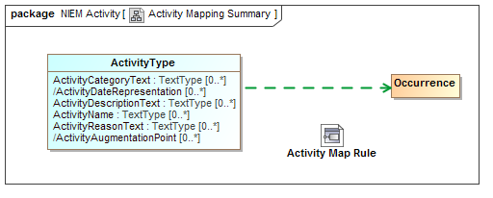

Figure Activity Mapping Summary Example

The above example shows that an “ActivityType” from NIEM-Core represents an Occurrence as defined in the threat/risk conceptual model. By convention we show the represents dependency as a green dashed. Representations provide the ost abstract level of mapping. This diagram also shows that that there is a more detailed activity map rule for the same types which will map the properties and relationships between these types.

What this means is that *some* ActivityType instances represent *some* information about occurrences in “real world” activities. Based on the SMIF mapping riles, this also implies that relationships involving an occurrence can be validly mapped to relationships involving an activity and that properties of an occurrence can validly be mapped to properties of an activity, <<Represents>> relations provide type-safety for mappings.

What this does not say is that ActivityType and Occurrence are equivalent and can necessarily be mapped 1..1. How they are mapped is detailed in mapping rules. However, if the <map-all> tag of <<Represents>> is set true then ActivityType and Occurrence will be asserted as being mapped 1..1, bidirectionally (mapping of types and properties is considered independent, each property must also be mapped). Note that <map-all> implies nothing about the properties and relationships, only the mapped types (each type, property and relationship is an independent concept that is mapped independently).

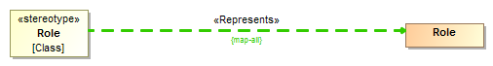

Figure {map all} Example

In the figure above, all UML classes stereotyped as <<Role>> will be mapped to the Role class in the SMIF model.

### Mapping Rules

The detail of mappings happens in classifiers stereotyped as <<Mapping Rule>>s. Mapping Rules define patterns of data types and patterns of concepts that have map correspondence rules. The <<Map>> correspondence rules do the real work, mapping element by element.

Mapping representation rules are, externally, not that interesting. They are just a classes or components stereotyped as <<Mapping Rule>>. However, note that Mapping Rules may specialize other rules – in which case they include the more general rule but may restrict the <<Match>> elements. Mapping rules may also <<Subsume>> other rules, in which case they take precedence over the other rule where the subsuming rule is in context.

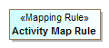

Figure Representation Rule External Example

The above defines a mapping rule for activities that is an assertion that the enclosed pattern must hold and provides a context (in this case the enclosing package) where the map rules are asserted. If we look inside the Activity Map Rule we see the structure and maps.

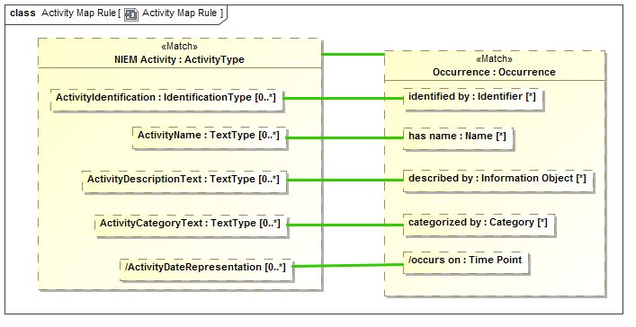

Figure Representation Rule Internal Structure

The above example is the internal “structure” of the Activity Map Rule. In this case the mapping is very 1..1 and simple. Inside of the rule we see “parts” that represent “ActivityType” named “NIEM Activity” and “Occurrence” named “Occurrence”. The green line between them is a “Map” rule, represented as a UML connector stereotyped as <<Map>>. This states that in this simple pattern NIEM Activities and Occurrences map 1..1. We could also have put filter constraints on that mapping, but in this case did not.

We also see the “<<Match>> on “Occurrence” and NIEM Activity. Match defines the “starting point” for the pattern with respect to the model containing the <<Match>> element. A mapping engine will find all instances of Occurrence (in any data format) and map those to NIEM Activity. It will also find all NIEM Activities and map them to Occurrences. All other parts of this mapping become relative to the “Match” elements.

Within both NIEM Activity and Occurrence we see other parts, parts of those types. The green lines create mapping assertions between those parts *within the context of this rule*. This within this rule “ActivityName: maps to “has name”.

A map correspondence is essentially “best efforts”, the types of the mapped elements must either match or have a mapping rule that allows them to be mapped. If, for example, an occurrence had an identifier that was an image and NIEM did not allow for image identifiers, that “fact” would not be mapped. How a mapping engine handles maps excluded by type is outside of this specification.

Mapping for primitive data types, such as strings and numbers, is provided by the mapping engine implementation based on each mapped technology. This allows, for example, an identifier that is represented as an integer to be mapped to a string.

The important point to remember is that mapping any fact requires that the types are compatible. That type compatibility is defined by <<Represents>> rules between the types. The requirement for type matching may be overridden by setting the <coerce> tag of the <<Map>> rule, but in most cases type safety of <<Map>> rules is desirable.

In that there may be multiple <<Map>> rules between the same thing, one can be marked as the <<Default>>. A default rule will be applied only if no other rules have fired.

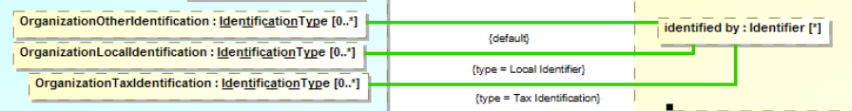

Figure . Default <<Map>> Example

Figure 30 shows a <<Mapping Rule>> fragment of three properties mapped to one based on types of the identifiers. If none of the more specific identifiers match “OrganizationOtherIdentification” will be the default. Similar defaults may be defined for subsets.

### <<Match>> Elements

The foundation of SMIF rules is patterns. When a rule is asserted the SMIF implementation attempts to “match” the pattern to existing situations and then “assert” that the pattern is “true”. The <<Match>> elements are those that must pre-exist for the pattern to even be considered. Relating this to a SQL Query, the <<Match>> elements would be in the “Where” clause.

If there is more than one related <<Match>> element, they must all be “true” for the pattern to hold (be asserted). If there are any constraints for the <<Match>> elements they must also hold. Constraints include condition expressions, the type(s) of the pattern elements and multiplicities.

Once a pattern is <<Matched>>, all properties, relationships and subsets from the match elements are “filled in” from existing information.

What happens if, as these other elements are being filled in, some other constraint is violated? This depends on the kind of rule. For a general rule the constraint will be asserted – made to be true by attempting to each required element. In the case of a mapping rule the rule is in an error state, the behavior of an implementation in response to an error state is implementation specific.

In a mapping rules, after the <<Match>> elements have been matched and any relationships followed, any <<Map>> rules for the pattern are applied.

Note that for a mapping rule there will be two “sides” that are matched – normally the “Conceptual” side and the “Physical/logical” side. Each “side” is considered a separate match set. Sides are determined by <<Match>> elements connected by anything other than a <<Map>> rule.

Figure 28 shows simple a <<Match>> that is simple – just matching a single element on each side. The next example shows more complex matches.



Figure . More Interesting <<Match>> Example

Figure 29 shows vary specific match patterns on both sides. On the UML side (left) a <<Match>> property must have a subset that is a <<Match>> Equivalent Property stereotype (this means match all properties that have the <<Equivalent Property>> stereotype applied. If “UML Property” is not a “Property” or there does not exist a subset of it that has the type :Equivalent Property then this “side of the pattern doesn’t match.

On the other side (the SMIF meta model) there must be a pattern of an “Equivalent” constraint that constrains exactly one “Property” and also constraints exactly one “Traversal”. These patterns are very specific because there are very specific ways to represent general concepts (like equivalence) in the UMLprofile.

Once a pattern on one side is matched, the other side is “asserted”, creating the required elements.

### Pattern element traversals and patterns

The above Activity Map Rule is simple and 1..1, when we get such a simple mapping we shout for joy – because our job is easy. However, there is frequently complexity on “both sides” of the mapping – something in the data model may map to multiple things in the conceptual model or require a “Path” through multiple concepts. Likewise, there may be intermediate “technical artifacts” that have no real meaning in a conceptual model. This is why we say we are mapping patterns.

For our next example we will look at Incidents, which are a subclass of activities in NIEM and occurrences in the threat/risk conceptual model. Since these are subclasses on “both sides”, we only need to describe the additional properties of an incident.

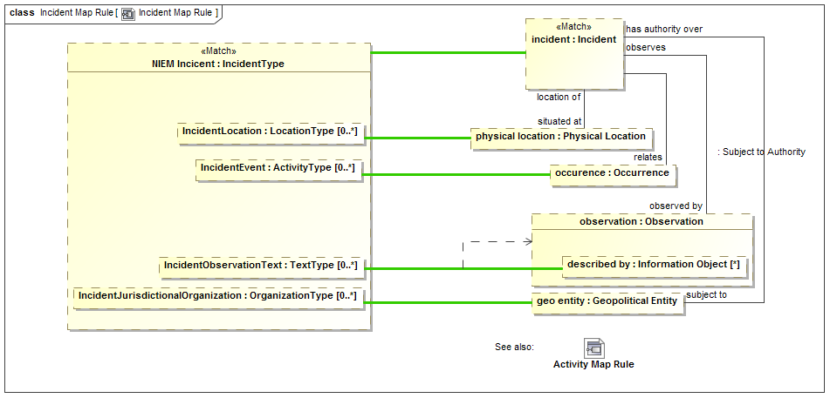

Figure More detailed map rule

The example above shows how a NIEM Incident (named NIEM Incident) maps to a conceptual incident (named “incident”). Incident Map is a subtype of Activity Map so the Activity map rules will all apply to incidents so we don’t need to repeat them here.

We will start with a <<Match>> of “Incident”. Note the line from “incident” to “physical location” labeled “situated at”. The mapping engine will start with an incident and fill in the set of “physical locations iff the “situated at” relationship exists *for that instance* and *what it relates to is a Physical Location*. If that relationship does not exist, “physical location” will be null (empty). Note that physical location could also have multiple values since “situated at” does not have a restricted cardinality.

The values that “end up” in “physical location” will be mapped to “IncidentLocation” in NIEM. Likewise, any mapping in the other direction will hold – any populated “IncidentLocation” will populate “physical location” as well as the relationship to an incident. Once the rule is satisfied, the pattern will hold for all instances of NIEM IncidentType and Incidents. How cardinality mismatches are handled is not specified by SMIF, a mapping engine could, for example, log issues.

Now consider the element “described by” within “observation”. This will be populated if the “has observation” relation exists from an incident and that instance has a “described by” property. IncidentObservationText is mapped to “described by” within such an observation. But, in this case, UML notation is a bit misleading, “described by” is a part of the Observation type, not this particular observation part. Since other objects in this rule may have a “described by” property it becomes non-deterministic which “described by” we are talking about. We want to say that we are mapping to the “described by” in the context of the “observation” part. The dependency from the green line to “observation” defines that the context of this map rule is only valid in the context of “observation”, thus making the map deterministic. As many context dependencies as are necessary may be specified for any map rule. All map rules are considered to be in the context of the enclosing Representation Rule. <<Match>> properties take precedence for resolution - some tools may report if a map is non deterministic.

### Multiplicity constraints in patterns

It is sometimes necessary to constraint pattern properties to have a specific number of values. This may occur either in matching the pattern or as the result of following various paths. The same multiplicity constraint that is used to constrain other properties, such as on the ends of relationships, may be used to constraint pattern properties. Multiplicity constraints may also be used on the “ends” of connectors between pattern properties, to constraint the number of relationships (actual ground facts) that must exist between the pattern properties.

Setting the multiplicity constraint of a pattern property constrains it to have the specified set of values. If a <<Match>> is constrained, the pattern must match the constraint. If not a match, the pattern multiplicity will be satisfied by the rules engine. If, for any reason, this and other constraints cannot be satisfied the issue will be handled by the rules engine. The method for handling constraint violations is not specified.



Figure . Example of setting multiplicity constraints on <<Match>>

In the above example a SMIF Equivalent has exactly 2 <constrains> entities. This is the condition for matching the pattern. This matching pattern then maps the Equivalent constraint to a UML dependency stereotyped as <<Equivalent with>>.

Once these base patterns are mapped the two mapped entities will be mapped to the <supplier> and <target> of the UML dependency via a “List First” rule. The List First rule separates a list into its first and remaining elements.

### Subsets of Pattern Elements

Conceptual models use sub classing, multiple inheritance, roles and phases to more accurately and intuitively represent the domain of interest. Many data technologies do not support these concepts and even if they did, would probably structure implementation classes differently. In other cases, there may be restrictions on the “extant” of what maps to what that require calculations or other constraints. To provide for these cases we use <<Subsets>> in mapping patterns. A subset defines another part (property) that holds a subset of the instances of the superset part, based on the type, relationship values and other constraints of the subset part.

To understand this feature we will first look at models for “Entity” and “Actor” in NIEM and the threat conceptual model, respectively.

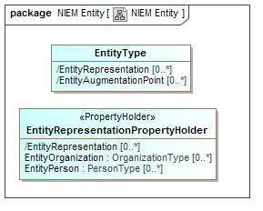

Figure NIEM Entity Example

In NIEM, an “EntityType” has a “substitution group” property with properties that can be “EntityOrganization” or “EntityPerson” to allow the entity to represent one or the other. The general rules for mapping NIEM state that substitution groups are considered subtypes of the primary type.

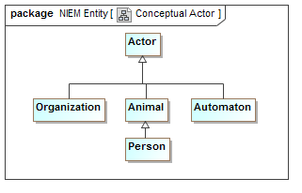

Figure Conceptual Actor Example

In the Threat conceptual model “Actor” is a Supertype of Organization and, indirectly person. It is also a Supertype of “Automaton”. An Automaton can’t be an actor in NIEM so it will not be mapped (However we could define a NIEM extension to allow this).

We want to map actors to NIEM entities, but see that they are very different “shapes”.

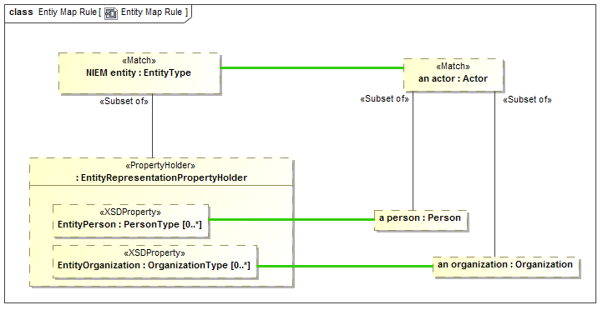

Figure Subset part example

In the above example we see the actor - EntityType mapping. Notice “a person” of type “Person”. “a person” is defined to be a <<Subset of>> actor – that is every actor that is of type “Person” will populate the “a person” part. If an actor is not a Person, “a person” will be null. “a person” is then mapped to “EntityPerson”, a property of “Entity” by way of the substitution group (sorry that this gets into some NIEM substitution group details, but you probably get the basic idea).

Likewise, “an organization” will map to EntityOrganization iff “an actor” is an Organization. Note that if “an actor” is neither of these, it will not map to any NIEM property.

Note also that there could be other constraints on the subset parts, such as required relations or constraint expressions.

### <<Pattern Element>> computations and constraints

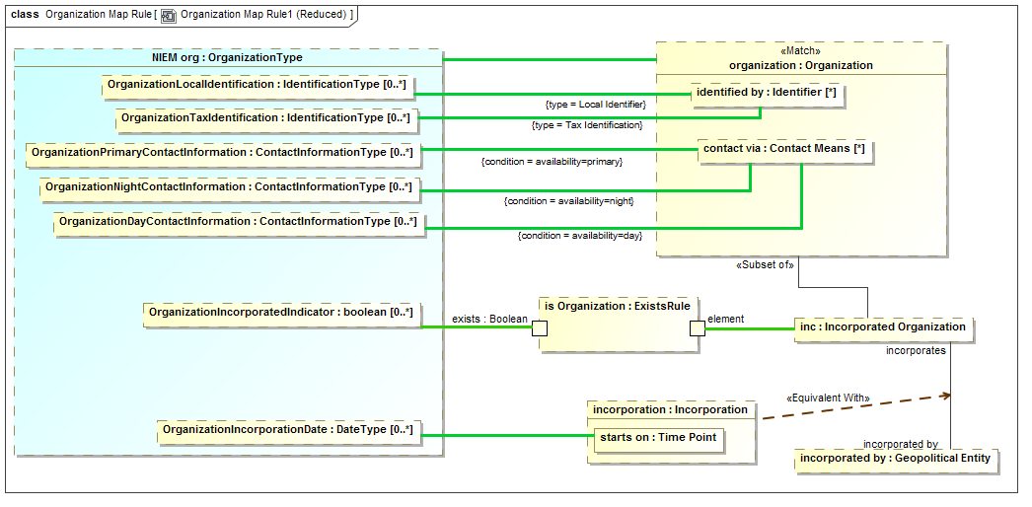

Figure Map constraints example

To continue the tour of the primary mapping capabilities we will look at a subset of the “Organization” mapping.

Note the “type=” on two maps to “identified by”. In the conceptual model there are subtypes of identifiers. In NIEM there are special properties for some of these identifiers. The “type=” constraint on a map says that the map will be constrained to the type (on the specified end) of the actual instance matched the specified type. So “OrganizationLocalIdentification” will only map to “identified by” if the type if the identifier includes “Local Identifier”. Likewise, “OrganizationTaxIdentification” will only map to “identified by” if the type includes “Tax Identifier” (remembering that a SMIF concept instance can have multiple types). Likewise, the reverse is true; those properties will “assert” the type of the identifiers they reference.

On the maps to “contact via” we see “condition=”. Condition is a tag of <<Pattern Element>> that references a UML expression. The conditions referenced are properties of the association between an organization and “Contact Means”. The maps will be constrained to the “availability” property is set as indicated. Likewise, if an organization is being created, that property will be set by the same condition.

Note that “inc” is a subset of an organization only if it plays the role of an “Incorporated Organization”. In NIEM there is a Boolean set if the organization is incorporated. The “ExistsRule” is a computation rule (that is its implementation is outside the specification). But in this case ExistsRule’s behavior is defined – the exists Boolean will be true when the mapped “element” has some value. This results in the NIEM “OrgainizationIncorporatedIndicator” corresponding to the organization being incorporated.

If the organization is incorporated it will have an incorporation relationship to its incorporating body (incorporated by). That incorporation relationship will contain its date of incorporation, which is mapped to the NIEM property. In UML association classes have to be put into a structure like this in two pieces, the “line” and the “box”. Since both the line and the box represent the same “fact”, they are asserted to be equivalent – this is only required when association class properties need to be accessed and is required because UML has no way to show connectors as association classes.

The end result is that the more “flat” representation of an Organization in NIEM is mapped to the concept model.

### <<Pattern Element>> strength

A connector between parts will both follow a relationship and assert that relationship. There are times when the “strength” of a rule implied by a connector needs to be more explicitly specified. The <strength> tag of <<Pattern Element>> allows different options for what is asserted by a connector. These are: match, assert, default and exists. The default is “assert”. Definitions of each of these is in the reference section. In the following sections we will provide some examples. Note that strength=Match is the same as the <<Match>> stereotype and is not repeated here.

### <<Pattern Element>> strength=Assert

Assert, the default, defines a pattern element. A pattern element operates in two modes: Pattern match and assertion.

When the <<Match>> elements match an existing situation the rule is consider to have “fired”. Properties and relationships of the matched elements, that are represented in the pattern as <<pattern elements>>, are “filled in” by following paths from the <<Match>> elements through properties and relationships to other pattern elements. Note that property elements may be null, contain a single element or contain sets of elements.

Once elements are matched and the properties and relationships followed, the <<Map>> rules “assert” that corresponding elements represent the same “facts”, perhaps in other forms or structures. Relationships between the elements, also represented as pattern elements, are then also asserted between the mapped elements. In this way the entire pattern on “both sides” (if it is a mapping pattern) is “made consistent”.

Strength=assert defines a pattern element as playing both roles – as a part of the pattern match “query” as well as what should be asserted within a pattern.

### <<Pattern Element>> strength=Exists

In some cases it is required that we match a pattern but do not “assert” that some element or relationship exists, but if it does exist we need to apply some more rules. “Exists” will test for an element with creating it.

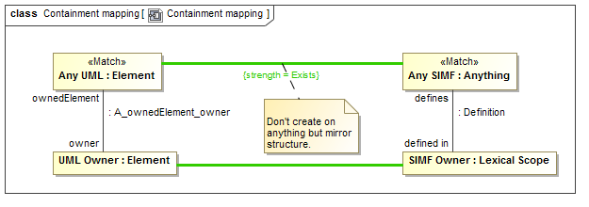

Figure strength = Exists example

In mapping UML to SMIF we do not necessarily want to map every element. But where there are mappings we would like to make the ownership hierarchies match. A match of “Any UML” has a <<Map>> to <<Any SMIF>> but the <strength>> is specified as “Exists”. This means that they should be mapped if the elements exist but the mapping should not be asserted by this rule (it may be asserted by other rules). Where they do exist, the UML owner should be mapped to the SMIF owner.

### <<Pattern Element>> strength=Default

Model information can come from multiple sources, model organizations and rules. There are time where a pattern element should be a default, asserted only if no other source is asserting the same element.

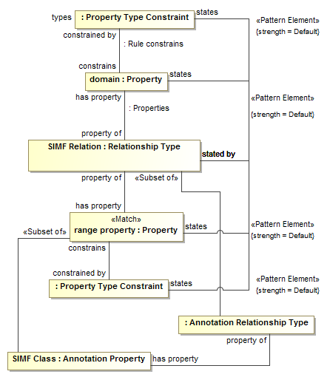

Figure strength = Default example

In the above fragment we several states/stated by connectors that have strength=Default. What is intended is that “states” (which defines model organization) will be asserted by this rule only if the value is not asserted by some other rule.

### <<Pattern Element>> quantifier

There are times when we need to define generic rules, not specific to a mapping or populate rule variables based on the entire extent of a type, or some constrained subset of the extent. In logic this is done with “quantifiers”. A <<Pattern Element>> may have a <quantifier> tag that specifies the content of a pattern property based on the extent of its type.

The quantifier can have values of: None, There Exists, Exactly One, Some, Most, All or Match. Note the close correspondence of quantifiers with those in predicate logics (with some extension). Definitions of each of these is in the reference section.

The quantified properties may then be used as the ends of relationships, making assertions about the set of quantified things.

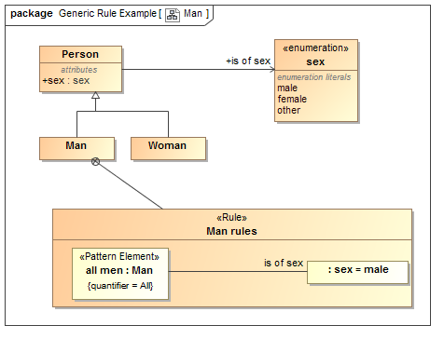

Figure Generic Rule Using Quantifiers

In the above example we assert the fact that “all men <is of sex> Male” in a <<Rule>> called “Man rules”. This rule is owned by (and therefor in the context of), the class “Man”.

The pattern element named “all men” has a type of “Man” and a quantifier=All. This means that the element will be “filled” with all men, statements made in this rule will apply to all men. We then have a connector typed <is of sex> to “Male”. This asserts that all men are male.

Note that quantified elements can also have connectors to other quantified elements, so we could say things like “all men like Most tools” or “John likes all supermodels living in New York”.

Note that how rules are resolved is implementation specific. Some “inference” systems may create new facts while others may check that certain facts are correct.

### <<Pattern Element>> explicit

Most elements are mapped regardless of their source – explicitly asserted in a model or derived based on rules. There are times where only explicitly asserted elements need be mapped. In this case the element is marked with the <explicit> tag as TRUE.

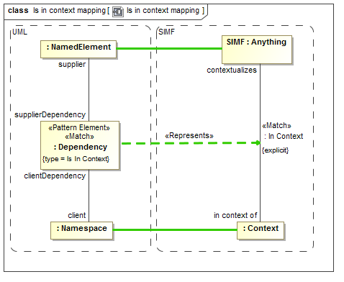

Figure Example of "explicit" pattern elements

The above example shows that the “in context of” relationship in SMIF should only be mapped to UML if it is explicitly asserted.

### Property Chains

Rules may also be used within a conceptual or logical model, an example being the “property chain” concept from OWL which allows a “path” through properties to be equivalent to another property.

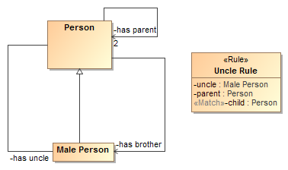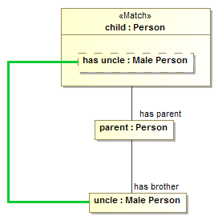

Figure Property Chain Example

In this example we see a simple model of a person with parents and male people that can be brothers or uncles. The “Uncle Rule” states that the “path” through “has parent” to “has brother” <<Map>>s to “has uncle”.

The above is one way to specify a chain, another would be with the <chain> tag of an <<Equivalent Property>> which is more compact but less powerful.

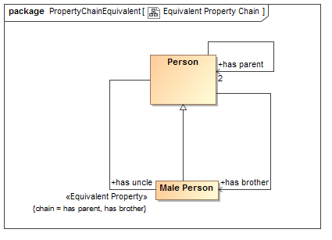

Figure Property Chain as Equivalent Property

The above example says the same thing as the property chain rule, using the more compact <chain> tag of <<Equivalent Property>>

### Pattern Precedence

It is possible for more than one pattern to match for the same set of values. The general rule is that all patterns that match will execute. Where this may produce redundant elements a pattern may either subtype or subsume another. Where a pattern subtypes another and the more specific pattern matches, the more specific pattern will include the rules of the more general pattern.



Figure . Example of Pattern Generalization

An incident is a kind of activity. The incident rules subtypes and subsumes that activity map. An activity that is an incident will use the incident map rules as well as the sub-rules defined within activity.

Where a pattern uses a <<Subsumes>> dependency, if the <supplier> pattern matches it will prevent the <target> pattern from executing for the same set of values.



Figure . Example of Rule Subsumption

Using “Equivalent With” is more general but >Equivalent Property” more compact. If equivalence can be expressed with “Equivalent Property” it subsumes “Equivalent With”.

### Generic Rules

Most of our examples have used mapping rules. Rules are also generic patterns that can be asserted to hold within some context. Generic rules generally use quantifiers rather than <<Match>> but can be stated either way. A quantifier defines a pattern property that contains a set of instances defined by the property type. The quantifier specifies how many instances will be in the set from none to all.



Figure . Generic Rule Example

Figure 47 provides an example of a generic <<Rule>>. The rule states that as part of the definition of the class Man, the “Man rule” applies which says that all men <is of sex> male. The Pattern element “all men” has “quantifier = All” which is really what makes it represent all men, not the name. “all men” then has a relationship to a constant “sex = male” (the default value of a property is considered its value). The result is the “assertion” that all men will have the same sex.

Note that more than one property may be quantified, for example we could say “All men like at least one supermodel” by quantifying “a supermodel” with “quantifier = There exists” and creating a connector “likes” between them. Options for quantifiers are: None, There Exists, Exactly One, Some, Most, All. Note that for an interpretation in first order logic, There Exists, Some and Most are the same, even if they may have an intuitive distinction. In other logics concepts like “Most” may offer a default.

### Facades and Representation Computations

In some cases, it is desirable to have mapping rules as “reusable pieces” that can provide a “Face” to a model that fits better for one or more mapping rules. There is also the case where these rules fall outside of the expressive power of mapping rules and are best done in calculations (program code or fUML models).

Facades provide for making a new “face” of either a conceptual model or data model element. A Façade is a class with additional properties and/or relations that can be derived from the element it represents. Either mapping rules or computations are then used to “populate” the façade or map the façade back to what it represents. The façade implementation keeps the façade properties consistent as any connector implies change in a property value.

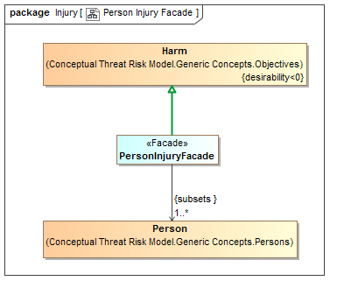

Figure Facade Example

The “PersonalInjuryFacade” above represents the concept of “Harm” but only where the harm impacts a Person. In NIEM, injury is only considered relative to a person – so this façade provides such a “View” of the conceptual model, harm restricted to personal injury. In this case no additional representation rule is required, but such a façade could also define new properties or associations that would be populated in the same way as a data model.

Note that in this case the <<Represents>> relation is applied to a generalization to assert that “PersonInjuryFacade” includes all of the features of “Harm” and is also a representation of it.

Facades can also use “Computations” or Representation Rules to define their properties.

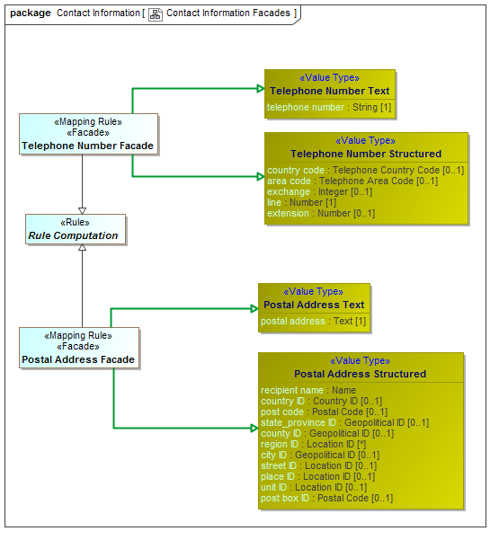

Figure Computation Facade Examples

In the above example both a telephone number façade and address façade are “computed” based on combining both a structured and unstructured representation of telephone numbers and addresses. The specific computation is external to the specification and defined by implementations. These implementations could be implemented in any language, including “ALF”, the executable language of UML.

The mapping engine is responsible for implementation of computation behavior and should update a computed Façade whenever any of its elements changes (some implementations may group such changes in a transaction).

In summary, facades and computations provide for reusability and extensibility of mappings.

## SMIF Profile::SMIF Rules Profile Reference

The SMIF rules profile defines the way to model rules and mapping within and between data sources via a conceptual model.

### Diagram SMIF Rules Profile

603307669.emf

**Figure 1 SMIF Rules Profile**

Computation computes a value for the mapping end based on the expression applied to the mapped property or relationship.

Where computation is used inverse mapping is not specified - any inverse mapping is implementation specific.

### Stereotype Facade

<<Facade>> defines a classifier as being a view of (facade of) one or more other classifiers. Facades usually define additional properties that match some external view of a conceptual model element.

A facade will represent the classifier for which it is a facade. A Facade will use one of two methods to relate the facade properties to the conceptual Model:

* <<Rule>> using the facade.

* Applying the <<computation>> stereotype and Subclassing "Representation Computation"

Base Classes

* Classifier

### Stereotype Map

<<Map>> defines an equality rule between two properties in a <<Rule>> - they must represent the same information, perhaps using different representations.

Maps should be drawn <from> the representation <to> the more conceptual.

<<Map>> may be used between models, as is common for a <<Mapping Rule>> or within one model to equate different representations for the same thing (e.g., property paths).

Base Classes

* Connector

Tag Definitions

958301894.emf coerce : Boolean

Where <coerce> has a value of TRUE a map rule will be evaluated even if the <from> is not type compatible with the <to> type.

Where <coerce> is FALSE or unstated a map rule will be evaluated only if the <from> is type compatible with the <to> type.

Type compatible shall be defined as one of: Being the same type, <from> being a subtype of <to> (as defined by a type generalization rule), <from> being a representation of <to> (as defined by a representation rule).

Representation rules applied to a supertype apply to a subtype.

958301894.emf condition : ValueSpecification

<condition> is an expression that must be true for the map rule to hold.

958301894.emf default : Boolean

<default> is true if the map should be enforced only if no other maps apply.

958301894.emf type : Classifier

<type> is a restriction on the type of a property or relation that a map represents. One "side" of the map connector must have this type.

### Stereotype Mapping Rule

<<Mapping Rule>> defines a pattern structure described by a structured classifier that shows how both "sides" of a representation (conceptual and logical) are related. Each "side" must match, including any traversals through structures defined with properties and connectors. Such traversals are links which may also have filters to more precisely define the pattern.

The pattern is described using structured classifier properties and connectors.

The mapping engine ensures that the patterns match, bidirectionally.

Base Classes

* StructuredClassifier

Direct Supertypes

* Rule

### Stereotype Match

Match specifies an element in a structure that must match a model element for the pattern to match. The match is the starting point for the pattern from which all paths are computed.

<<Match> is a shortcut for <<Pattern Element>> strength=Match

Base Classes

* Connector
* ConnectorEnd
* Property

Direct Supertypes

* Pattern Element

### Stereotype Pattern Element

<<Pattern element>> further defines a connector, connector end or property within a pattern based on the tag values.

Note that the UML default value may be used to set the initial value of a pattern element.

Base Classes

* Connector
* ConnectorEnd
* Property

Tag Definitions

958301894.emf computation : ValueSpecification

<computation> computes a value for the pattern element based on the expression.

Where computation is used inverse mapping is not specified - any inverse mapping is implementation specific.

958301894.emf condition : ValueSpecification

<condition> states a condition that must be true within the scope of the pattern element. This can be used for pattern matching, setting values or restriction of paths.

958301894.emf explicit : Boolean [0..1]

If <explicit> is true, the pattern element must be explicitly asserted as the indicted type, not derived or inferred from a supertype or super property.

958301894.emf quantifier : Quantifier

A property that defines a quantification within a pattern. The quantifier defines the set of things that will populate the pattern property for all instances of the pattern.

Quantifiers operate over the type of a pattern element and define a set or subset that corresponds to the extend of the pattern elements type.

e.g. for all people p: People is the context and P is the quantified property. In SMIF the quantified property would typically be named <quantifier> <type>. So the above quantified property would be named "all people". The quantified property will be asserted to have the quantified type.

958301894.emf strength : Pattern Element Strength

<strength> defines the behavior of an element with respect to a pattern - how it impacts the selection, evaluation or assertion of the pattern.

958301894.emf type : Classifier

<type> is a restriction on the type of a property or relation that a pattern element represents.

### Enumeration Pattern Element Strength

Pattern Element Strength defines a set of options for the mapping behavior of a pattern element.

Literals:

1297872297.emf Assert

The element will be asserted as required for a valid pattern. Assert is the default.

1297872297.emf Default

The element will be asserted only if no other values are asserted within the pattern or as pre-existing assertions.

1297872297.emf Exists

Existing element that will be used to compute other values but does not otherwise impact the pattern.

1297872297.emf Match

Match is used in query and mapping patterns, all elements of the classified type that match the pattern are selected as instances of the pattern.

Match may be considered a qualified "All". Match does not assert the existence of something, it determines the existence of a pattern match such that other assertions may be made.

Relationships between properties with <quantifier>=Match must hold between the matched properties for the pattern to match.

### Enumeration Quantifier

The set of quantifiers for pattern variables. Quantifiers operate over the type of a pattern element and define a set or subset that corresponds to the extend of the pattern elements type.

Literals:

1297872297.emf All

The universal quantifier - the quantified property is a stand-in for all elements of the extent of the quantified type

1297872297.emf Exactly One

The existential quantifier limited to exactly one of a potentially larger set

1297872297.emf Most

A stratified existential quantifier with a default for a "typical" value - example: <Most> people have 2 arms.

For logics that do not support "most", most may be interpreted as "There Exists".

1297872297.emf None

A quantifier where no instance of the type may fill the role. E.g. "there may not exist".

1297872297.emf Some

A stratified existential quantifier for a common values - example: <Some> people like computers.

For logics that do not support "some", some may be interpreted as "There Exists".

1297872297.emf There Exists

The existential quantifier - at least one element must exist.

### Stereotype Represents

<<Represents>> is an assertion that the source type or feature provides a more concrete way to represent the target type or feature. Represents may be used within conceptual models or from a physical model to a conceptual model.

• A representation that is a dependency or realization makes no assumption that the types are substitutable.

• A representation that is a generalization is substitutable for what it represents.

Base Classes

* Dependency
* Generalization

Tag Definitions

958301894.emf condition : ValueSpecification

<condition> is an expression that must be true for the source to represent the target.

958301894.emf map-all : Boolean

<map-all> implies a direct mapping between instances of the types in both directions.

<map all> is equivalent to a mapping with a rule mapping properties of each type but is lower precedence than other mappings - if types have a more specific map it will apply first.

### Stereotype Rule

<<Rule>> defines a pattern that must hold true for the context of the rule.

The pattern is described using structured classifier properties and connectors.

A rule is a pattern structure described by a structured classifier that shows how elements are related. Each mapped element must match, including any traversals through structures defined with properties and connectors. Such traversals are links which may also have filters to more precisely define the pattern. The mapping engine ensures that the patterns match, bidirectionally.

Base Classes

* StructuredClassifier

Tag Definitions

958301894.emf holds within : Namespace

<holds within> is the context in which a rule is asserted (required to be true). Anything contextualized by the context is subject to the proposition.

If not stated the rule is asserted by its owner.

### Stereotype Rule Model

A <<Rule Model>> defines a package as containing rule specifications and asserts those rules to be true.

Base Classes

* Package

Direct Supertypes

* Model

### Stereotype Subset of

In a pattern or mapping rule, <Subset of> defines a pattern property that represents a subset of another property. The subset may be constrained by a more specific type, expressions, values or required cardinalities.

Subset stereotypes the end of a connector that is the superset.

Base Classes

* ConnectorEnd

Tag Definitions

958301894.emf default : Boolean [0..1]

True if the subset should be populated only if no other subsets have been populated.

### Stereotype Subsumes

<<Subsumes>> is a dependency between rules. When a rule subsumes another the subsumed rule will not apply (fire). if the <subsumed by> rules applies (fires).

Where rules are also patterns, a rule may specialize another which will subsume the specialized rule as well as include the generalized rule parts as parts of the specialized rule.

Base Classes

* Dependency

## SMIF Profile::SMIF Computation Rules

Computation rules define mappings that are implemented via external methods. As such the implementation is defined by implementations, not the specification.

### Diagram SMIF Computation Rules

1940672626.emf

**Figure 1 SMIF Computation Rules**

### Class ExistsRule

<<Exists Rule> is a rule to map the existence of an <element> to a boolean.

<exists> is true iff <element> is not null.

Direct Supertypes

* Rule Computation

Attributes

-1258462637.emf element

-1258462637.emf exists : Boolean

### Class List First

The <List First> rules will take the <list> property and place the first element into<first>. If <list> is empty, <first> will be empty.

If there are more <list> elements than 1, all remaining elements are placed as a set in <remainder>.

If <list> is an un-ordered set the order will be indeterminate but repeatable.

<<List First>> is bidirectional and will compute <list> by appending <first> and <remainder>.

Note that this will act like a LISP CDR/CAR pair

Direct Supertypes

* Rule Computation

Attributes

-1258462637.emf first [0..1]

-1258462637.emf list [*]

-1258462637.emf remainder [*]

### Class MapID

<<MapID>> is a rule where the source is an ID and the target is a class, maps an instance of the ID to an instance of the class.

Direct Supertypes

* Rule Computation

Attributes

-1258462637.emf id : Classifier

-1258462637.emf identified : Classifier

### Class Rule Computation

<<Rule Computation>> is an abstract supertype for a facade that includes external implementation. The implementation is outside of this specification.

### Class Summarize

<<Summarize>> is a rule that produces a natural language description of an element. Summarize may not be bi-directional and is expected to have information loss.

<summary> is a summary of <element>.

Content of summary is implementation specific.

Direct Supertypes

* Rule Computation

Attributes

-1258462637.emf element

-1258462637.emf summary : String

# Profile mapping to SMIF Model (Normative)

The following diagrams summarize the mapping which is further defined in the UML mapping model.

## SMIFProfileToModelMapping::High level representation

The following diagrams show the <<Represents>> rules defined between the profile and the SMIF model.

### Diagram: Anything

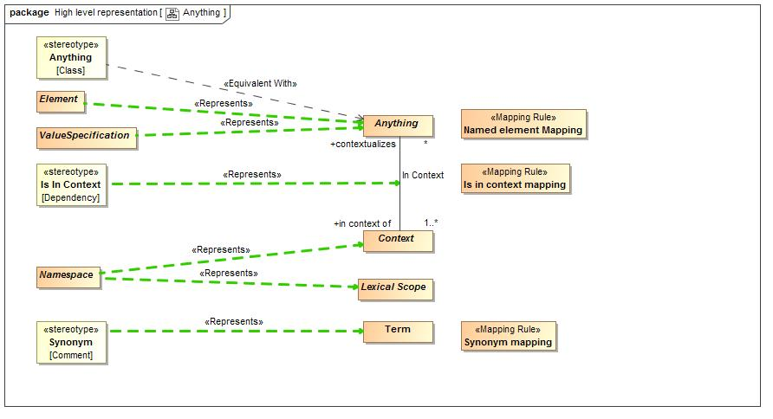

1. Anything

### Diagram: Classes

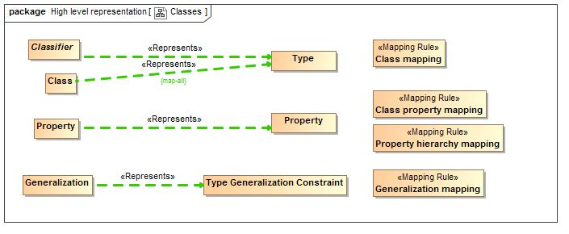

1. Classes

### Diagram: Lexical Structure

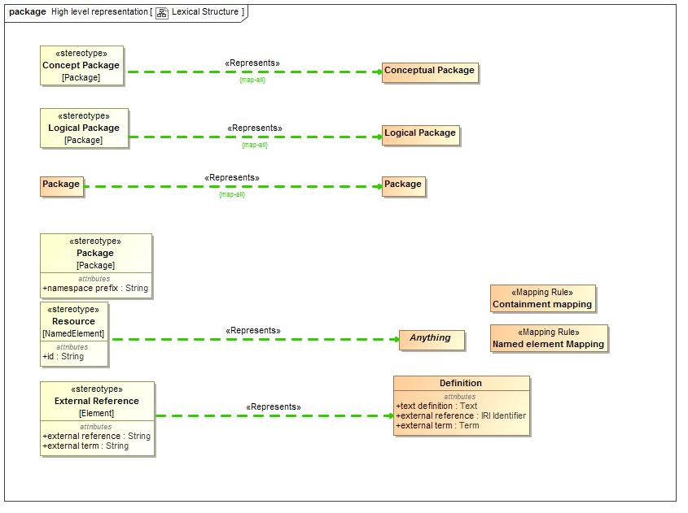

1. Lexical Structure

### Diagram: Patterns

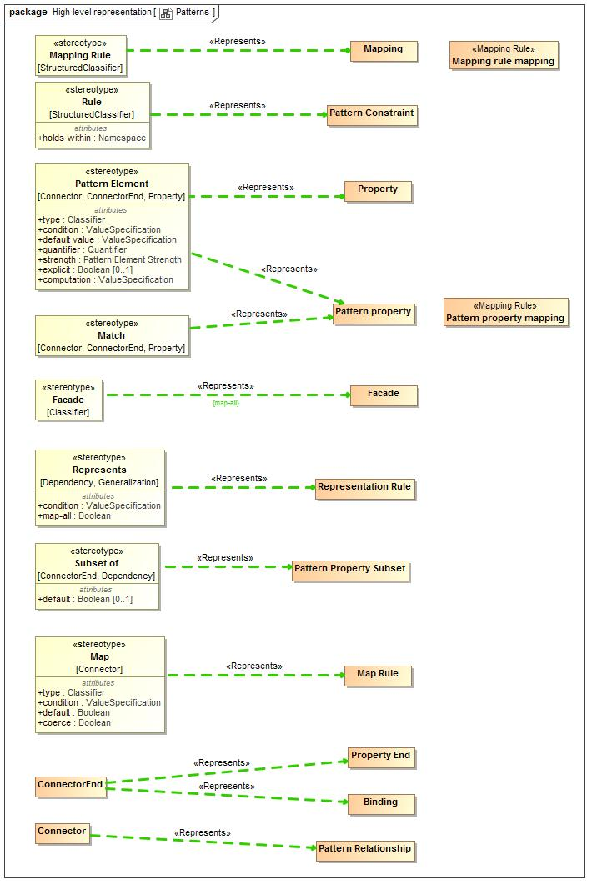

1. Patterns

### Diagram: Relationships

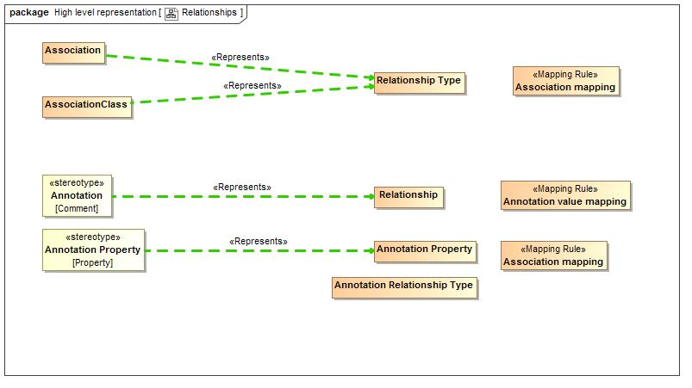

1. Relationships

### Diagram: Rules

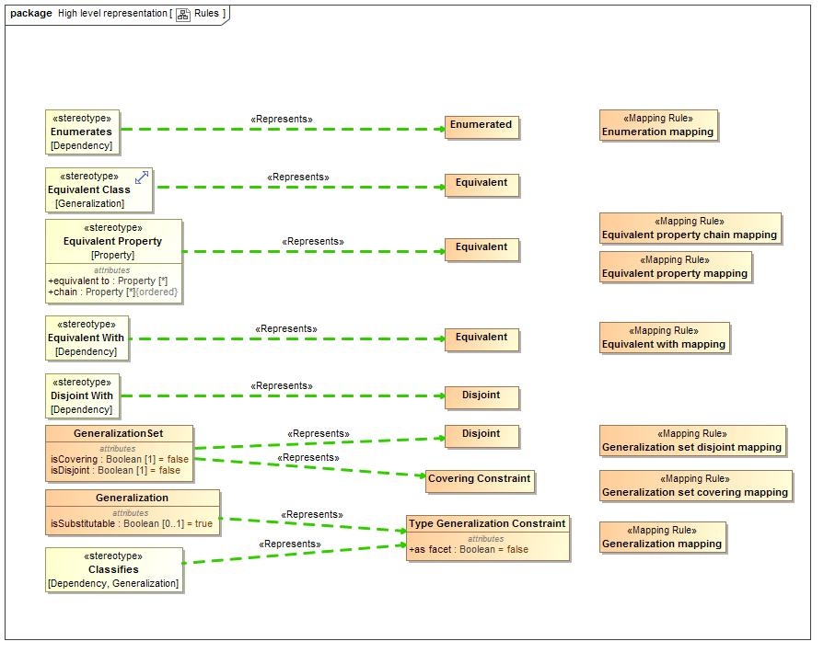

1. Rules

### Diagram: Types

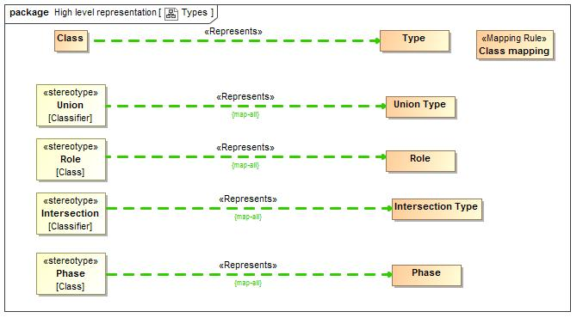

1. Types

### Diagram: Values

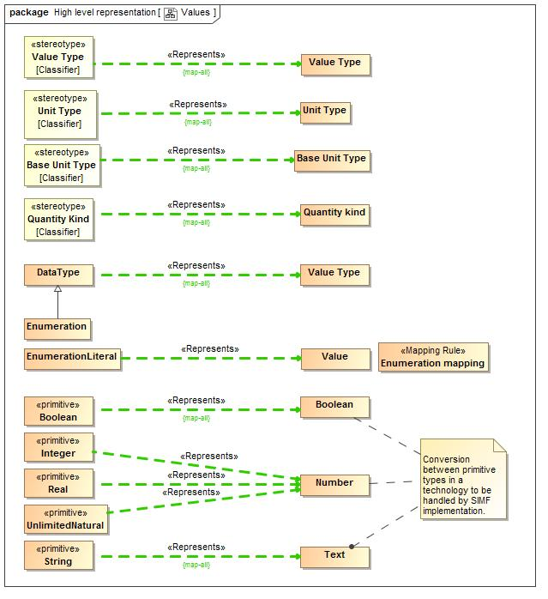

1. Values

## SMIFProfileToModelMapping::Mapping rules

The following are the mapping rules that hold for mapping the SMIF profile to the SMIF model.

## Class Annotation value mapping

Annotation value mapping defines a direct correspondence between a UML <<Annotation>> stereotype of a comment and a SMIF Relationship typed by a Annotation Relationship Type. It then creates the properties for the Annotation Relationship Type and binds the subject of the annotation to the annotated element and the annotation property to the string "body" value of the annotation.

Note that an annotation defines a property instance, it does not define a new property.

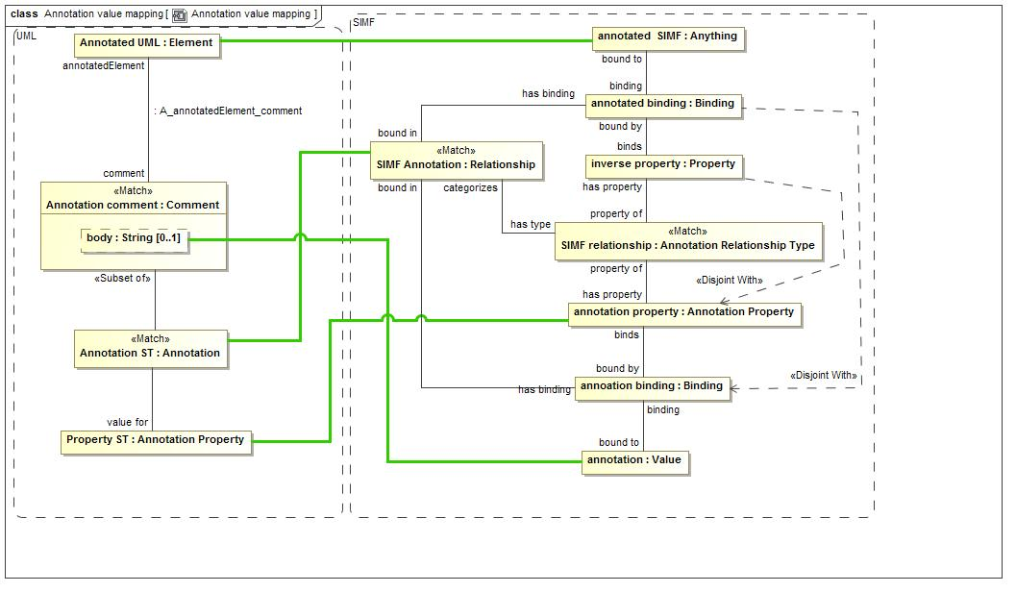

1. Annotation value mapping

**package** SMIFProfileToModelMapping::Mapping rules

## Class Association mapping

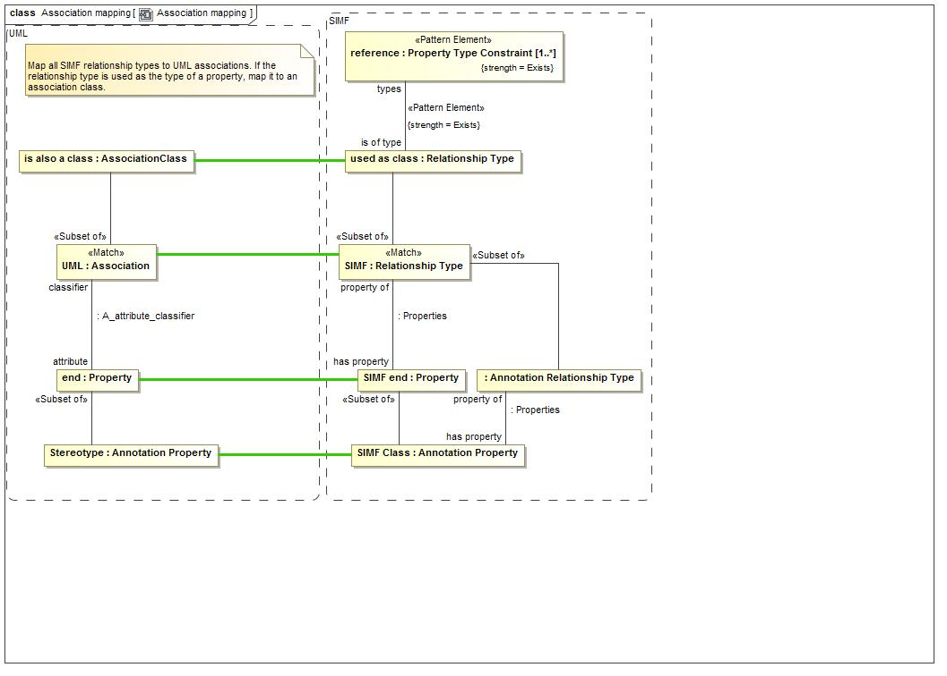

1. Association mapping

The Association mapping draws a direct correspondence between a UML association and a SMIF Relationship Type. It maps each property of the association to a SMIF property.

SMIF does not distinguish between associations and association classes (all associations are essentially classes). As a convention, a UML association class will be created only when the association is used as an type of some other property.

For annotations, UML <<Annotation Property>> corresponds with a SMIF Annotation Property as a property of a Annotation Relationship Type.

**package** SMIFProfileToModelMapping::Mapping rules

## Class Class mapping

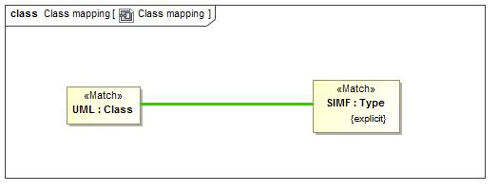

1. Class mapping

UML Classes correspond directly to explicitly asserted SMIF types.

**package** SMIFProfileToModelMapping::Mapping rules

## Class Class property mapping

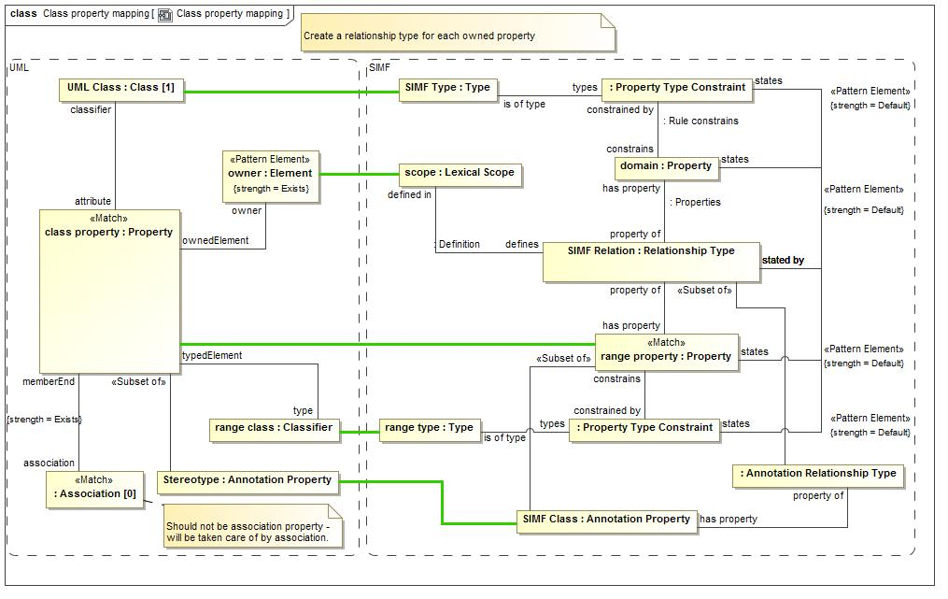

1. Class property mapping

Properties of UML classes correspond with a pattern involving a relationship. SMIF conceptual models to not define properties directly on types but each is an independent relationship type.

Each UML Property corresponds with a SMIF property with a type that matches the UML property type. The SMIF property becomes a property of a Relationship Type with a "domain" property corresponding to the UML class owning the property.

UML properties marked as an <Annotation Property>> Correspond to a SMIF Annotation Property and further classify the relationship as a Annotation Relationship Type.

**package** SMIFProfileToModelMapping::Mapping rules

## Class Containment mapping

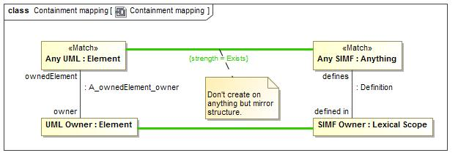

1. Containment mapping

Containment mapping forces the UML ownership structure and the SMIF lexical structure to match.

**package** SMIFProfileToModelMapping::Mapping rules

## Class Enumeration mapping

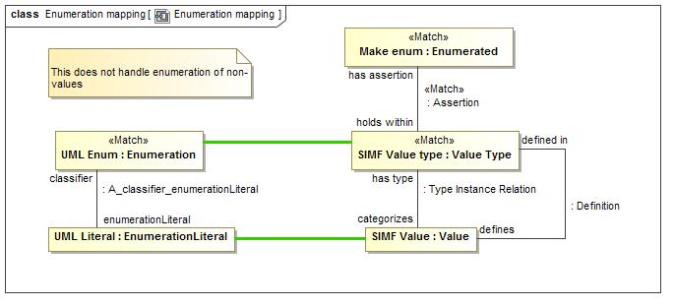

1. Enumeration mapping

Enumeration mapping draws a correspondence between UML Enumerations and a SMIF Value Type with an "Enumerated" constraint.

While SMIF may enumerate non-value types UML does not support this semantic.

**package** SMIFProfileToModelMapping::Mapping rules

## Class Equivalent property chain mapping

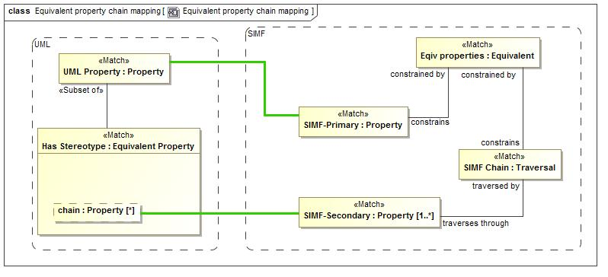

1. Equivalent property chain mapping

Equivalent property chain mapping maps the UML stereotype <<Equivalent Property>> with a "chain" tag to a SMIF "Equivalent" constraint constraining a SMIF Traversal of that chain.

The stereotyped property corresponds with the <constrains> property of the Equivalent constraint.

**package** SMIFProfileToModelMapping::Mapping rules

## Class Equivalent property mapping

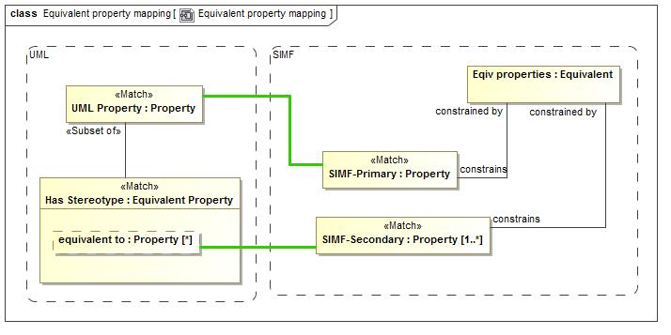

1. Equivalent property mapping

Equivalent property chain mapping maps the UML stereotype <<Equivalent Property>> with a <equivalent to> tag to a SMIF "Equivalent" constraint constraining a SMIF Secondary property.

The stereotyped property corresponds with the <constrains> property of the Equivalent constraint.

**package** SMIFProfileToModelMapping::Mapping rules

## Class Equivalent with mapping

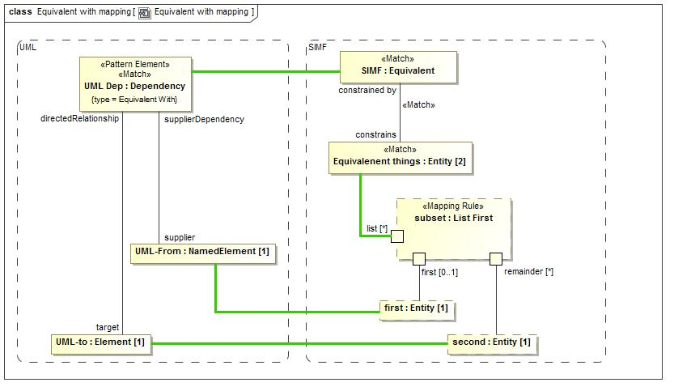

1. Equivalent with mapping

Equivalent with draws a correspondence between a UML dependency stereotyped as <<Equivalent With>> and a SMIF equivalent constraint with exactly 2 constrained elements. The first element is mapped to the dependency supplier and the second element to the dependency target.

The "List First" rule is used to divide the list elements.

Note that SMIF Equivalent constraints with more than 2 constrained elements will map to a generalization set.

**package** SMIFProfileToModelMapping::Mapping rules

## Class Generalization mapping

The generalization mapping rule draws a direct correspondence between a UML Generalization and a SMIF Type Generalization Constraint.

The UML <<Classifies>> constraint corresponds with the "as facet" boolean of the SMIF constraint.

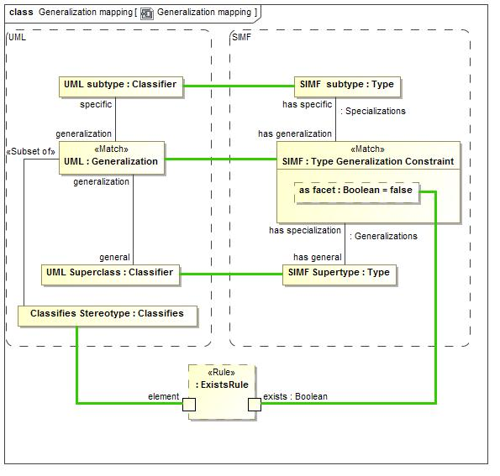

1. Generalization mapping

**package** SMIFProfileToModelMapping::Mapping rules

## Class Generalization set covering mapping

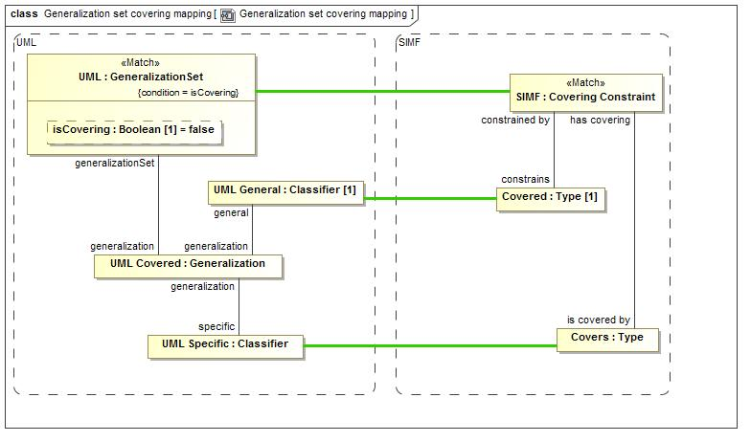

1. Generalization set covering mapping

Generalization set covering constraint draws a correspondence between a generalization set where isCovering is true and a SMIF Covering Constraint.

The generalization set has a set of UML covered <<Generalization>>s, all of which must have the same <general> Classifier, which is mapped to the <holds within> type.

The <specific> classifiers correspond to a set of <is covered by> types.

**package** SMIFProfileToModelMapping::Mapping rules

## Class Generalization set disjoint mapping

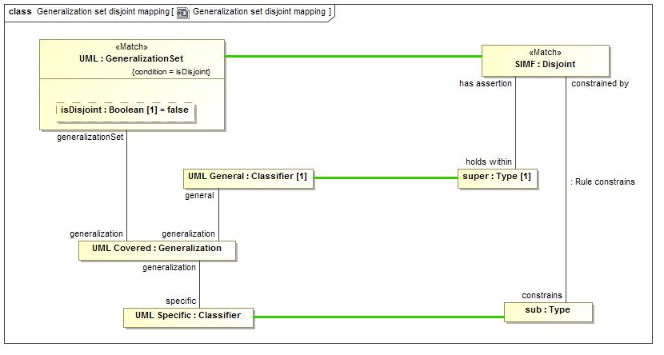

1. Generalization set disjoint mapping

Generalization set disjoint constraint draws a correspondence between a generalization set where isDisjoint is true and a SMIF Disjoint Constraint.

The generalization set has a set of UML covered <<Generalization>>s, all of which must have the same <general> Classifier, which is mapped to the <holds within> type.

The <specific> classifiers correspond to a set of <is covered by> types.

**package** SMIFProfileToModelMapping::Mapping rules

## Class Is in context mapping

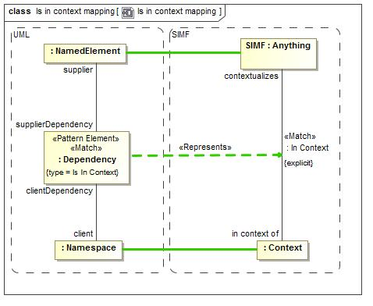

1. Is in context mapping

Is in contest mapping draws a correspondence between a UML dependency with a <<Is In CContext>> stereotype and an explicit "In Context" Relationship. The relationship is Explicit if it has been explicitly asserted, not inferred.

**package** SMIFProfileToModelMapping::Mapping rules

## Class Mapping rule mapping

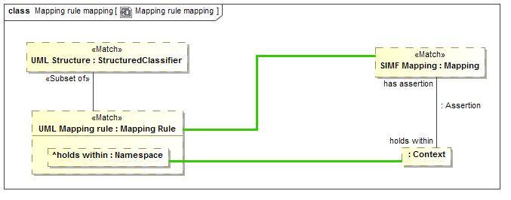

1. Mapping rule mapping

The Mapping rule mapping draws a correspondence between any UML StructuredClassifier marked as a <<Mapping Rule>> and a SMIF Mapping. The <holds within> tag then maps to the context the mapping holds within.

Any structured classifier may be created from SMIF.

**package** SMIFProfileToModelMapping::Mapping rules

## Class Named element Mapping

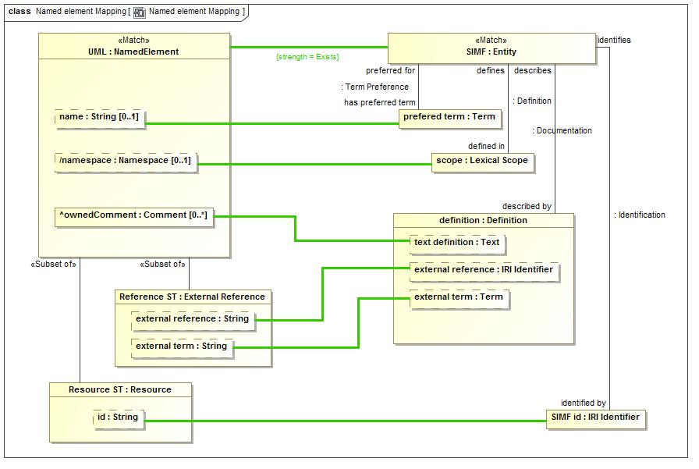

1. Named element Mapping

**package** SMIFProfileToModelMapping::Mapping rules

## Class Pattern property mapping

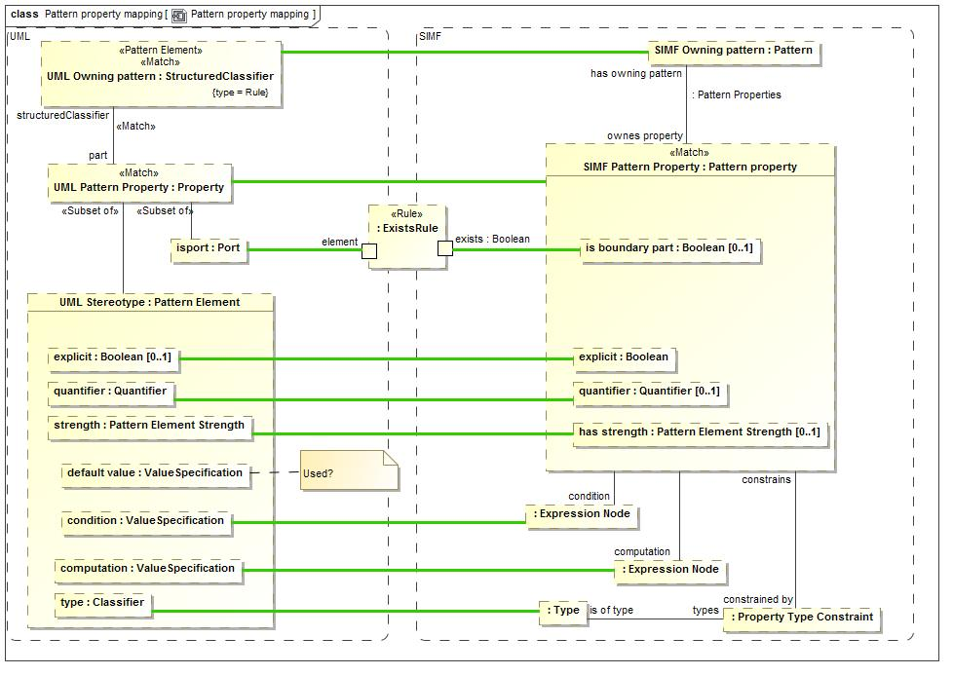

1. Pattern property mapping

Pattern property mapping makes a correspondence between any UML property that is <part> of a <Rule> and a SMIF Pattern Property.

The owning StructuredClassifier corresponds with the pattern that owns the Pattern Property.

If the UML Property is stereotyped as a <<Pattern Element>> the tags correspond with the explicit, quantifier, condition, computation and has strength properties of the SMIF pattern property.

The <type> of the UML Pattern Element is constrained to be a required <is of type> of the pattern property.

**package** SMIFProfileToModelMapping::Mapping rules

## Class Property hierarchy mapping

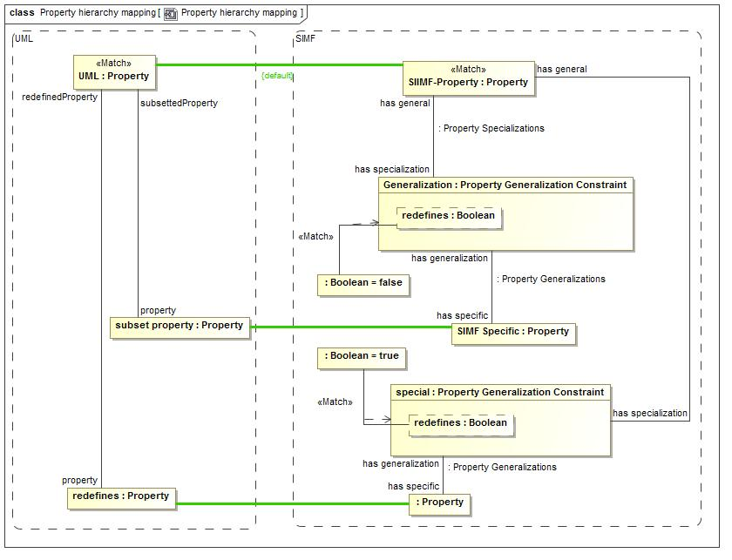

1. Property hierarchy mapping

Property hierarchy mapping, for properties that have been mapped in other ways, maps UML subsetted properties to a Property Generalization Constraint with redefines=false.

It also maps UML redefines properties to a Property Generalization Constraint with redefines=true.

**package** SMIFProfileToModelMapping::Mapping rules

## Class Synonym mapping

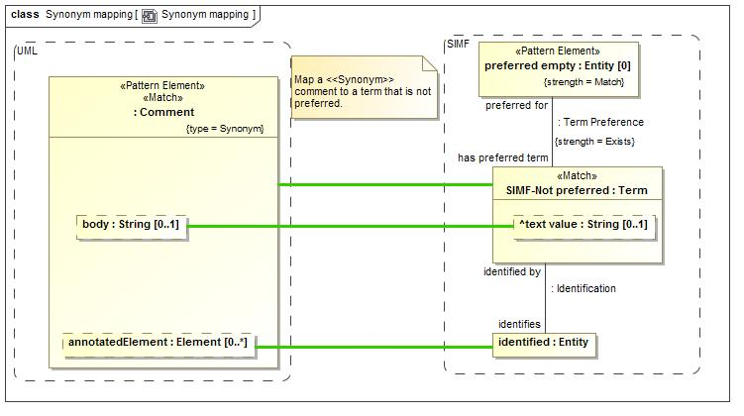

1. Synonym mapping

Synonym mapping maps a UML Comment with a <<Synonym>> stereotype to a SMIF Term that identifies the element that is annotated by the comment in UML.

A Synonym term is not a preferred term.

**package** SMIFProfileToModelMapping::Mapping rules

# Concept Index

about, 68

about type, 97

Actual Entity, 98

Actual Situation, 93

All, 75

Annotation Property, 76

Annotation value mapping, 188

Assert, 75

asserted by, 62

asserted type, 62

Assertion, 99

Assertion Statement, 66

asserts, 99

asserts pattern, 74

Association mapping, 189

at once, 88

Base Unit Type, 107

binds, 77

bound by, 77

bound in, 77

Bound Individual, 77

Bound Property, 77

Bound Subject, 77

bound to, 77

calls, 46

categorizes, 104

Characteristic Binding, 77

Characteristic Type, 77

Class mapping, 189

Class property mapping, 190

coerce, 63

computation, 63

Computed Facade, 61

concept rule, 65

Conceptual Package, 56

concrete end, 61

Concrete Map End, 61

concrete mapping, 61

concrete pattern, 61

Concrete Pattern Relation, 61

condition, 63, 65, 72, 86

Conditional Rule, 86

Constant Reference, 44

Constant Value, 44

constrained by, 90

constrains, 90

Containment mapping, 191

Context, 99

contextualizes, 45, 100

Covering Constraint, 87

default, 63

Default, 75

defaut, 73

defined by, 67

defined in, 57

defined within system, 108

defines, 57, 67

Defining Relative Property, 70

Definition, 56, 67

Definition Relationship, 67

Disjoint, 87

Entity Type, 103

Enumerated, 87

Enumeration mapping, 191

Equality, 45

Equality Constraint, 45

Equivalent, 87

Equivalent property chain mapping, 192

Equivalent property mapping, 192

Equivalent with mapping, 193

evaluated by, 46

evaluates, 46

evaluates in, 45

Evaluation, 45

Exactly One, 75

Exists, 75

explicit, 72, 73

Expression Context, 45

Expression Evaluation, 46

Expression Node, 46

expression text, 46

expression text language, 46

extends scope, 59

Extent of Context, 99

Extent of Type, 103

external reference, 67

external term, 67

Facade, 61

Facet, 104

Facet Classification Constraint, 87

Focus Property, 71

Function Call, 46

Function Called, 46

Function Implementation, 47

Function Type, 47

Generalization, 88

Generalization mapping, 193

Generalization set covering mapping, 195

Generalization set disjoint mapping, 196

has binding, 77

has covering, 87

has equal, 45

has equality, 45

has general, 88

has generalization, 91

has map rule, 71

has metadata, 68

has multiplicity, 89

has name, 51

has owning pattern, 72, 73

has preferred, 50

has prefix, 58

has property, 78

has record, 68

has specialization, 88

has specific, 91

has strength, 73, 74

has supertype, 105

has type, 104

has unique, 92

has uniqueness constraint, 92

has value, 44

holds within, 99

Identifiable Entity, 100

Identification, 49

identified by, 49

Identifier, 50

Identifier in Namespace, 50

Identifier Preference, 50

identifies, 49

implemented by, 47

implements, 47

in context of, 100

Include, 57

Information Source, 67

information stated by source, 68

Intersection Type, 104

inverse, 48

IRI Identifier, 50

is boundary part, 71

is covered by, 87

is defined by, 71

Is in context mapping, 197

is of type, 89

is primary identity, 92

is sufficent, 88

is used by, 46

Lexical Reference, 57

Lexical Scope, 57

Logical Package, 57

map all, 65

map rule of, 71

Map Rule Type Assertion, 61

Mapped Property, 62

Mapped Relationship, 62

Mapping, 62

Mapping Package, 57

Mapping Pattern, 62

Mapping rule mapping, 197

maps property, 62

maps relationship, 62

match from, 61

Match Rule, 63

Match Rule End, 63

Match Rules, 71

match to, 64

maximum number, 88

Metadata, 67

metadata about, 68

Metadata relationship, 68

mininum number, 88

Model, 57

Most, 75

Multiplicity Constraint, 88

multiplicity of, 89

Multiplicity Reference, 88

Multiplicity Target, 89

Name, 50

Named element Mapping, 198

names, 51

Namespace, 51

Naming Relationship, 51

None, 75

Object Management Group, Inc. (OMG), xiii

Object Operation Type, 47

offset, 110

OMG specifications, xiii

OO Target, 47

owns property, 72

owns relationship, 73

Package, 58

Part Property, 71

path expression, 74

Pattern, 71

Pattern Element Strength, 74

Pattern of Type, 72

Pattern Properties, 72

Pattern Property, 72

Pattern property mapping, 199

Pattern Property Subset, 73

Pattern Relationship, 73

Phase, 104

Physical Package, 58

preferred for, 50

Prefix, 58

prefix of, 58

prerequisite type, 90

properties of type, 90

Properties Relationship, 78

Property Binding, 78

Property Chains, 167

Property Constraint, 89

property end, 62

Property End, 63

Property hierarchy mapping, 200

property of, 78

Property Transitivity Constraint, 89

Property Type, 78, 89

Property Type Constraint, 90

Proposition, 100

Quantified Property, 73

quantifier, 73

Quantifier, 75

Quantity kind, 108

Quantity Value, 108

ratio, 109

received by, 47

receiver, 47

Record, 96

Record of a thing, 68

Record Type, 96

Record types for a type, 97

recording typs, 97

redefines, 91

reference end, 64

Reference Map End, 64

reference mapping, 64

reference pattern, 64

Reference Pattern Relation, 64

referenced by, 44, 58

Referenced scope, 58

Referenced System of Units, 108

references, 59

Relationship, 80

relationship end, 62

Relationship End, 64

Relationship Type, 81

Relative Property, 74

relative to, 71

Representation, 64

Representation Rule, 64

represented by, 64

represented concept, 65

Represented Concept, 65

represents rule, 64

respect of, 89

Result type, 47

resulting type, 47

returned by, 47

Role, 104

Rule, 90

Rule Constrains, 90

Rule Subsumption, 90

Scope, 58

Scope Reference, 59

scopes identifier, 50

Select, 75

Situation, 93

Situation Type, 94

source of information, 68

Source of Information, 68

sourced from, 66

Specialization, 91

stated by, 59

Statement, 59, 68

statement date and time, 68

states, 59, 67

Structure, 97

Structure Property Binding, 97

Structure Type, 97

Structured Property Type, 97

Structured Value, 109

Structured Value Type, 109

Subject of Pattern Relationship, 74

subject type, 74

subsumed by, 91

subsumes, 91

summary description, 67

symbol, 110

Synonym mapping, 201

System of Units, 109

Technical Identifier, 51

Temportal Entity, 100

Term, 51

text definition, 67

Text Identifier, 51

There Exists, 75

Thing, 100

transaction id, 68

Traversal, 48

Traverse Through, 48

traverse to relation, 48

traversed by, 48

traverses through, 48

Type, 105

Type Constraint, 91

Type Generalization Constraint, 91

Type Pattern Property, 74

typographical conventions, xiv

Union Type, 105

Unique Identifier, 52

Unique Set, 92

Unique Text Identifier, 52

unique within, 50

Uniqueness Constraint, 92

unit of system, 109

unit reference, 110

Unit Type, 109

value, 51, 108

Value, 110

Value Type, 110

version, 68

with respect to, 88

1. ECSS is an initiative established to develop a coherent, single set of user-friendly standards for use in all European space activities [ECSS].
2. Not to be confused with how “domain” is used in the intelligence community, which refers to levels of security
3. https://en.wikipedia.org/wiki/Mars_Climate_Orbiter